**CS 475/575 -- Spring Quarter 2017**

**Project #0**

**Simple OpenMP Experiment**

**Professor Mike Bailey**

**Xiao Tan**

In this project, I ran this program in the server (flip.engr.oregonstate.edu), which belongs to OSU, and I got the following results while I set subdivision as 2 million, and number of tries as 50 times.

First result

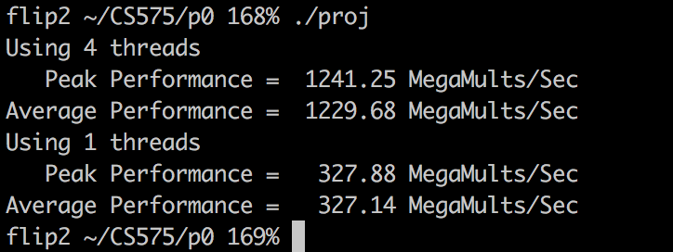

Second result

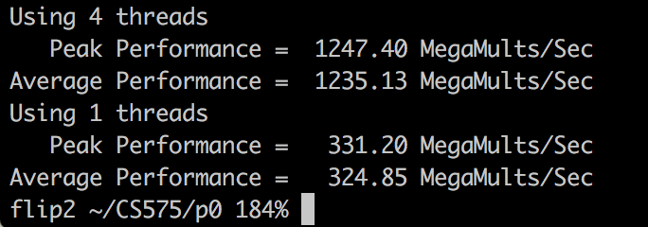

Third result

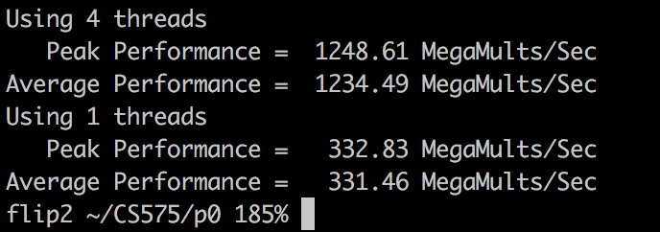

According to equation, here I use average performance of first result to calculate, 4-thread-to-one-thread speedup is S = 1229.68 / 327.14 = 3.76.

Because it is executing C[i] = A[i] * B[i], they will not affect each other, this program works like splitting one work to four independent parts to do, therefore, we can get these results which four threads will 4 times to one thread.

According to Parallel Fraction is Fp = ( 4. / 3, ) * ( 1. - ( 1. / S )), I got the Fp is 0.98.

This is a super easy project. Mostly, I got right results in this program, however, I got some bad results sometimes, this is maybe machine I used problem, sometimes, I got 4-thread performance is twice to 1-thread performance.