Wireless projector

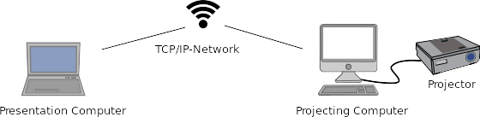

Overwiew
TODO

Comparision between VNC and ffmpeg
Either VNC or ffmpeg is used for streaming.
TODO.

Choosing a good screen-resolution
There are three screen-resolutions to deal with:
- The screen-resolution of the presentation-computer
- The resolution of the video-stream
- The resolution of the projecting-computer

TODO: tradeoff bandwidth vs. Latency and quality

TODO: how to choose which resolution

Installation of the VNC-Server-software
TODO

Installation on Linux
TODO

Installtion on Mac-OS
TODO

Installation on Windows
TODO

Installation of ffmpeg
TODO

Installation on Linux
TODO

Installtion on Mac-OS
TODO

Installation on Windows
TODO

