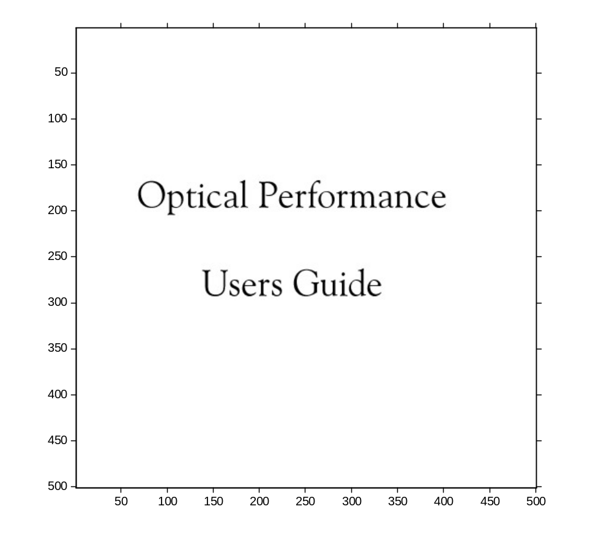

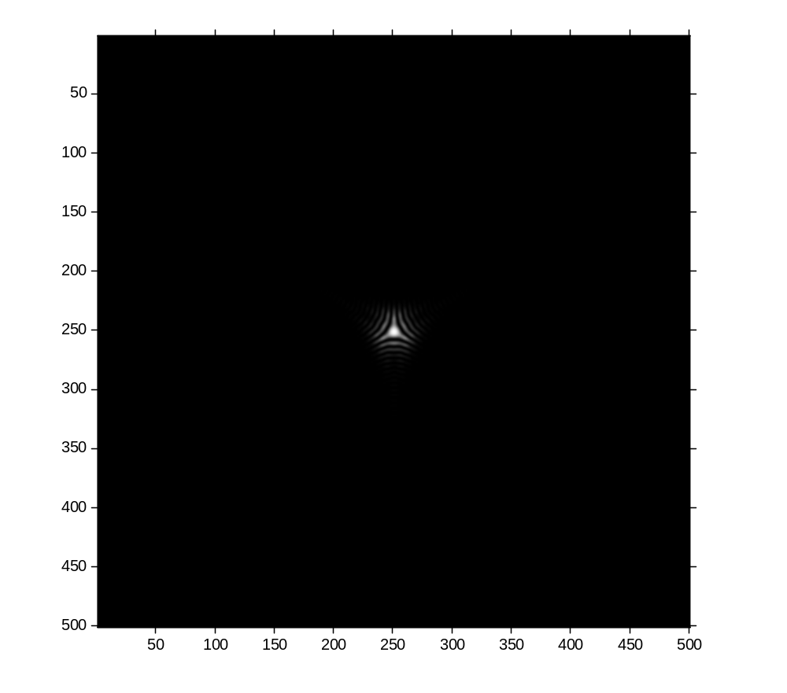

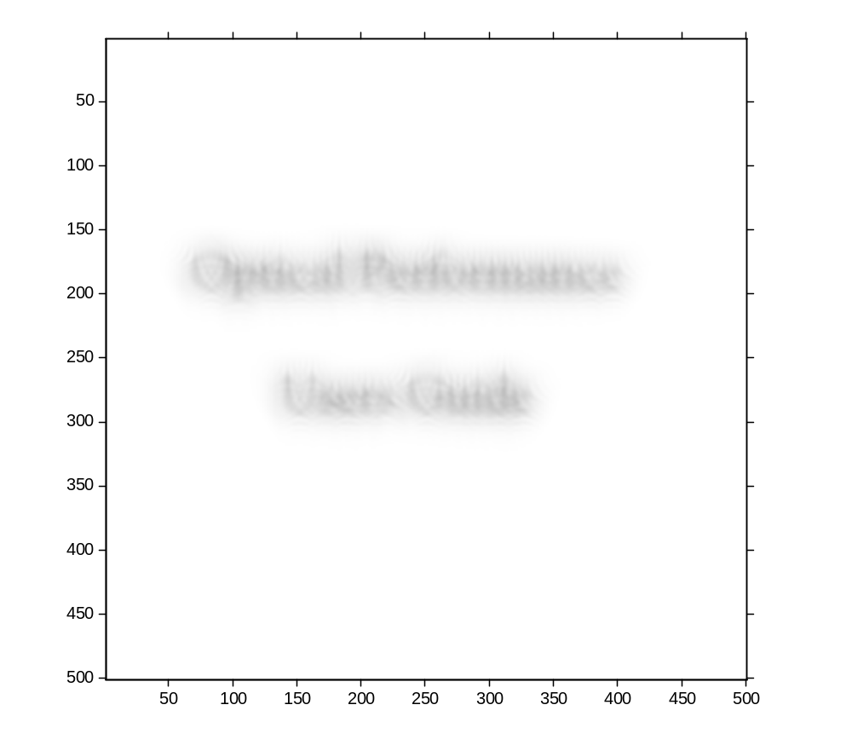

Austin Roorda September 16, 2009
(updated, Sept 26, 2013)

Introduction

Optical Performance is a set of Matlab scripts that are used to analyze wave aberration data. The wavefront aberration is represented by a Zernike polynomial. Appendix 1 provides the full polynomial equation (up to 10th order) and outlines the specific ordering and numbering scheme that has been adopted. The program computes and display wave aberration plots, point spread functions, and modulation transfer functions. In addition, the program computes spectacle refraction, rms wave aberration and Strehl ratio. Many outputs are displayed directly to the screen and some outputs get saved to a file. The program is intended to be edited to suit whatever calculations you intend to do. While the program is free os bugs, it is not a robust software package. It requires some effort on your to ensure that you are getting the results that you intend. But it is a powerful set of tools for analyzing wavefront aberrations, and it is very adaptable for many different applications.

Starting the program:

Open Matlab and set path to the folder that contains the optical_performance.m script and other programs.

Open the script optical_performance.m. This is the main program that you will be running and editing.

The program is split into several parts:

Part 1: sets up the basic parameters. Some are only set here, other parameters may be reset later in the program, but you will be warned when that happens.

PARAMS(1): This parameter set the matrix size for the calculations. Since wavefronts, point spread functions and MTF’s are represented as matrices, it follows that the larger this number the more sampling you have for your calculation. But large number here also make the program run much slower.

*PARAMS(2): When you use preset coefficients, then this number represents the pupil size that the Zernike coefficients correspond to. When you read in a set of zernike coefficients from a “*.zer” file then this value is overridden by the value contained in the file.

*PARAMS(3): Sometimes your coefficients define a wavefront for a pupil that is larger than the pupil size that you want to analyze. Generally these are the same, but you may make this value smaller.

*PARAMS(4):When you make a matrix representing the wavefront, you do not necessarily want the pupil to occupy the entire extent of the matrix. This is because the fourier transform of large objects turn into small features and vice versa. So, by making the pupil occupy a small space within the matrix (defined in PARAMS(1)) you actually magnify the image of the PSF in the image. Generally, this parameter is at least 2 times the size of the pupil (in mm).

PARAMS(5): This is the wavelength used to do the calculation. Wavelength must be considered when calculating the PSF. For example, shorter wavelengths are less affected by diffraction than longer wavelengths.

PARAMS(6): This value is used later in the program, so a place holder is made for it here.

PARAMS(7): This parameter sets the density of the wavefront image that is displayed. It does not affect any other calculation in the program. Use a large number here to get a finer contour map of the wave aberration.

Part 2: The Zernike coefficients are the weighting factors for the Zernike polynomials that define the wavefront., This part of the program allows to either input your own Zernike coefficients by editing the program, or to read them in from a file.
The program has placeholders for the user to input any value of any coefficients. The preset values can be used to visualize individual aberrations or combinations of them.
The choice is made through a windows dialog box.
When the coefficients are read in from a file, PARAMS 2 3 and 4 are all set and will override any settings made in part 1.

Part 3: The best spectacle refraction is calculated, based on the Zernike coefficients. The result is displayed in the Matlab command window.

Part 4: This section is used to edit the Zernike coefficients for whatever purposes. For example, if you want to visualize the PSF for an eye whose defocus is corrected, then you would set the coefficient c(4) to 0 here. C(3) and c(5) can be set to 0 here to remove astigmatism from the calculation.
The RMS of the remaining terms is calculated and displayed in the Matlab command window. The RMS is calculated as the vector sum of the zernike coefficients. You can edit the lines to to calculate the RMS of any subset of Zernike coefficients.
Part 5: This section calls the script compWaveOSA, which computes and displays the wave aberration as a contour map. To edit the display, you will need to open and idet the script compWaveOSA.

Part 6: This section calls the script compPSFOSA, which computes and displays the PSF, as well as displays the Strehl ratio. Once the PSF is calculated some script in the main program is used to save an image of the PSF as a tif file, as well as to compute the PSF size relative to a 20/20 letter (used to aid a convolution simulation). Another function is called here, called MakeAnE.m which generates an image of letter E that can be used for convolution.

Part 7: Computes the MTF by calculating the fourier transform of the PSF from section 6. The 3 D MTF is displayed as well as the radial average MTF, the MTF for horizontal gratings, and the MTF for vertical gratings. A text file with the values for the rdial average MTF is saved to a file.

The Scripts:

optical_performance.m | Main program
spectacleOSA.m | computes spectacle refraction from the Zernike coefficients c(3) c(4) and c(5)
compWaveOSA.m | Computes and displays the wave aberrations as a contour plot (calls ZwaveMahajanOSA.m)
Zwave_MahajanOSA.m | This script contains the Zernike polynomial and converts it to a wavefront height map
compPSFOSA.m | Computes and displays the PSF and Strehl ratio (calls ZphaseMahajanOSA.m)
MakeAnE.m | This function is used to generate an image of a letter E of a specific size to be used for convolution
Zphase_MahajanOSA.m | This script contains the Zernike polynomials and converts it to a complex phase map.
compMTF.m | Computes and displays the MTF as a surface plot
compMTF_radial.m | Computes the radial average MTF from the plot above
compMTF_HV.m | Extracts the horizontal and vertical cross-sections of the 3-D MTF and displays them as line plots .

Other programs:

CONVOLVE.m

This program will allow you to read in two images and convolve them with each other. The images have to be the same size in pixels, but they can be in a number of different formats. The most conventional application is to blur objects with a point spread function. In that case, you would read in an image, read in a PSF and the program will compute and display the convolved image.

Some Exercises:

- Compute the diffraction limited PSF and MTF for a range of pupil sizes from 1 to 7 mm.
- For a fixed pupil size, compute the PSF for wvalengths from 400 to 700 nm in 100 nm steps. How does the size change?
- Read in the coefficients for a typical eye. Generate all outputs for all a) the terms, b) all terms except defocus (set c(4) to zero) and c) all terms except defocus and astigmatism (set c(3), c(4) and c(5) to zero). How do the values change.
- Read in the coefficients for a typical eye. Remove defocus and astigmatism. Generate all outputs for defocus ranging from -2 D to +2 D in 0.25 D steps. At what defocus does the minimum value for RMS occur. What defocus has the maximum Strehl ratio?
Appendix 1: The First 65 Zernike Polynomials (up to 10th order)

The wavefront is fit to a Zernike polynomial. The equation is written as
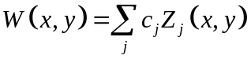
where j represents the specific coefficient, c, and its associated polynomial equation Z(x,y).

Each individual and each pupil size within that individual will have its own specific set of coefficients, c. The polynomials can be ordered by a single index scheme, but they are also ordered by a double indexing scheme. The relationships shown below are common indexing schemes.

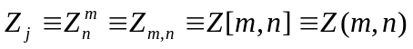 where j indicate the single index counter and n (radial order) and m (tangential order) are used to indicate the double index counters.

The table shows the list of polynomials with both indexing schemes. This particular ordering and normalization are the accepted standard for representing aberrations in the human eye ¹.

j-index | n | m | Zernike term nickname | Zernike term
Zeroth order
0 | 0 | 0 | Piston | 1
First order (prism)
1 | 1 | -1 | Vertical prism | 2*ρ*sin(θ)
2 | 1 | 1 | Horizontal prism | 2*ρ*cos(θ)
second order (defocus and astigmatism)
3 | 2 | -2 | Astigmatism | √6*ρ²*sin(2θ)
4 | 2 | 0 | Defocus | √3*(2*ρ²-1)
5 | 2 | 2 | Astigmatism | √6*ρ²*cos(2θ)
Third order (coma-like terms)
6 | 3 | -3 | Trefoil | √8*ρ³*sin(3θ)
7 | 3 | -1 | Vertical coma | √8*(3*ρ³-2*ρ)*sin(θ)
8 | 3 | 1 | Horizontal coma | √8*(3*ρ³-2*ρ)*cos(θ)
9 | 3 | 3 | Trefoil | √8*ρ³*cos(3θ)
Fourth order
10 | 4 | -4 | Quadrafoil | √10*ρ⁴*sin(4θ)
11 | 4 | -2 | Secondary astig. | √10*(4*ρ⁴-3*ρ²)*sin(2θ)
12 | 4 | 0 | Spherical aberration | √5*(6*ρ⁴-6*ρ²+ 1)
13 | 4 | 2 | Secondary astig. | √10*(4*ρ⁴-3*ρ²)*cos(2θ)
14 | 4 | 4 | Quadrafoil | √10*ρ⁴*cos(4θ)
Fifth order
15 | 5 | -5 |  | √12*ρ⁵*sin(5θ)
16 | 5 | -3 |  | √12*(5*ρ⁵-4*ρ³)*sin(3θ)
17 | 5 | -1 |  | 1√12*(10*ρ⁵-12*ρ³+3*ρ)*sin(θ)
18 | 5 | 1 |  | √12*(10*ρ⁵-12*ρ³+3*ρ)*cos(θ)
19 | 5 | 3 |  | √12*(5*ρ⁵-4*ρ³)*cos(3θ)
20 | 5 | 5 |  | √12*ρ⁵*cos(5θ)
Sixth order
21 | 6 | -6 |  | √14*ρ⁶*sin(6θ)
22 | 6 | -4 |  | √14*(6*ρ⁶-5*ρ⁴)*sin(4θ)
23 | 6 | -2 |  | √14*(15*ρ⁶-20*ρ⁴+6*ρ²)*sin(2θ)
24 | 6 | 0 |  | √7*(20*ρ⁶-30*ρ⁴+12*ρ²-1)
25 | 6 | 2 |  | √14*(15*ρ⁶-20*ρ⁴+6*ρ²)*cos(2θ)
26 | 6 | 4 |  | √14*(6*ρ⁶-5*ρ⁴)*cos(4θ)
27 | 6 | 6 |  | √14*ρ⁶*cos(6θ)
Seventh order
28 | 7 | -7 |  | √16*ρ⁷*sin(7θ)
29 | 7 | -5 |  | √16*(7*ρ⁷-6*ρ⁵)*sin(5θ)
30 | 7 | -3 |  | √16*(21*ρ⁷-30*ρ⁵+10*ρ³)*sin(3θ)
31 | 7 | -1 |  | √16*(35*ρ⁷-60*ρ⁵+30*ρ³-4*ρ)*sin(θ)
32 | 7 | 1 |  | √16*(35*ρ⁷-60*ρ⁵+30*ρ³-4*ρ)*cos(θ)
33 | 7 | 3 |  | √16*(21*ρ⁷-30*ρ⁵+10*ρ³)*cos(3θ)
34 | 7 | 5 |  | √16*(7*ρ⁷-6*ρ⁵)*cos(5θ)
35 | 7 | 7 |  | √16*ρ⁷*cos(7θ)
Eighth order
36 | 8 | -8 |  | √18*ρ⁸*sin(8θ)
37 | 8 | -6 |  | √18*(8*ρ⁸-7*ρ⁶)*sin(6θ)
38 | 8 | -4 |  | √18*(28*ρ⁸-42*ρ⁶+15*ρ⁴)*sin(4θ)
39 | 8 | -2 |  | √18*(56*ρ⁸-105*ρ⁶+60*ρ⁴-10*ρ²)*sin(2θ)
40 | 8 | 0 |  | √9*(70*ρ⁸-140*ρ⁶+90*ρ⁴-20*ρ²+ 1)
41 | 8 | 2 |  | √18*(56*ρ⁸-105*ρ⁶+60*ρ⁴-10*ρ²)*cos(2θ)
42 | 8 | 4 |  | √18*(28*ρ⁸-42*ρ⁶+15*ρ⁴)*cos(4θ)
43 | 8 | 6 |  | √18*(8*ρ⁸-7*ρ⁶)*cos(6θ)
44 | 8 | 8 |  | √18*ρ⁸*cos(8θ)
Ninth order
45 | 9 | -9 |  | √20*ρ⁹*sin(9θ)
46 | 9 | -7 |  | √20*(9*ρ⁹-8*ρ⁷)*sin(7θ)
47 | 9 | -5 |  | √20*(36*ρ⁹-56*ρ⁷+21*ρ⁵)*sin(5θ)
48 | 9 | -3 |  | √20*(84*ρ⁹-168*ρ⁷+105*ρ⁵-20*ρ³)*sin(3θ)
49 | 9 | -1 |  | √20*(126*ρ⁹-280*ρ⁷+ 210*ρ⁵-60*ρ³+ 5*ρ)*sin(θ)
50 | 9 | 1 |  | √20*(126*ρ⁹-280*ρ⁷+ 210*ρ⁵-60*ρ³+ 5*ρ)*cos(θ)
51 | 9 | 3 |  | √20*(84*ρ⁹-168*ρ⁷+105*ρ⁵-20*ρ³)*cos(3θ)
52 | 9 | 5 |  | √20*(36*ρ⁹-56*ρ⁷+21*ρ⁵)*cos(5θ)
53 | 9 | 7 |  | √20*(9*ρ⁹-8*ρ⁷)*cos(7θ)
54 | 9 | 9 |  | √20*ρ⁹*cos(9θ)
Tenth order
55 | 10 | -10 |  | √22*ρ¹⁰*sin(10θ)
56 | 10 | -8 |  | √22*(10*ρ¹⁰-9*ρ⁸)*sin(8θ)
57 | 10 | -6 |  | √22*(45*ρ¹⁰-72*ρ⁸+28*ρ⁶)*sin(6θ)
58 | 10 | -4 |  | √22*(120*ρ¹⁰-252*ρ⁸+168*ρ⁶-35*ρ⁴)*sin(4θ)
59 | 10 | -2 |  | √22*(210*ρ¹⁰-504*ρ⁸+ 420*ρ⁶-140*ρ⁴+ 15*ρ²)*sin(2*θ)
60 | 10 | 0 |  | √11*(252*ρ¹⁰-630*ρ⁸+ 560*ρ⁶-210*ρ⁴+ 30*ρ²-1)
61 | 10 | 2 |  | √22*(210*ρ¹⁰-504*ρ⁸+ 420*ρ⁶-140*ρ⁴+ 15*ρ²)*cos(2*θ)
62 | 10 | 4 |  | √22*(120*ρ¹⁰-252*ρ⁸+168*ρ⁶-35*ρ⁴)*cos(4θ)
63 | 10 | 6 |  | √22*(45*ρ¹⁰-72*ρ⁸+28*ρ⁶)*cos(6θ)
64 | 10 | 8 |  | √22*(10*ρ¹⁰-9*ρ⁸)*cos(8θ)
65 | 10 | 10 |  | √22*ρ¹⁰*cos(10θ)

Reference List

Thibos, L. N., Applegate, R. A., Schwiegerling, J., Webb, R. H., VSIA Standards Taskforce Members Standards for reporting the optical aberrations of eyes. Vision Science and its Applications 232-244 (2000).

scripts that run on Octave (open access software) is also included. They are identified with the same names but with an _octave appended to the filename. To download and learn more about using Octave, link to http://www.gnu.org/software/octave/download.html

