E2:

1. For ec.ho, the result for ping is “Name or service not know”. I think it is that this host is not exist as I also cannot open it in browser.
2. For pin.gs, same as ec.ho.
3. For nasa.gov, This is obviously the official NASA website, can be open in browser. But 100% packet loss means there is a communication failure between two communicating devices, my local computer and NASA’s server. One possibility is that NASA's servers do not allow ping access to unknown computers for security reasons and another reason is the packet loss which causes by the queue. When the queue is full, the coming package will loss, but it is basically impossible to lose 59 packages together.

All other hosts are reachable.

E3:

How many routers are there between your workstation and [www.tu-berlin.de](http://www.tu-berlin.de/)?

A: 15(first one is not my workstation and the last one is www.tu-berlin.de)

How many routers along the path are part of the UNSW network?

A: 5

Which router is the first router outside of Australia?

A: router 10

Which router is the first router in Europe?

A: router 7(sing means Singapore)

2.

 At which router do the paths from your machine to these three destinations diverge

A: At router 7

Find out further details about this router.

A: Abuse contact for '113.197.15.0 - 113.197.15.255' is 'abuse@aarnet.edu.au', so at route 7, it is in a same server.

Is the number of hops on each path proportional to the physical distance?

A: Not at all, the connection between them is not absolute.

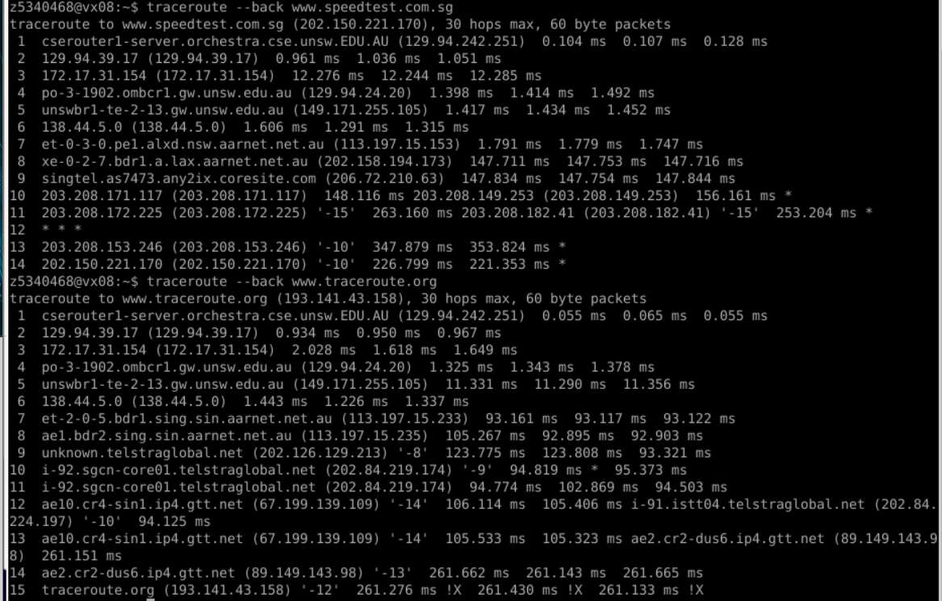

What are the IP addresses of the two servers that you have chosen?

A: www.speedtest.com.sg (202.150.221.170), www.traceroute.org (193.141.43.158)

Does the reverse path go through the same routers as the forward path?

A: So, traceroute is just guessing the reverse path and it is nearly same. But in the real situation, there will be plenty of paths to choose from, depending on the traffic jam etc., it may same or quite different.

E4:

1.

Can you think of at least two reasons why the y-axis values that you plot are greater than 2?

A: In a real transmission, there would be non-physical delays, where queueing delays could be the cause. In the transmission process of these data, some busy routes may have passed, resulting in a long queue time.

Is the delay to the destinations constant, or does it vary over time? Explain why.

A: Basic certainty, first If choose the same path the physical distance doesn't change, even change the path as it travels in light speed, the delay will not change a lot. zSecond, the length of the queue is uncertain during each transmission, which may be none or a little too long, leading to fluctuations in latency.

Which of these delays depend on the packet size and which do not?

A: Transmission delay and queuing delay depend on packet size, propagation delay and processing delay are not