The models cover all multicopter airframe for PX4 autopilot：http://dev.px4.io/en/airframes/airframe_reference.html

ModelParam_uavType = 1: Tricopter Y+
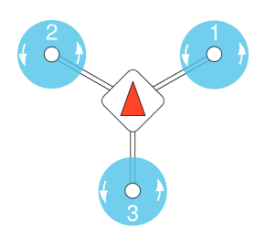

ModelParam_uavType = 2: Tricopter Y-
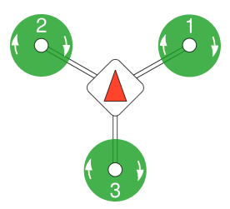

ModelParam_uavType = 3: Quadrotor X
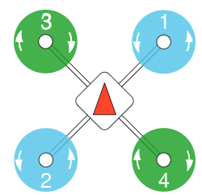

ModelParam_uavType = 4: Quadrotor +
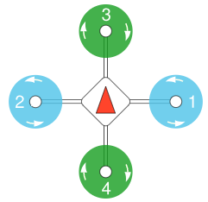

ModelParam_uavType = 5: Hexarotor x
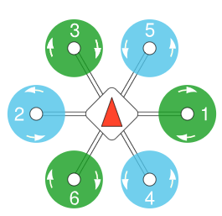

ModelParam_uavType = 6: Hexarotor +
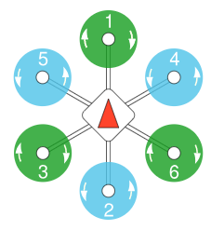

ModelParam_uavType = 7: Hexarotor Coaxial
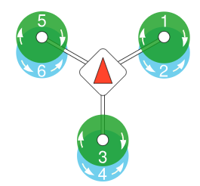

ModelParam_uavType = 8: Octorotor x
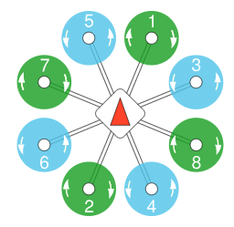

ModelParam_uavType = 9: Octorotor +
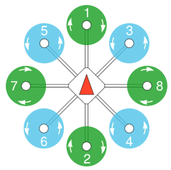

ModelParam_uavType = 10: Octorotor Coaxial
