Design Decision:

1. Breaking Down the Task
2. Loading Barcode Data with FDA API (Scanning Page)
   * Access the phone’s camera
   * Search for food info using FDA API
   * Cast the returned package into App’s food object
   * Saved the food object
3. Edit Personal Recipe (Editing Page)
   * Foods can be loaded from data base
   * Names/serving size/nutrition info can be edited
   * Recipe for each day can be saved/loaded
4. Data Managing (Save-file Page)

* User’s data should be saved on the cloud server with their UID
* User should login using Google account

1. Work flow of the App

Camera Scanning

Read Barcode

Access API

Cast Nutrition Data => <Food> Object

Save <Food> Object into Data Base

Add Food & Serving Size in the Editing Page

Calculate the Nutrition Summary

1. Class/Object Structure

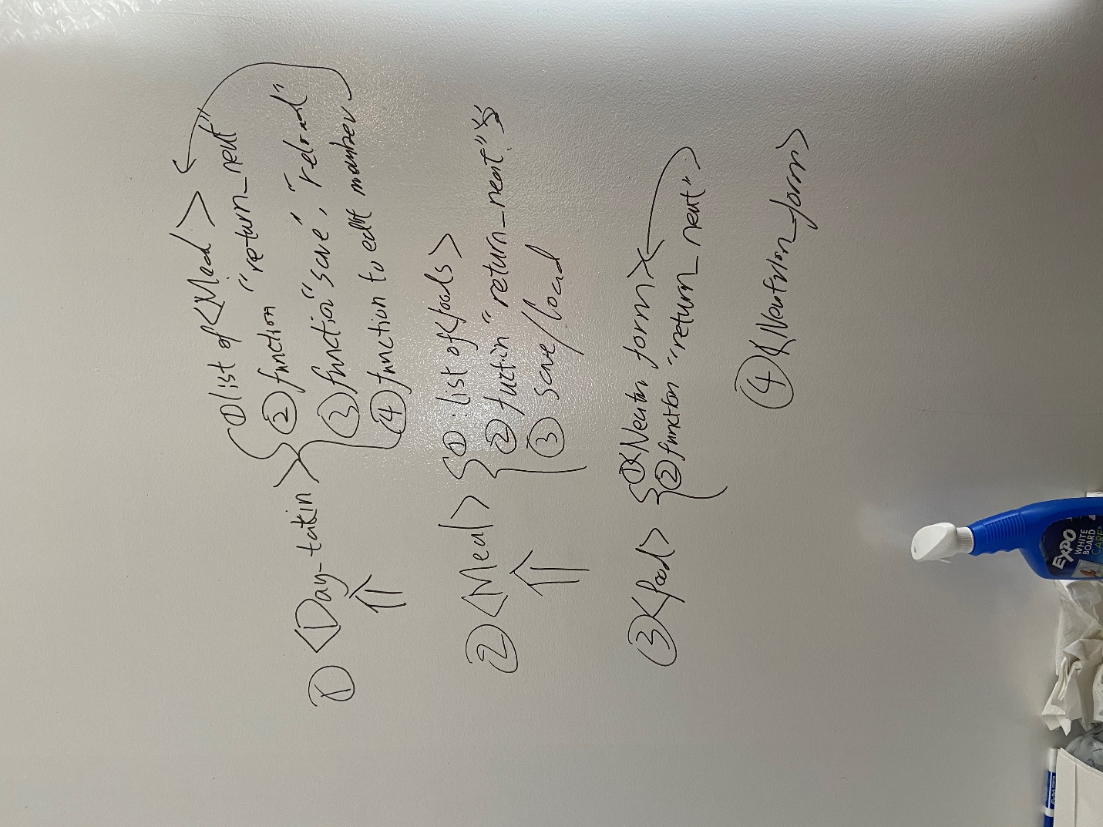

1. Could Storage

User’s data is stored with the Google account’s UID

