统计数据集
统计数据集总数、统计不同位数验证码的数量与所占比例。
总条数为： 40000 条

验证码的数量:
3 16183
1 9844
4 8065
2 5908

验证码数量所占比例：
3 0.404575
1 0.246100
4 0.201625
2 0.147700

模型的结果特点与设计思想
- 只能使用卷积神经网络；
- 只能设计一个模型来完成不定长度验证码的识别（端到端模型）；
- 输出模型参数数量，参数数量不得多于300万。
- 使用一个或多个name_scope（或variable_scope）包裹模型或模型中的相关操作部分。

由于CNN结果输出为定长，所以按照常规的CNN方式肯定是不能得到预期结果。
故，在最末尾一层加入CTC模型

Layer (type) Output Shape Param # Connected to
============================================================================================
input_1 (InputLayer) (None, 43, 57, 1) 0
___________________________________________________________________________________________
conv2d_1 (Conv2D) (None, 43, 57, 32) 320 input_1[0][0]
____________________________________________________________________________________________
conv2d_2 (Conv2D) (None, 43, 57, 32) 9248 conv2d_1[0][0]
____________________________________________________________________________________________
max_pooling2d_1 (MaxPooling2D) (None, 21, 28, 32) 0 conv2d_2[0][0]
_________________________________________________________________________________________
conv2d_3 (Conv2D) (None, 21, 28, 64) 18496 max_pooling2d_1[0][0]
____________________________________________________________________________________________
conv2d_4 (Conv2D) (None, 21, 28, 64) 36928 conv2d_3[0][0]
___________________________________________________________________________________________
max_pooling2d_2 (MaxPooling2D) (None, 10, 14, 64) 0 conv2d_4[0][0]
___________________________________________________________________________________________
conv2d_5 (Conv2D) (None, 10, 14, 128) 73856 max_pooling2d_2[0][0]
____________________________________________________________________________________________
conv2d_6 (Conv2D) (None, 10, 14, 128) 147584 conv2d_5[0][0]
____________________________________________________________________________________________
max_pooling2d_3 (MaxPooling2D) (None, 5, 7, 128) 0 conv2d_6[0][0]
________________________________________________________________________________________
reshape_1 (Reshape) (None, 5, 896) 0 max_pooling2d_3[0][0]
___________________________________________________________________________________________
dense_1 (Dense) (None, 5, 32) 28704 reshape_1[0][0]
____________________________________________________________________________________________
gru1 (GRU) (None, 5, 32) 6240 dense_1[0][0]
____________________________________________________________________________________________
gru1_b (GRU) (None, 5, 32) 6240 dense_1[0][0]
_________________________________________________________________________________________
add_1 (Add) (None, 5, 32) 0 gru1[0][0]
gru1_b[0][0]
____________________________________________________________________________________
gru2 (GRU) (None, 5, 32) 6240 add_1[0][0]
______________________________________________________________________________________
gru2_b (GRU) (None, 5, 32) 6240 add_1[0][0]
_______________________________________________________________________________________
concatenate_1 (Concatenate) (None, 5, 64) 0 gru2[0][0]
gru2_b[0][0]
________________________________________________________________________________________
dropout_1 (Dropout) (None, 5, 64) 0 concatenate_1[0][0]
_________________________________________________________________________________________
dense_2 (Dense) (None, 5, 11) 715 dropout_1[0][0]
___________________________________________________________________________________
the_labels (InputLayer) (None, 4) 0
_________________________________________________________________________________________
input_length (InputLayer) (None, 1) 0
___________________________________________________________________________________________
label_length (InputLayer) (None, 1) 0
___________________________________________________________________________________________
ctc (Lambda) (None, 1) 0 dense_2[0][0]
the_labels[0][0]
input_length[0][0]
label_length[0][0]
==========================================================================================
Total params: 340,811
Trainable params: 340,811
Non-trainable params: 0

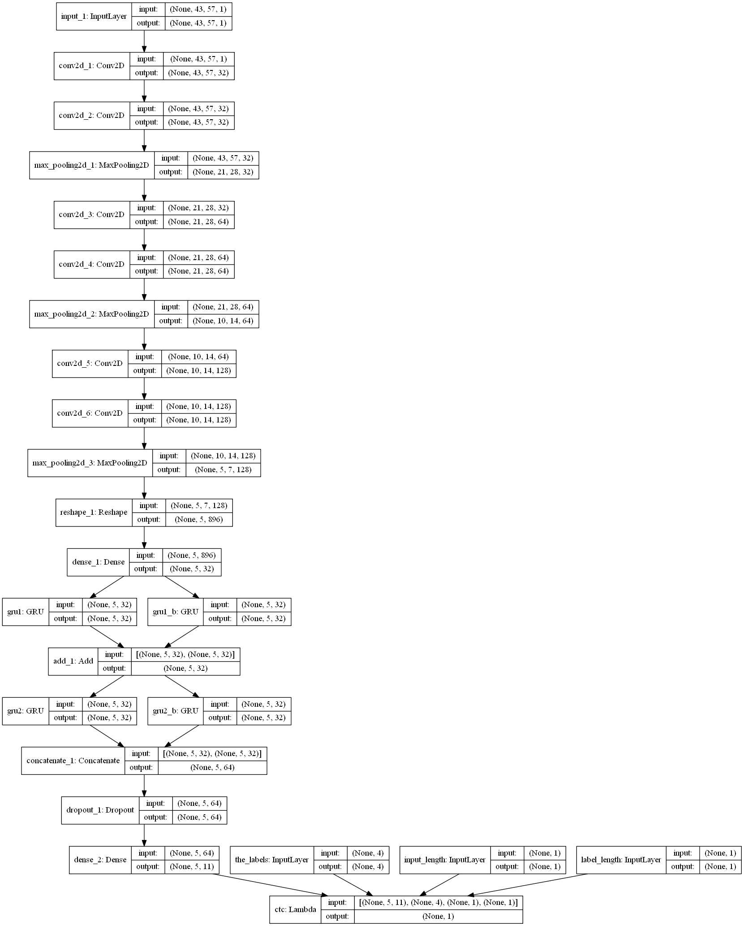

验证模型。
- 要求输出验证码字符识别正确率与验证码识别正确率，最终正确率取二者平均值；
- 训练完毕，分别输出模型在每个数据集（训练集、验证集、测试集）上的正确率的期望，并分析正确率在不同数据集上结果不同的原因。
- 将分析结果写入文档。
验证集正确率：0.75525
测试机正确率：0.74575

利用训练结果提供Web API进行验证码识别
文件说明：
work3_CNN.py
训练模型
load_CNN.py
加载模型
web.py
Web测试模型
接口说明：
Im_label=load_CNN2(file_url,model_file='../data/model.h5')
参数file_url为图片的地址，
参数model_file为CNN模型参数文件位置

