R-Project-2025-Cleaned-Up-.R

mpiso

2025-05-11

set.seed(6398792)  
  
################################################################  
# Global parameters in a single list  
################################################################  
par <- list(  
 N = 100000, # Number of simulations  
 mu = 0.1, # Expected return  
 sigma = 0.2, # Volatility  
 r = 0.03, # Risk-free interest rate (cont. comp.)  
 Tdays = 183, # Time to maturity in calendar days  
 S0 = 100, # Initial stock price  
 K = 110 # Strike price  
)  
par$T <- par$Tdays / 365 # Time to maturity (years)  
par$td <- 1 / 365 # One trading day (years)  
par$n_days <- par$Tdays # Number of re-hedge steps  
################################################################

# Exercise a  
with(par, {  
 epsilon_T <- rnorm(N) # Simulation of shocks  
 final_value <- S0 * exp((mu - 0.5 * sigma^2) * T + sigma * sqrt(T) * epsilon_T)  
 call_payoff <- ifelse(final_value > K, final_value - K, 0)  
 p_positivepayoff <- mean(call_payoff > 0) # P(call ends ITM)  
 cat("(a) P(call ends ITM) =", p_positivepayoff, "\n")  
 hist(call_payoff[call_payoff > 0], breaks = 100, freq = FALSE,  
 main = "Histogram of positive payoffs", xlab = "Payoff")  
})

## (a) P(call ends ITM) = 0.34778

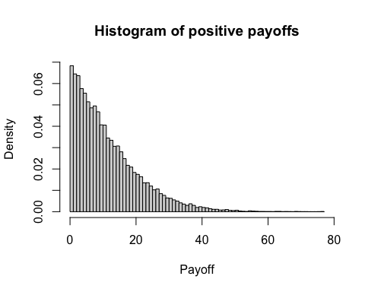

# Exercise b  
# Simulate whole path matrix once (shared across strategies)  
S_paths <- with(par, {  
 Z <- matrix(rnorm(N * n_days), nrow = N, ncol = n_days)  
 lr <- (mu - 0.5 * sigma^2) * td + sigma * sqrt(td) * Z  
 log_prices <- t(apply(lr, 1, function(x) log(S0) + cumsum(x)))  
 exp(log_prices)  
})  
ST <- S_paths[, par$n_days]  
  
# Case A: Trader Alice without hedging  
payoff_A <- 100 * pmax(ST - par$K, 0)  
P0_A <- quantile(payoff_A, 0.99) / exp(par$r * par$T) # 99-% price  
cat("(b1) No-hedge 99%-price P0_A =", P0_A, "\n")

## (b1) No-hedge 99%-price P0_A = 3421.255

# Case B: Trader Bradley with stop-loss hedging  
P_and_L_B <- numeric(par$N) # pre-allocate storage for speed  
for (i in seq_len(par$N)) {  
 path <- c(par$S0, S_paths[i, ])  
 cash <- stock <- numeric(par$n_days + 1)  
 for (j in 1:par$n_days) {  
 # If spot > strike we want 100 shares, else 0  
 if (path[j] > par$K && stock[j] == 0) {  
 cash[j] <- cash[j] - 100 * path[j] # Buy 100 shares  
 stock[j] <- 100  
 } else if (path[j] <= par$K && stock[j] == 100) {  
 cash[j] <- cash[j] + 100 * path[j] # Sell 100 shares  
 stock[j] <- 0  
 }  
 # We park cash (or debt) at the risk-free rate  
 cash[j + 1] <- cash[j] * exp(par$r * par$td)  
 stock[j + 1] <- stock[j]  
 }  
 call_payoff_i <- 100 * pmax(path[par$n_days + 1] - par$K, 0)  
 P_and_L_B[i] <- cash[par$n_days + 1] + stock[par$n_days + 1] * path[par$n_days + 1] -  
 call_payoff_i  
}  
disc_PnL_B <- exp(-par$r * par$T) * sort(P_and_L_B)  
P0_B <- -quantile(disc_PnL_B, 0.01)  
cat("(b2) Stop-loss 99%-price P0_B =", P0_B, "\n")

## (b2) Stop-loss 99%-price P0_B = 1592.077

# Case C: Trader Claire with delta hedging  
bs_delta <- function(S, t, p) { # Black-Scholes delta helper  
 tau <- p$T - t  
 if (tau <= 0) return(as.numeric(S > p$K))  
 d1 <- (log(S / p$K) + (p$r + 0.5 * p$sigma^2) * tau) / (p$sigma * sqrt(tau))  
 pnorm(d1)  
}  
P_and_L_C <- numeric(par$N)  
for (i in seq_len(par$N)) {  
 path <- c(par$S0, S_paths[i, ])  
 cash <- shares <- numeric(par$n_days + 1)  
 for (j in 1:par$n_days) {  
 t_now <- (j - 1) * par$td  
 delta_now <- bs_delta(path[j], t_now, par)  
 target_sh <- 100 * delta_now  
 trade_sh <- target_sh - shares[j]  
 cash[j] <- cash[j] - trade_sh * path[j]  
 shares[j + 1] <- target_sh  
 cash[j + 1] <- cash[j] * exp(par$r * par$td)  
 }  
 payout <- 100 * pmax(path[par$n_days + 1] - par$K, 0)  
 P_and_L_C[i] <- cash[par$n_days + 1] + shares[par$n_days + 1] * path[par$n_days + 1] -  
 payout  
}  
disc_PnL_C <- exp(-par$r * par$T) * sort(P_and_L_C)  
P0_C <- -quantile(disc_PnL_C, 0.01)  
cat("(b3) Delta-hedge 99%-price P0_C =", P0_C, "\n")

## (b3) Delta-hedge 99%-price P0_C = 363.9774

# Final results summary  
cat("Trader A (No Hedge) Price P0:", P0_A, "\n")

## Trader A (No Hedge) Price P0: 3421.255

cat("Trader B (Stop-Loss) Price P0:", P0_B, "\n")

## Trader B (Stop-Loss) Price P0: 1592.077

cat("Trader C (Delta Hedge) Price P0:", P0_C, "\n")

## Trader C (Delta Hedge) Price P0: 363.9774

# Exercise c  
hist(payoff_A, breaks = 50, freq = FALSE,  
 main = "No-hedge payoffs (Alice)", xlab = "EUR")

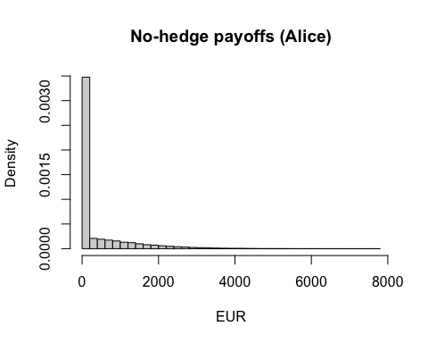

hist(P_and_L_B, breaks = 50, freq = FALSE,  
 main = "Stop-loss P/L (Bradley)", xlab = "EUR")

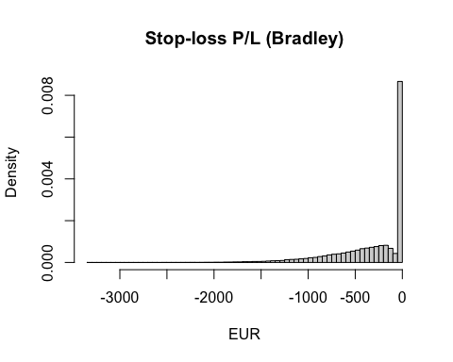

hist(P_and_L_C, breaks = 50, freq = FALSE,  
 main = "Delta-hedge P/L (Claire)", xlab = "EUR")

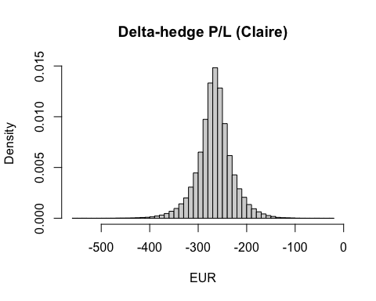

# Exercise d : CARA indifference prices for a grid of 'a'  
# The choice of six 'a' values is arbitrary; we wanted to test  
# lower levels of risk aversion and compare.  
risk_grid <- c(0.001, 0.002, 0.005, 0.01, 0.03, 0.05)  
indiff_tbl <- data.frame(a = risk_grid,  
 P0_A = NA_real_,  
 P0_B = NA_real_,  
 P0_C = NA_real_)  
  
for (k in seq_along(risk_grid)) {  
 a <- risk_grid[k]  
 utility <- function(x) if (a == 0) x else 1/a * (1 - exp(-a * x))  
 u0 <- utility(0)  
   
 EU_A <- function(P0) mean(utility(exp(par$r * par$T) * P0 - payoff_A))  
 EU_B <- function(P0) mean(utility(exp(par$r * par$T) * P0 + P_and_L_B))  
 EU_C <- function(P0) mean(utility(exp(par$r * par$T) * P0 + P_and_L_C))  
   
 find_P0 <- function(EUfun, lower = 0, upper = 1000, step = 100) {  
 while ((EUfun(lower) - u0) * (EUfun(upper) - u0) > 0) {  
 upper <- upper + step  
 if (upper > 1e6) stop("Could not bracket root")  
 }  
 uniroot(function(P0) EUfun(P0) - u0,  
 lower = lower, upper = upper)$root  
 }  
 indiff_tbl$P0_A[k] <- find_P0(EU_A)  
 indiff_tbl$P0_B[k] <- find_P0(EU_B)  
 indiff_tbl$P0_C[k] <- find_P0(EU_C)  
}  
print(indiff_tbl, row.names = FALSE)

## a P0_A P0_B P0_C  
## 0.001 1092.975 405.1072 262.6908  
## 0.002 2821.675 548.3318 263.3741  
## 0.005 5444.518 1315.5674 265.4600  
## 0.010 6499.995 2208.3800 269.1353  
## 0.030 7229.854 2919.3310 291.8288  
## 0.050 7380.175 3069.5391 343.8152

cat("\n")

# Exercise e  
B <- 90 # Barrier level at €90  
breached <- apply(S_paths, 1, function(x) any(x <= B))  
itm <- ST > par$K # Indicator if regular call finishes ITM  
cond_prob <- sum(breached & itm) / sum(itm)  
cat("(e) P(DO call worthless | call ITM) =", cond_prob, "\n")

## (e) P(DO call worthless | call ITM) = 0.0476407