# # BLOOD CONNECT

A Content Management System for a website developed on

BLOOD DONATION

using PHP and MySQL database server

* HOME PAGE

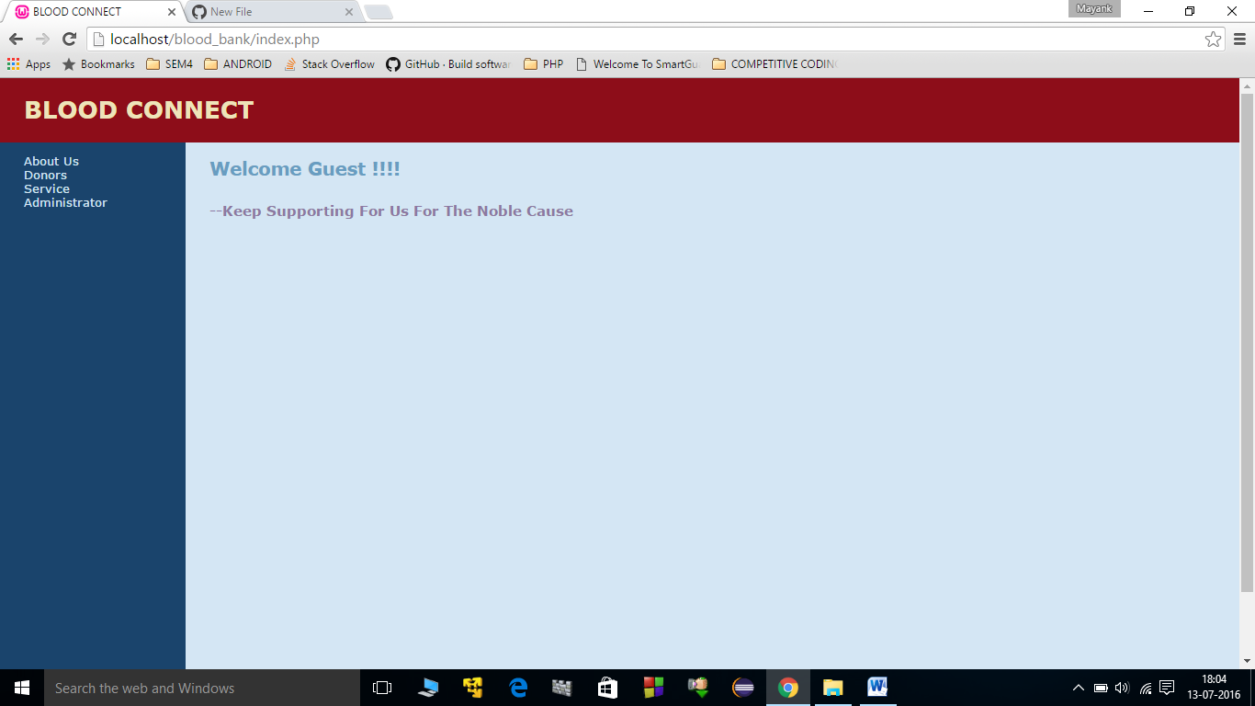

* DONORS LISTED BY TYPE

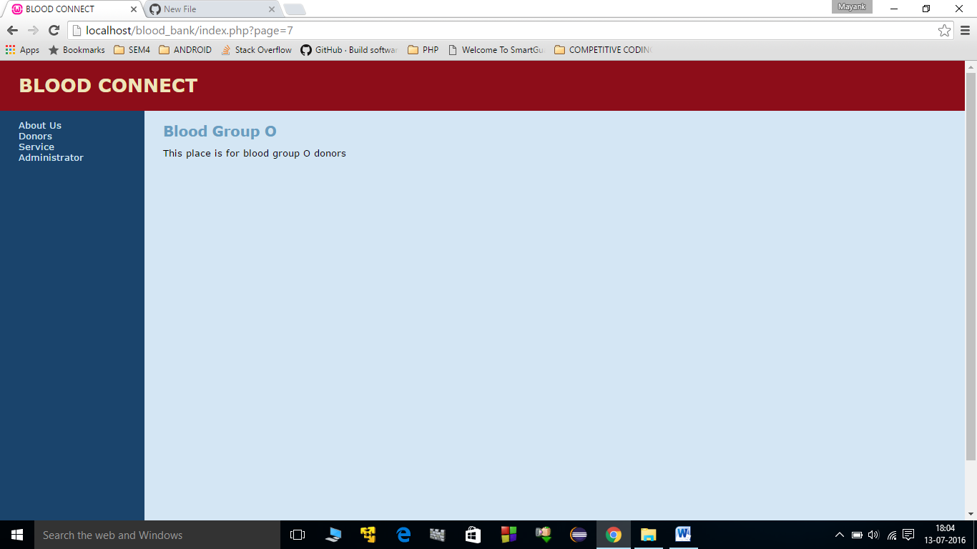

* SERVICE: REGISTER AS A DONOR

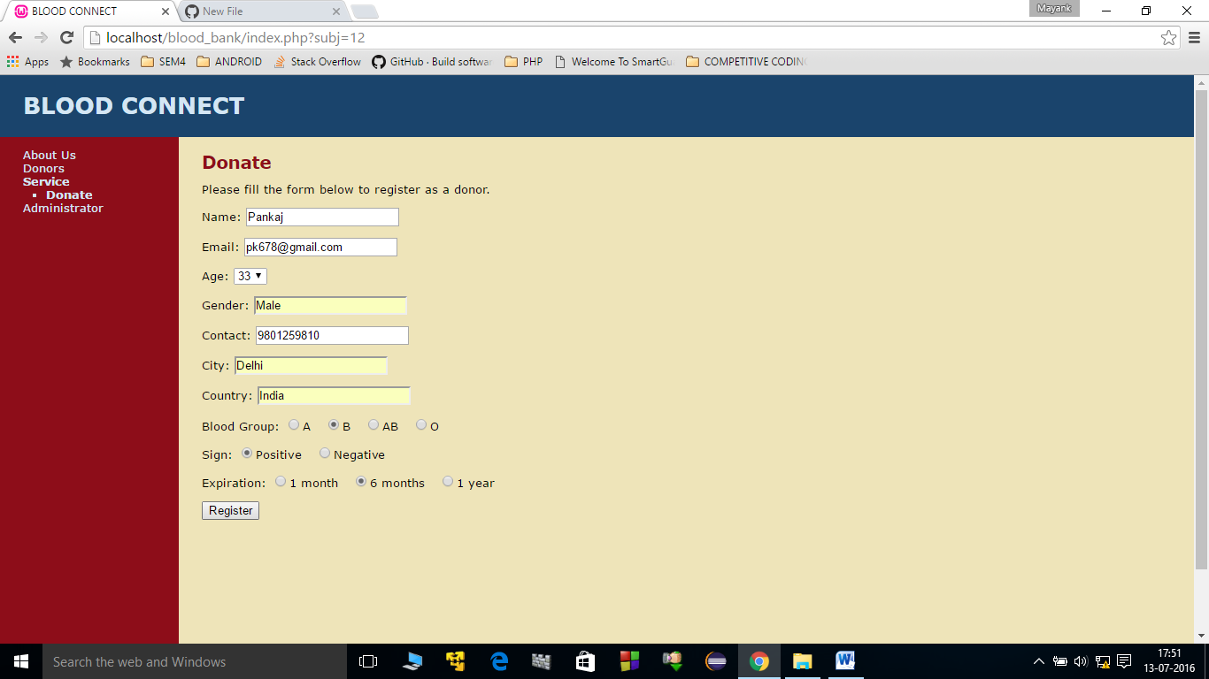

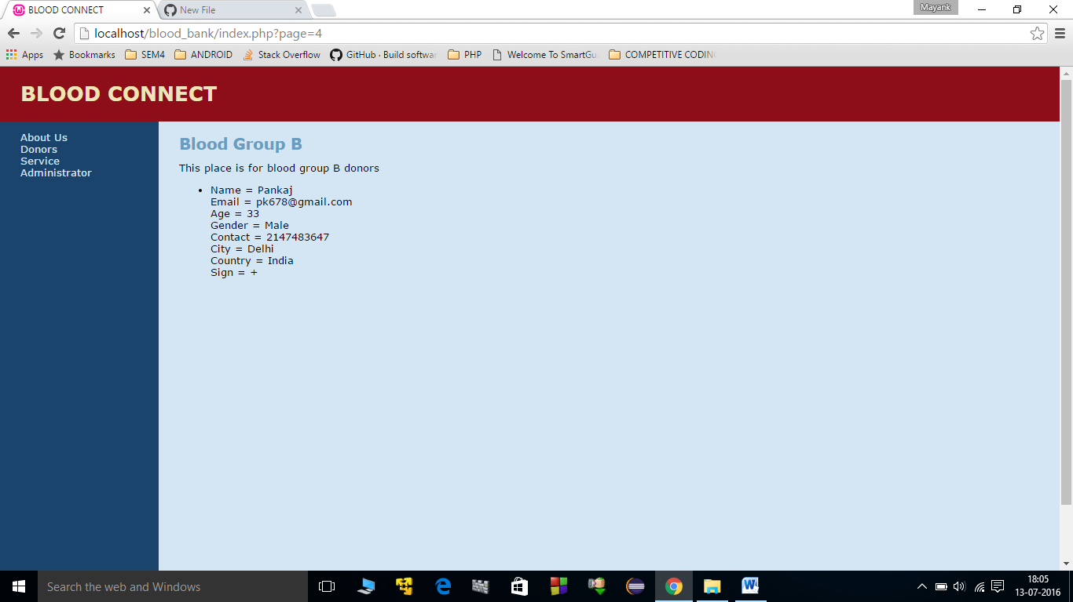

* ADMINISTRATOR LOGIN

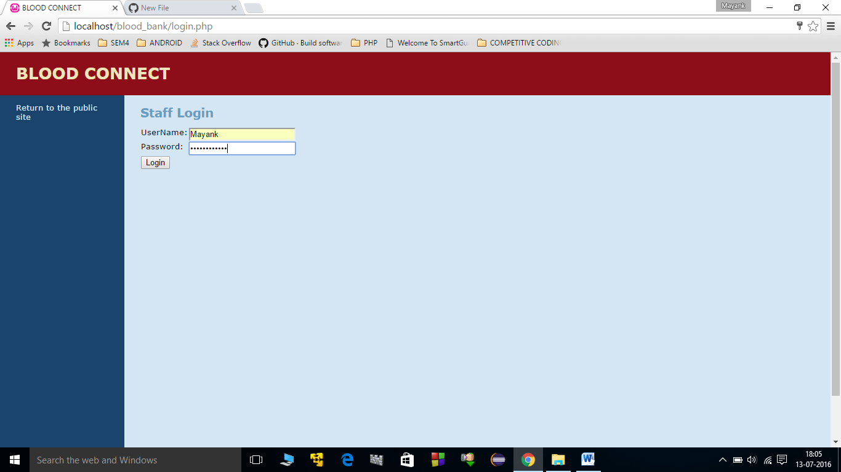

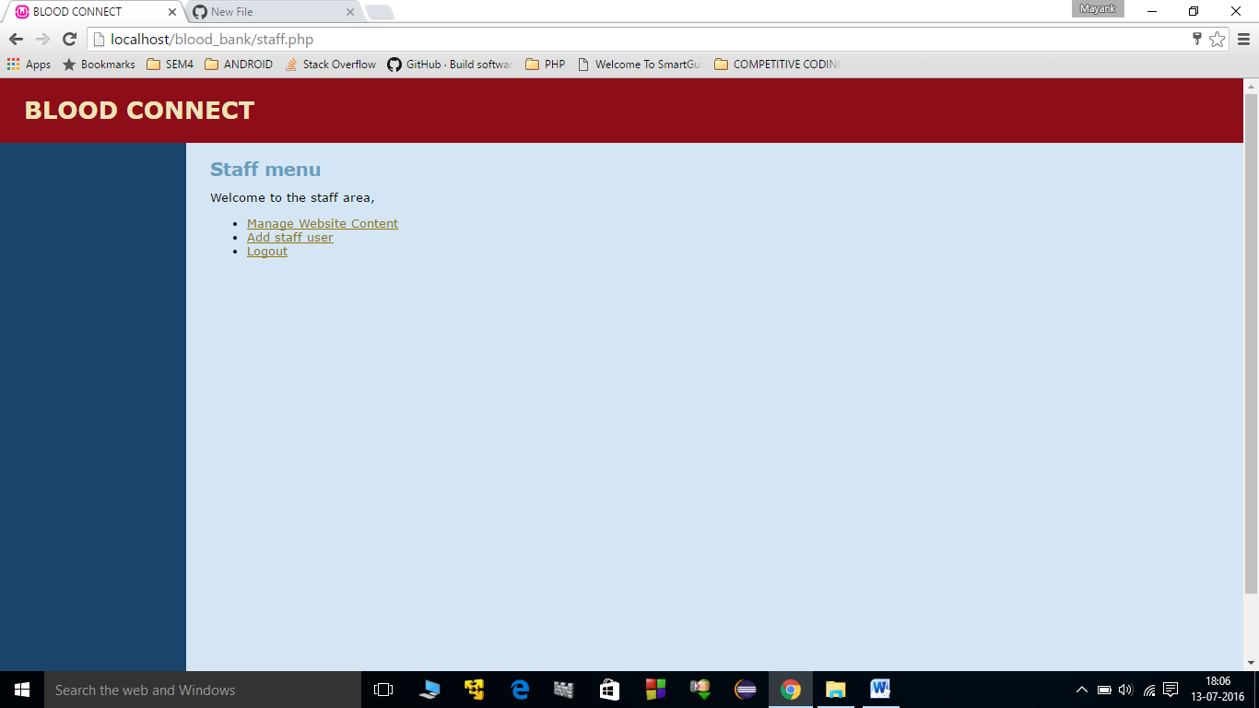

* Content Management Area

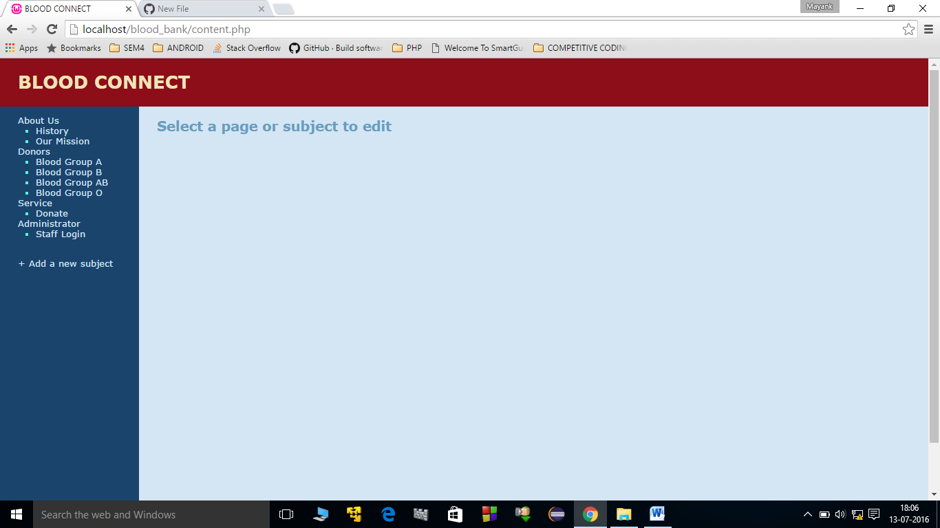

* **EDIT HISTORY PAGE**

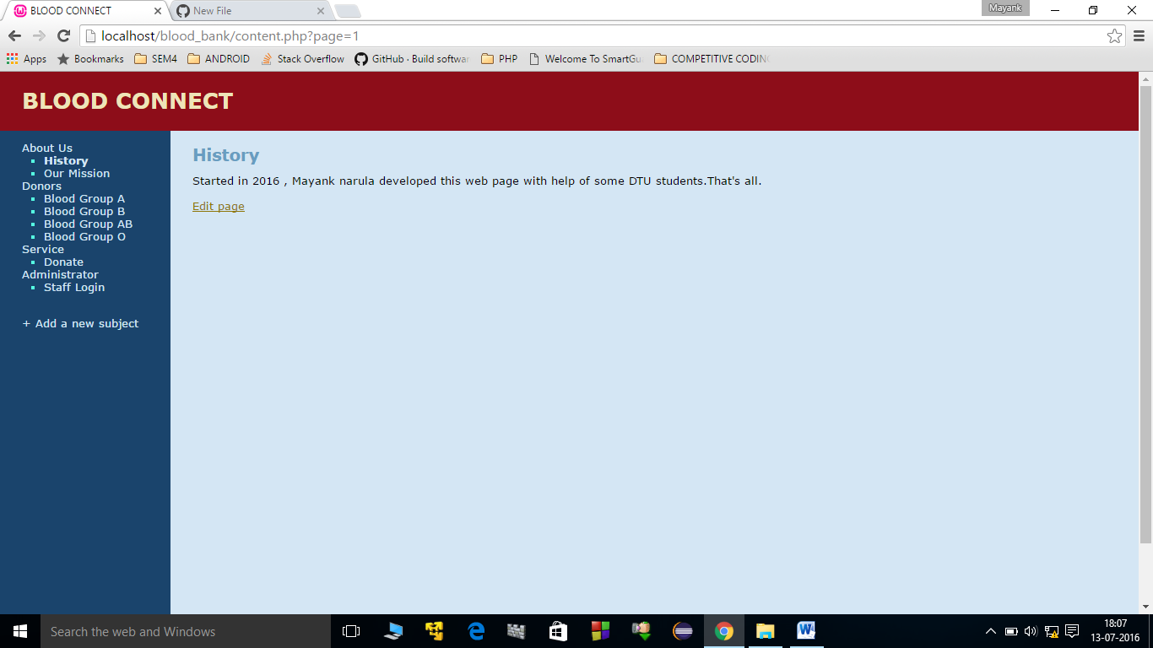

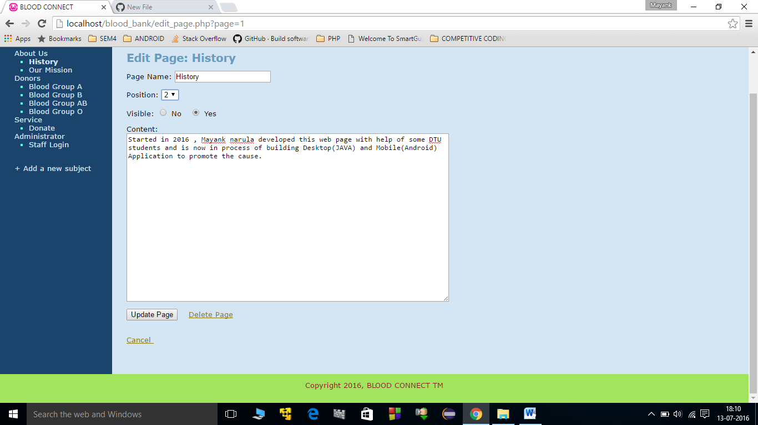

* CONTENT UPDATE BY MYSQL SERVER

