**Readme** The code for PCA is written in R. It should be run either from Rstudio or from R console.

* **Running with Rstudio:**

1. Download the Rstudio and run it <https://www.rstudio.com/products/rstudio/download/>
2. Open the code.R file

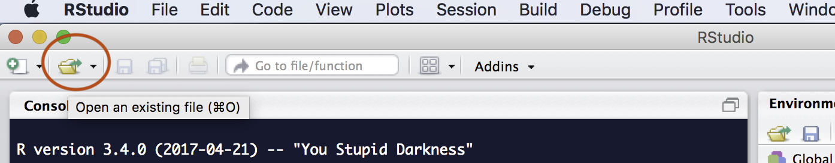

1. Read the required dataset by passing its value in read.delim() on line 4 of the code.



1. Source the file

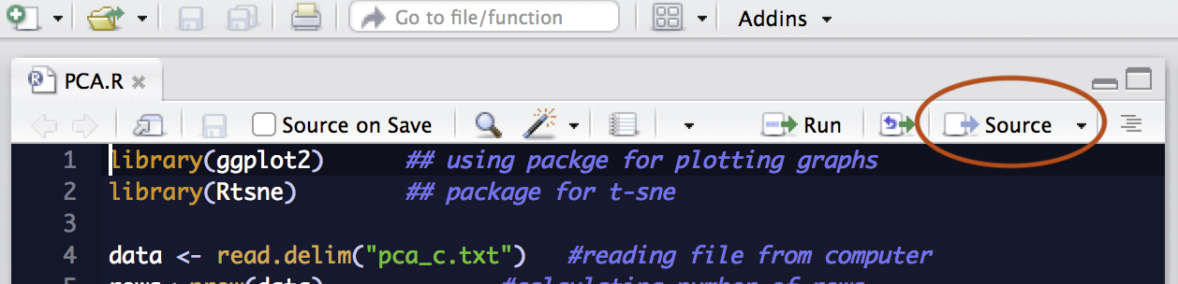https://cran.r-project.org/mirrors.html

* **Running with R console**

1. Install R console

<https://cran.r-project.org/mirrors.html>

1. Source script.