Annabelle Flanagan S4011122

Assessment 1 Web Development

HTML validation

Index.html page:

ContactUs.html page:

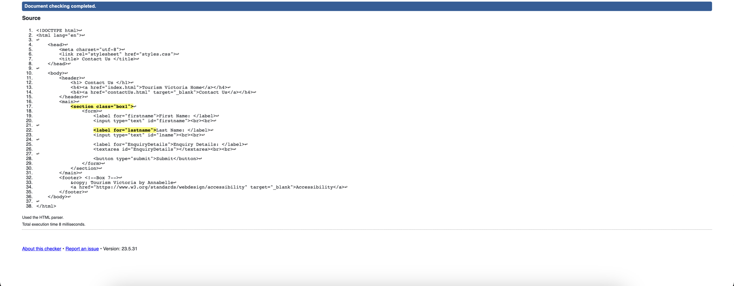

I fixed the warning by adding a <h2> tag to my ContactUs.html page.

I fixed the error by editing the id on line 23 to read lastname rather than lname.

