Annabelle Flanagan S4011122

Assessment 1 Web Development

Testing in two different browsers:

Chrome index.html:

Chrome ContactUs.html

Safari index.html:

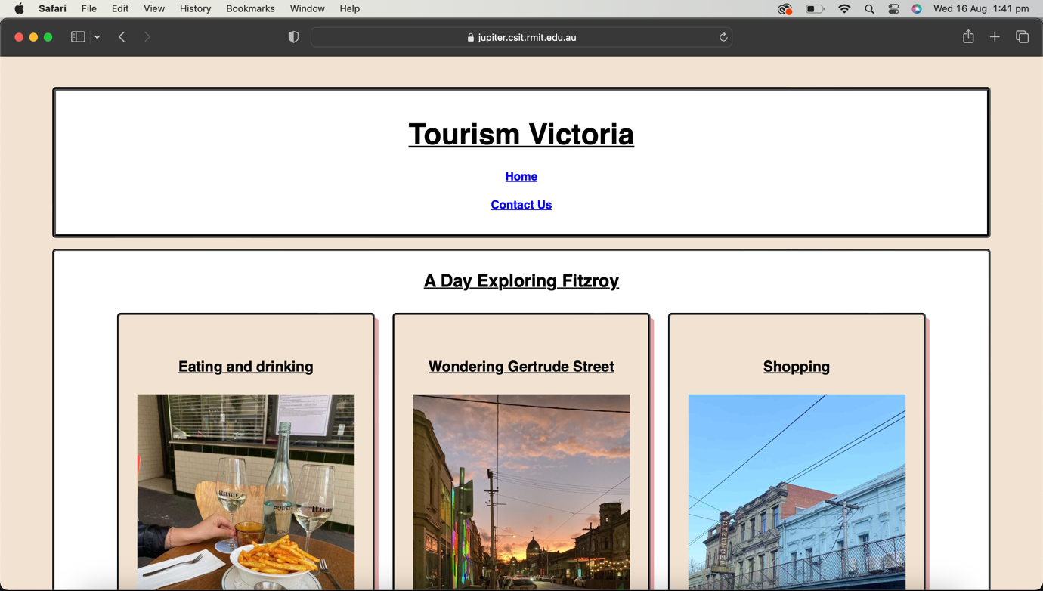

Safari contactUs.html:

