* A high-level description of the process you automated: Extract freelancing jobs details from Upwork.
* Whether the process will be unattended or attended 🡪 Attended,
* And expand on:
  + When/if it will be scheduled: NA
  + How often it will run: NA
  + If it will be used by a user: Yes
* The 5+ data types used:
  + Boolean
  + Browser
  + DataTable
  + QueueItem
  + SecureString
  + String
* The 2+ applications it is automating interaction with:
  + Chrome
  + Excel
  + Outlook
* The asset value and names stored in Orchestrator and used during the process:
  + Asset name: "Upwork_credentials"
  + Asset value: Username and password credentials of my Upwork account.
* Names of at least 3 invoked workflow files:
  + Generic_TakeUserInput
  + Generic_OpenChromeTab
  + Upwork_Login
  + Upwork_SearchForJobs
  + Upwork_ScrapeJobs
  + Upwork_Logout
  + Generic_CloseChromeTab
  + Upwork_FilterJobs
  + Generic_QueueDispatcher
  + Generic_QueuePerformer
  + Generic_SaveDataTable
  + Outlook_SendMail
* The Orchestrator Queue name used or why you didn't use a Queue:
  + "UpworkJobs"
* The data manipulation activity or function used and what it does for the overall process: There are several functions and activities in the project. For example, the screen below, I manipulate the mail body string that will be sent in the end of the process:  
    
  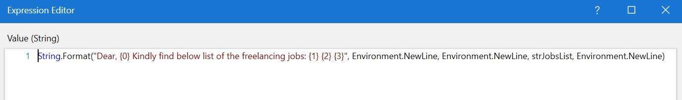
* What dependencies are needed for the process to run:
  + If the reviewer can run without a prerequisite:   
    Reviewer must have an asset defined in Orchestrator which contains a valid Upwork login credentials, and the queue name used in the process. Both names are mentioned above in this document.
  + Any applications that are specific to you or your work environment:  
    Google Chrome and Outlook
  + Any email addresses they must change: They must change the default value of the variable “strMailRecipient” to their email address to receive the final mail.
  + Any Queue or Assets they must create in Orchestrator: Yes.  
    Queue name: "UpworkJobs"  
    Asset names: "Upwork_credentials"
* Any possible additions or modifications:
  + Additions or integrations you would like to add: NA
  + Updates to the automation if the versions of the applications change: NA
* Explain how unknown errors are handled (e.g., sending an email to the user, taking a screenshot and putting it in a folder for the developer to check, etc.):  
  By logging their source and exception message.