Process Definition Document

*Process Name: Invoice Scraping*

Table of Contents

**Introduction** **1**

Purpose of the Document 1

Objectives 1

Process Key Contact 1

Minimum Prerequisites for Automation 1

**As-Is Process Description** **2**

Process Overview 2

Applications used in the Process 3

As-Is Process Map 3

**To-Be Process Description** **4**

Detailed Process Map 4

Robot Type 4

Business Exceptions Handling 4

Known Exceptions 4

Unknown Exceptions 5

System Exceptions Handling 5

**Other Observations** **5**

**Additional sources of process documentation** **5**



# Introduction

## Purpose of the Document

The Process Definition Document outlines the business process chosen for automation using UiPath Robotic Process Automation (RPA) technology.

The document describes the sequence of steps performed as part of the business process, the conditions and rules of the process prior to automation and how they are envisioned to work after automating it, partly or entirely. This specifications document serves as a base for developers, providing them with the details required for applying robotic process automation to the selected business process.

## Objectives

The process has been selected for RPA as part of the project initiative conducted within Techno Computers Inc., the Finance department.

The objective of this process automation is linked to the project business case and is mainly intended to:

* Deliver faster processing
* Reduce redundant activities
* Improve overall performance and reliability

## Process Key Contact

The specifications document includes concise and complete requirements of the business process and it is built based on the inputs provided by the process Subject Matter Expert (SME)/ Process Owner.

The Process Owner is expected to review it and provide signoff for accuracy and completion of the steps, context, impact and a set of process exceptions. The details are to be included in the table below.

|  |  |  |  |
| --- | --- | --- | --- |
| Role | Name | Contact Details (email & phone number) | Notes |
| Process Owner | Niyaz Ahmed | [niyaz.ahmed@uipath.com](mailto:niyaz.ahmed@uipath.com) +91-9870333008 |  |
| Business Analyst | Niyaz Ahmed | [niyaz.ahmed@uipath.com](mailto:niyaz.ahmed@uipath.com) +91-9870333008 |  |

## Minimum Prerequisites for Automation

|  |  |
| --- | --- |
| Met (Y/N) | Prerequisites |
|  | A filled in and completed Process Definition Document |
|  | Closure of any open process questions |
|  | Environment set up |
|  | Test Data to support development and testing |
|  | User access and creation of user accounts (licences, permissions, restriction to create accounts for robots) |

# As-Is Process Description

## Process Overview

General information about the process selected for RPA prior to automation.

|  |  |  |
| --- | --- | --- |
| # | Item | Description |
| 1 | Process Full Name | Invoice Scraping |
| 2 | Process Area | Personal |
| 3 | Department | Finance |
| 4 | Process Short Description  (operation, activity, outcome) | A process that will scrape relevant data from the invoices for further processing. The Robot will read through emails and download the invoices received in the form of an email attachment as a PDF. It will extract specific data and store those values in an Excel spreadsheet and a subset of values will be uploaded to the Orchestrator Queue. And finally, the robot will email the spreadsheet to yourself when finished. |
| 5 | Role(s) required for performing the process | Any |
| 6 | Process schedule and frequency | As needed (recommended End of Day [EOD]) |
| 7 | # of items processed /reference period | 100-150 invoices |
| 8 | Process execution time | 4-5 seconds/invoice |
| 9 | Peak period(s) | N/A |
| 10 | Transaction Volume During Peak period | N/A |
| 11 | Total # of FTEs supporting this activity | N/A |
| 12 | Expected increase of volume in the next reference period | N/A |
| 13 | Level of exception rate | N/A |
| 14 | Input data | Invoices as an attachment over email |
| 15 | Output data | Order details uploaded to Orchestrator Queue |

*Add more rows to the table to include relevant data for the automation process. No fields should be left empty. Use “n/a” for the items that don't apply to the selected business process.

## Applications used in the Process

The table includes a comprehensive list of all the applications that are used as part of the process to be automated to perform the given steps in the flow.

|  |  |  |  |  |  |
| --- | --- | --- | --- | --- | --- |
| # | Application Name & Version | System Language | Thin/Thick Client | Environment/ Access Method | Comments |
| 1 | Microsoft Outlook Version 2006 | English | Thin | PC |  |
| 2 | Microsoft Excel 2016 | English | Thin | PC |  |
| 3 | Adobe Reader PDF | English | Thin | PC |  |

*Add more rows to the table to include the complete list of applications.

**-------------Complete the rest of the document and submit along with your final submission.-------------**

## As-Is Process Map

**High Level As-Is Process Map:** This chapter depicts the As-Is business process at a High Level to enable developers to have a high-level understanding of the current process.

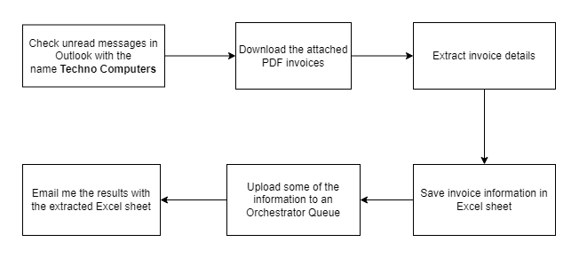

**Detailed Process Map:** This chapter depicts the As-Is business process at a detailed view to enable process owners to document their process

|  |  |  |  |
| --- | --- | --- | --- |
| # | Step Action/Description | Screenshot | Remarks |
| 1 | Extract the unread messages in Outlook with the name Techno Computers | NA | NA |
| 2 | Download the attached PDF invoice from the extracted mail messages. | NA | NA |
| 3 | Extract invoice details | NA | NA |
| 4 | Save invoice information in Excel sheet | NA | NA |
| 5 | Upload some of the information to an Orchestrator Queue | NA | NA |
| 6 | Email me the results with the extracted Excel sheet. | NA | NA |
| 7 | Repeat steps from 3 to 6 for each PDF invoice. | NA | NA |

# To-Be Process Description

## Detailed Process Map

**High Level To-Be Process Map:** This chapter depicts the To-Be automation process at a High Level to enable developers/COE to have a high-level understanding of the to be developed process.

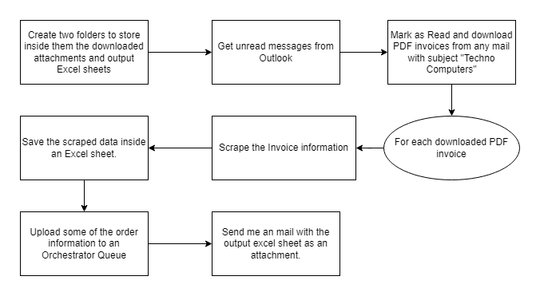

**Detailed Process Map:** This chapter depicts the To-Be automation process at a detailed view to enable developers/COE to see the workflows involved in the RPA solution

|  |  |  |  |  |  |
| --- | --- | --- | --- | --- | --- |
| **Workflow Name** | **Description** | **Pre-conditions** | **Post-actions** | **Arguments** | **Notes** |
| Generic_AppendDataRows | Append a group of DataRows that are in a dictionary format to a datatable. | A dictionary of (string, string) and a datatable should be provided. | The key and value pairs of the dictionary will be appended to the first and second columns as a new row for each pair. | in_dictDataRows  io_dtDataTable | NA |
| Generic_clearFolder | Delete all files in a given folder. | A folder path should be provided. | All files inside the given folder will be deleted. | in_strFolder | NA |
| Generic_CreateFolderIfNotExists | Create a folder if it doesn't already exist. | A folder path should be provided to the workflow. | The input folder path will be created if it was not already exist. | in_strFolderPath | NA |
| Generic_ExtractRegexDataTable | Extract a datatable from a given text using regular expressions. | A text string should be provided to the module. | A datatable of the order information will be extracted. | in_strText  out_dtOrderInformation | NA |
| Generic_ExtractRegexString | Extract the first match of a provided regular expression in a given string. | A text string and a regular expression string should be provided. | The first captured match will be extracted. | in_strRegexExpression  in_strText  out_strCapturedText | NA |
| Generic_QueueDispatcher | Upload a data saved in a dictionary to Orchestrator Queue. | A queue name and data dictionary should be provided. | Data will be uploaded to the Queue and in case of any failure in the upload process, the source and error message will be captured in the logs. | in_strQueueName  in_dictQueueData | NA |
| Generic_WriteExcelSheet | Save a datatable in an Excel sheet format. | The datatable and the Excel sheet path should be provided. Optionally, you can provide the sheet name and the start Cell as well, if needed. | The datatable will be saved inside the provided Excel sheet path. | in_strOutputSheetPath  in_strSheetName  in_strStartCell  in_dtDataTable | NA |
| Outlook_DownloadAttachments | Download the mail attachments if its subject match the provided string to the module. | The mail messages, the target subject string and the folder path where robot will download the attachments inside it should all be provided. | All attachments inside the targeted mail will be downloaded to the provided attachments downloads folder. | in_mailMessages  in_mailSubject  in_downloadsFolderPath | NA |
| Outlook_GetUnreadMessages | Get the unread mail messages from Outlook. | The folder name that will be searched, along with the last mails count that will be checked should be provided. | The last N unread mail messages inside the given mail folder will be extracted. | in_strMailFolder  in_intLastMailsCount  out_mailMessages | NA |
| Outlook_SendMail | Send Outlook mail. | The To email address, the subject, the body message, and the attachment path should be provided. | An email message will be sent using the provided information to the module. | in_strTo  in_strSubject  in_strBody  in_strAttachmentPath | NA |
| PDF_ReadIntoString | Read PDF into a string. | A PDF file path should be provided. | The PDF text content will be extracted inside a string variable. | in_strPDFPath  out_strPDFText | NA |

## Robot Type

|  |  |  |  |  |
| --- | --- | --- | --- | --- |
| # | Attended | Unattended | Trigger | Comments |
| 1 |  | Checkmark with solid fill |  |  |

## Business Exceptions Handling

The Business Process Owner and Business Analysts are expected to document below all the business exceptions identified in the automation process. These can be classified as:

### Known Exceptions

The table below reflects all the business process exceptions encountered during the process evaluation and documentation. These are known exceptions that occurred before. For each of these exceptions, define a corresponding expected action that the robot should complete if it encounters the exception.

|  |  |  |  |  |
| --- | --- | --- | --- | --- |
| BE # | Exception Name | Step | Parameters | Action to be Taken |

### Unknown Exceptions

For all other unanticipated or unknown business (process) exceptions, the robot should:

## System Exceptions Handling

A comprehensive list of all errors, warnings or notifications should be consolidated here with the description and action to be taken, for each, by the robot.

Errors identified in the automation process can be classified as:

|  |  |  |  |  |
| --- | --- | --- | --- | --- |
| SE # | Exception Name | Step | Parameters | Action to be Taken |
| 1 | Upload to Queue | When order information is uploaded to the queue, if any error occurred, an exception will be raised. | NA | Robot will try to upload the information to the queue, and if any error is raised, the robot will log the exception message and source. |

For all the other unanticipated or unknown system exceptions, send an email to **<placeholder>** and attach a screenshot of the error message.

# Other Observations

Include below any other relevant observations you consider needed to be documented here.

# Additional sources of process documentation