Class StaffStudent extends Staff }

Student s1 ;

TO DO :

1) School Lab Level 1

2) 3.1, 3.2

3) Lab 3 Level 1

4) School Lab Level 2 StaffStudent

5) Then Level 2, etc.

SEE THE NEXT PAGE!

To Debug :

1) White-box - run it in your mind

2) System.out.println

System.out.println( “at 1 sum = “ + sum + “I = “ + i)

for ( int I …

System.out.println( “at 2 sum = “ + sum + “I = “ + i)

{

If (x == 4)

{

System.out.println( “at 3 sum = “ + sum + “I = “ + i)

} //end if

System.out.println( “at 4 sum = “ + sum + “I = “ + i)

} // end for

System.out.println( “at 5 sum = “ + sum + “I = “ + i)

3) Debugger

--------------------------------------------------------------------------------------

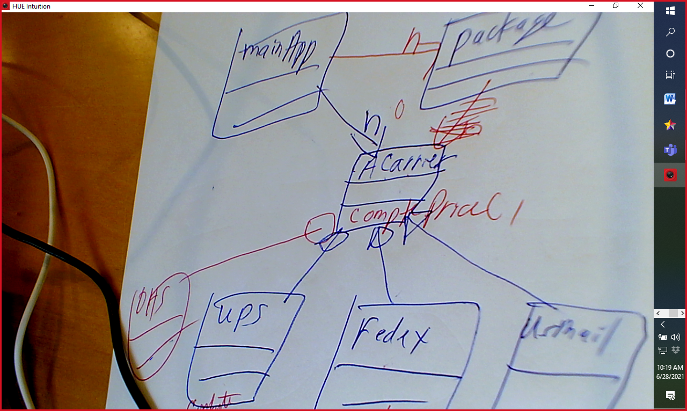

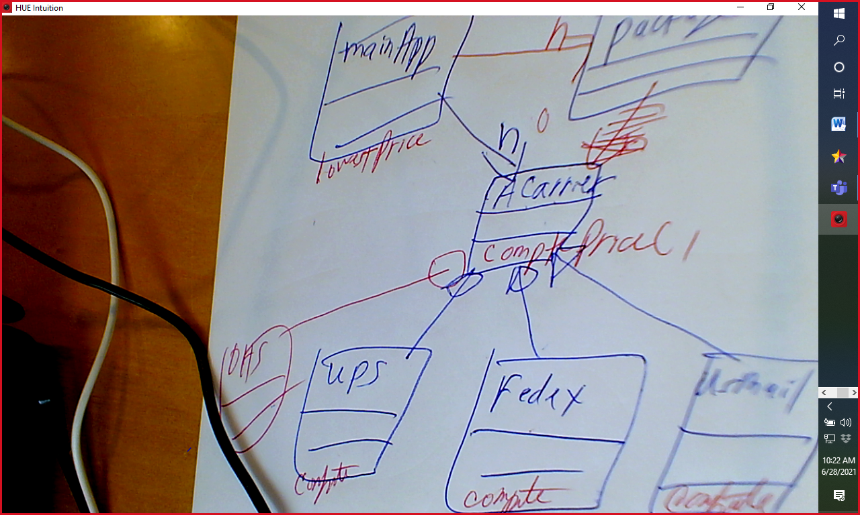

Date - > Not user-friendly, But very good for prinf

GregorianCalendar is much more user-friendly

LocalDateTime is NEWER and better