Access modifiers

private package(default) protected public

setEmployee (Employee e1)

{ employeeimpl = e1 }

Employee e2 = new Employee (….

new StudentEmployee (e2)

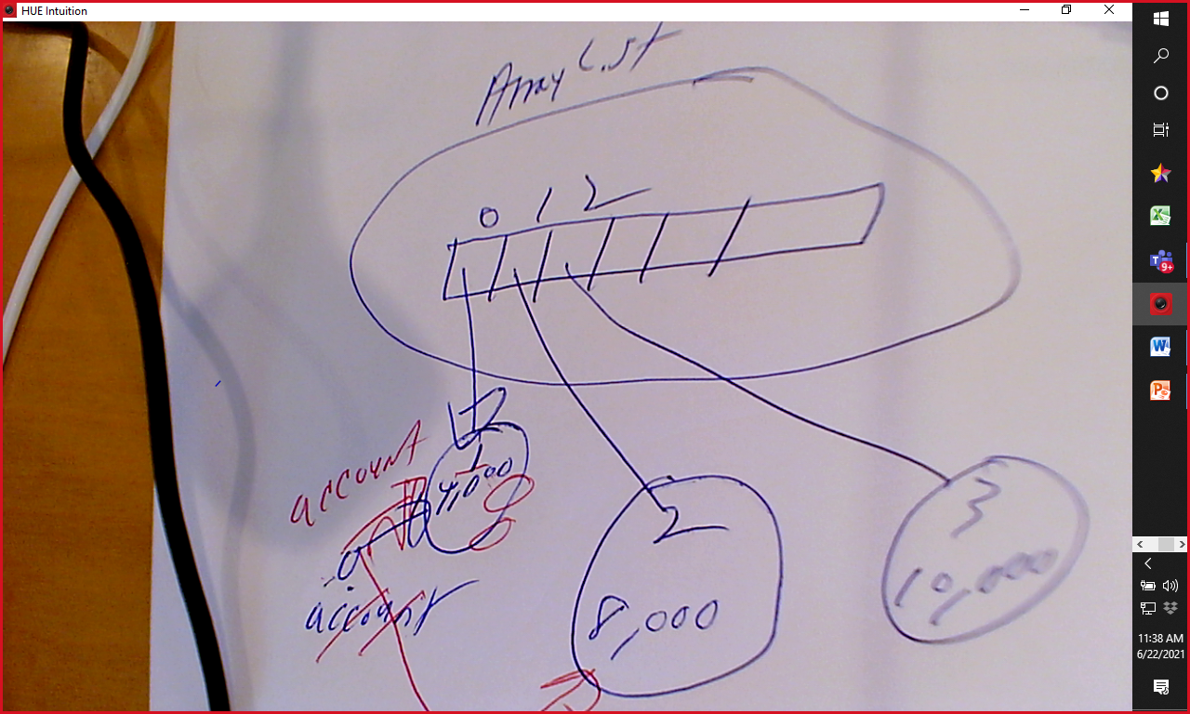

Tom 19

Sam 12

Susan 14

Class Department

{

Company c1 ;