Class Department {

List <Person> persons ;

Double unitsPerFaculty ( )

{

Double temp ;

for (Person p : persons)

{ if ( p instanceOf Faculty)

{ Faculty f1 = (Faculty) p ;

temp = f1.getTotalUnits ;

// print name and temp

} // end if

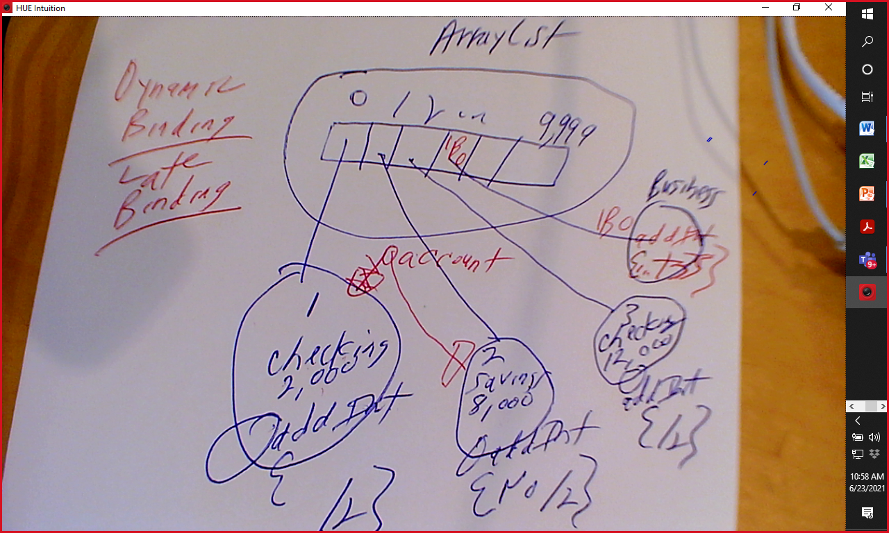

m1 (Person p) LSP