Reflection
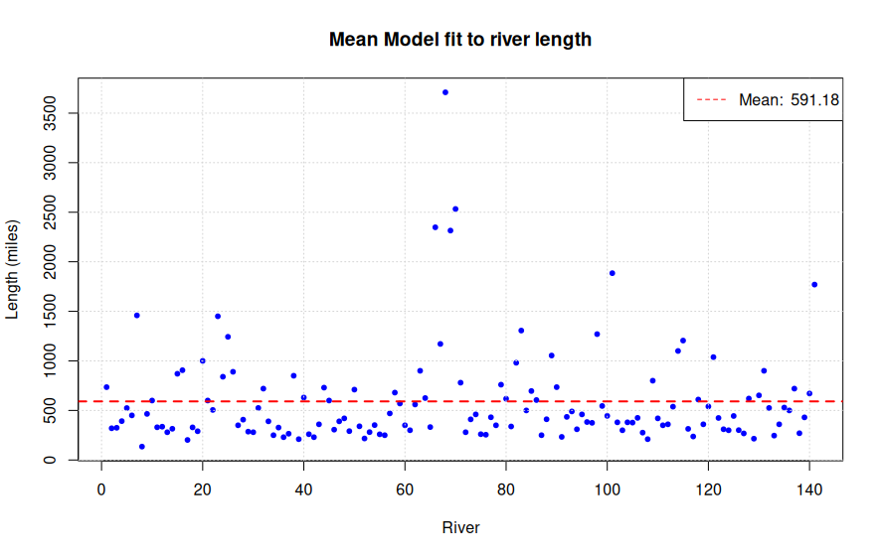
1. Do any observations look like potential outliers?
The calculated mean is 591.18 miles.
From the scatter plot in Step 3, there are potential outliers that fall far from the mean.
The most noticeable is the river with a length of 3,710 miles, and a couple of other values at 2,533, 2,348, and 2,315 miles, which look substantially separated from the majority of the observations.
There are also several rivers with long lengths, above 1,500 miles.
Those extreme values may have a substantial influence on the sample mean of 591.18 miles.
--I highlighted the largest five values on the scatter plot in the jupyter document.
2. Which confidence interval is wider, 95% or 90%? What does this suggest?
From Steps 5 and 6:
95% CI: (508.96, 673.41)
90% CI: (522.32, 660.05)
The 95% CI is wider because the critical t-value is larger:
t* (95%) ≈ 1.977, while t* (90%) ≈ 1.656.
Therefore, the 95% CI is wider because t* (95%) > t* (90%).
Since CI = x̄ ± t* * SE, a larger critical value (t*) means you move farther from the mean in both directions.
In short: The 95% CI is wider than the 90% CI, and this suggests that greater confidence in capturing the population mean requires a wider range of plausible values.
3. Would you get different answers to the questions above with another random sample of the same size?
Yes, another sample could have different observations and hence could produce different results. Therefore, the sample mean, amount of variation, standard error of the mean, and the bounds of the confidence interval could all change from one sample to another. However, repeated random samples from the same population are expected to produce estimates (bounds for the mean) that vary around the population parameter.
For example, at a 95% confidence level, repeating the procedure for 100 different samples of the same size could produce 100 different confidence intervals. Approximately 95 of them are expected to contain the value of the population parameter (the mean in our case).
4. Is it possible to have the same mean but a different amount of error with another random sample of the same size?
Yes, two random samples of the same size can have the same mean but different spreads. Different values could result in different amounts of variation, resulting in different standard deviations.
Since the standard error depends on the standard deviation (with n being the same for both samples), the standard error can be different.
The sample with greater variation will produce a greater standard error, hence a wider CI, meaning less precision in the population parameter estimate.

-----------------------------------
some statistics from the jupyter doc / R script resulting
sample standard deviation: 493.87, sample size: 141, standard error: 41.59

critical t-value for 95% confidence: 1.977
95% CI: (508.96, 673.41)

critical t-value for 90% confidence: 1.656
90% CI: (522.32, 660.05)

