WEEK 04 REFLECTION: UNDERSTANDING AND SIMULATING DISTRIBUTIONS

Introduction
In this analysis, We simulated 100 observations from three probability distributions: normal (mean = 20, variance = 25), uniform (minimum = 10, maximum = 30), and binomial (10 trials, probability of success = 0.50). We visualized each simulated dataset with histograms and overlaid the corresponding theoretical density or probability function. We then compared the distribution of mpg from the mtcars dataset to a normal distribution.

Simulated Distributions
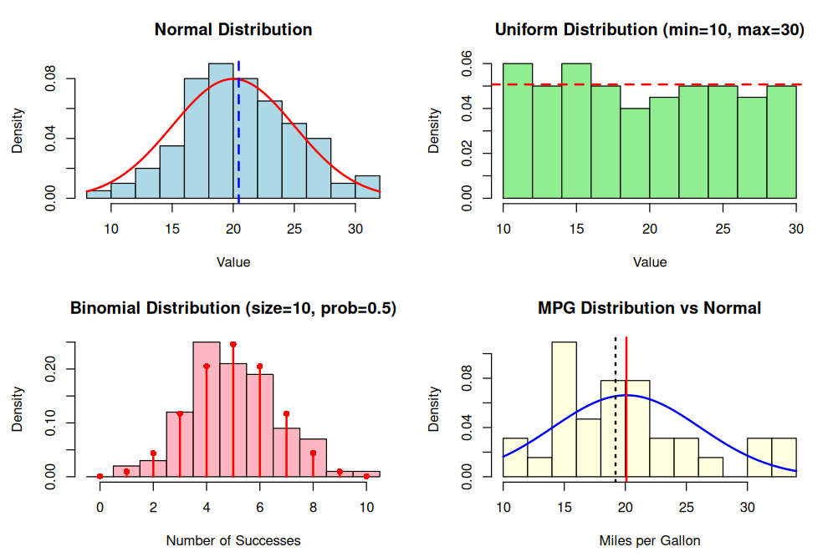
Normal Distribution
The histogram of the simulated normal data (mean = 20, sd = 5) is quite symmetric and bell-shaped, centered near 20. The theoretical normal curve (red line) aligns closely with the histogram, showing the simulated data follow the expected normal shape. The spread matches the standard deviation of 5, with most values falling between 15 and 25.

Uniform Distribution
The histogram for the uniform data (min = 10, max = 30) displays a relatively flat, rectangular shape across the interval [10, 30]. The theoretical uniform density is constant at 1/(30-10) = 0.05, shown as a dashed red line. The histogram bars follow this constant height, with minor random fluctuations for the small sample size.

Binomial Distribution
The histogram for the binomial data (size = 10, prob = 0.5) shows a discrete distribution with peaks around 5 successes. The theoretical binomial probabilities (red stems and points) match the observed frequencies well. The distribution looks quite symmetric, as expected when p = 0.5, with values ranging from about 1 to 10.

Comparison of MPG to a Normal Distribution
The mpg variable from mtcars has a mean of 20.09 and a standard deviation of about 6.03. The histogram with a normal curve (blue line) shows that the distribution is slightly right-skewed, with a longer tail towards higher mpg values. The actual data has a higher concentration around 15–20 mpg and a heavier right tail. We see the median (dotted black line) < mean (solid red line)
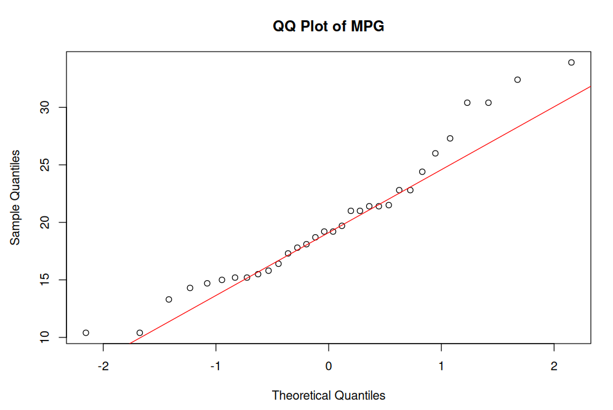
The QQ plot of mpg shows points that deviate from the straight line, more in the upper tail, indicating positive/right skewness and departure from normality. The Shapiro-Wilk test yields a p-value of about 0.12, which is greater than 0.05, so we do not reject normality at the 5% significance level. However, visually the distribution is not perfectly normal, it has a slight right skew and some outliers.

In conclusion, while the mpg distribution is not severely non-normal, it exhibits mild right skewness and does not perfectly follow a normal distribution. The simulated normal data, in contrast, adhered closely to theoretical expectations due to random sampling from a known normal distribution.

Key Statistics

Summary of normal_data:
Min. 1st Qu. Median Mean 3rd Qu. Max.
8.454 17.531 20.309 20.452 23.459 30.937
sd = 4.564079
Summary of uniform_data:
Min. 1st Qu. Median Mean 3rd Qu. Max.
10.13 14.51 19.49 19.72 24.60 29.64
sd = 5.886645

Summary of binomial_data:
Min. 1st Qu. Median Mean 3rd Qu. Max.
1.00 4.00 5.00 5.01 6.00 10.00
sd = 1.714437

MPG summary:
Min. 1st Qu. Median Mean 3rd Qu. Max.
10.40 15.43 19.20 20.09 22.80 33.90
MPG sd: 6.026948

Shapiro-Wilk normality test

data: mtcars$mpg
W = 0.94756, p-value = 0.1229

