Week 5: Exploring and Transforming Data to Meet Assumptions
Analysis of MPG in the mtcars Dataset

Introduction
This analysis examines whether the mpg variable in the mtcars dataset met two assumptions associated with parametric statistical analyses: normality and homogeneity of variance (homoscedasticity). Normality was assessed using a histogram, a normal Q-Q plot, and the Shapiro-Wilk test. Homoscedasticity was assessed by comparing the variances of mpg across the 4 , 6 , and 8-cylinder groups and by using Levene's test.
Because the original data showed evidence of unequal variances, logarithmic and square-root transformations were applied, and the same assumptions were reassessed for the transformed variables.
Normality of Original MPG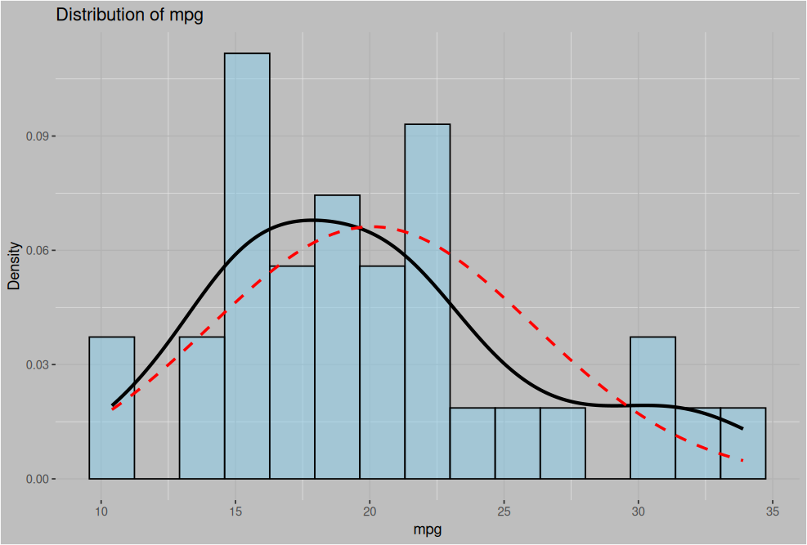
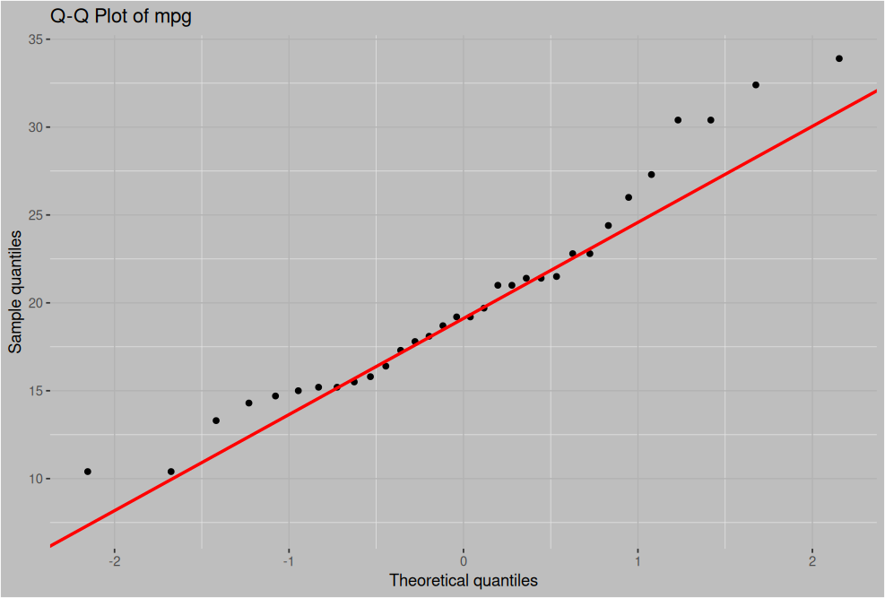
The histogram shows that mpg is not perfectly bell-shaped. The histogram is slightly right skewed, the mean is greater than the median, but the difference is small (20.09 vs 19.20)
The Q-Q plot also shows some departure from the reference line, especially toward the lower and upper tails.
The Shapiro-Wilk test produced W = 0.948 and p = 0.123. Because the p-value > 0.05, the null hypothesis of normality was not rejected. Therefore, the Shapiro-Wilk test did not provide sufficient statistical evidence that mpg is non-normal.
The visualizations and formal tests, considered together, show some departures from an ideal normal distribution, but the Shapiro-Wilk test does not identify a statistically significant violation at the 0.05 level, so we can consider normality to be valid.
Homogeneity of Variance
The variances of mpg differed substantially across the cylinder groups. The observed variances were:
Cylinders | Variance
4 | 20.34
6 | 2.11
8 | 6.55
And it’s also clear on the boxplot that it is clearly violated
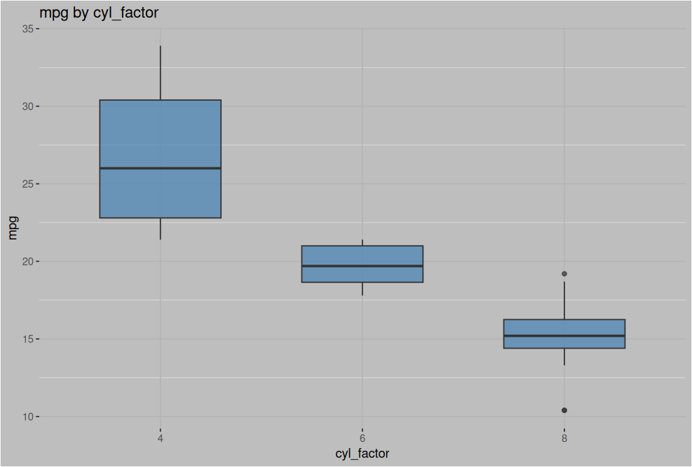
This is supported by the tests as well
Levene's test produced p = 0.009 < 0.05, so the null hypothesis of equal variances was rejected. Therefore, there is statistical evidence that the variances of mpg differ across the cylinder groups.
Logarithmic Transformation
A logarithmic transformation was applied to mpg. The logarithm compresses larger values more strongly and can reduce differences in variability across groups.
For log(mpg), the Shapiro-Wilk test produced p = 0.699. Therefore, there was no statistically significant evidence of non-normality.
Cylinders | Variance of log(mpg)
4 | 0.028
6 | 0.006
8 | 0.033
Levene's test produced p = 0.253 > 0.05. Thus, there was no statistically significant evidence of unequal variances after the logarithmic transformation.

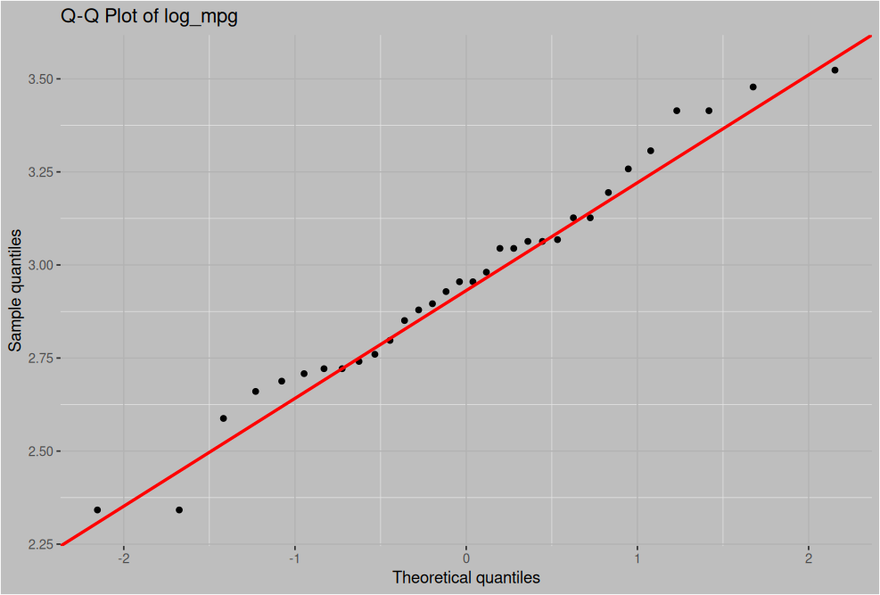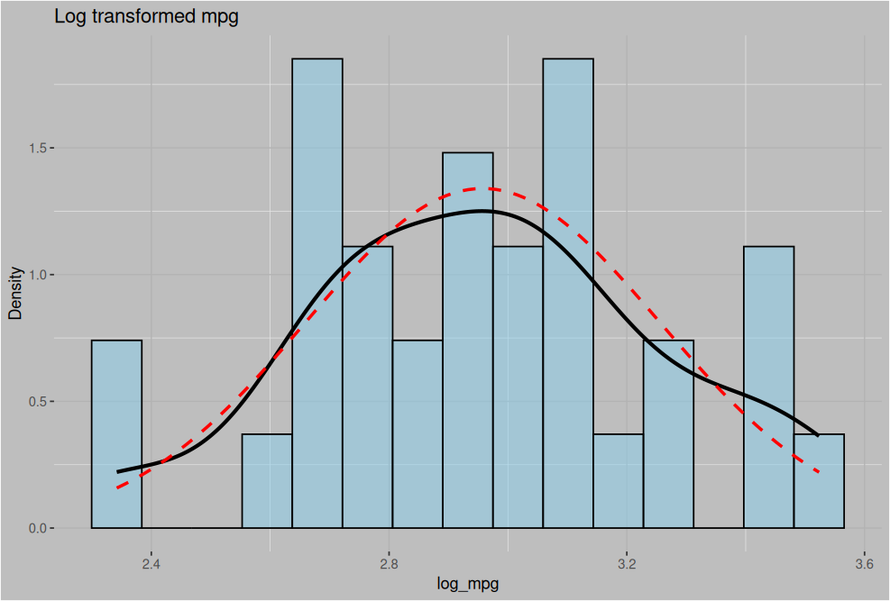
Square-Root Transformation
A square-root transformation was also applied to mpg. Like the logarithmic transformation, the square-root transformation compresses larger values, although less strongly.
For sqrt(mpg), the Shapiro-Wilk test produced p = 0.485 > 0.05. Therefore, there was no statistically significant evidence of non-normality.
Cylinders | Variance of sqrt(mpg)
4 | 0.188
6 | 0.027
8 | 0.115
Levene's test produced p = 0.073 > 0.05, thus, there was insufficient evidence to reject the assumption of equal variances at the 5% significance level. The square-root transformation therefore also reduced the evidence of heteroscedasticity.
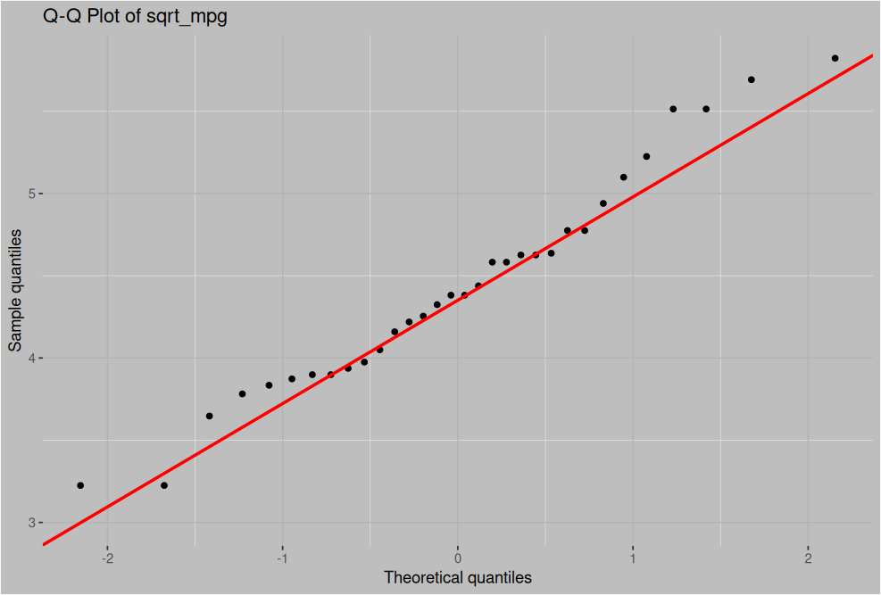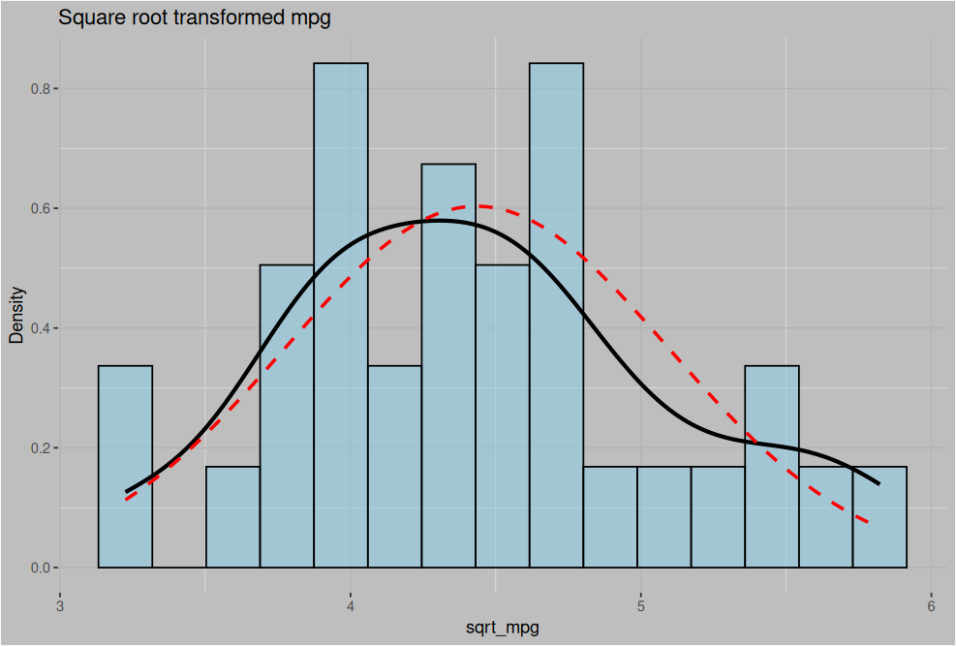

Summary of Results
Variable | Shapiro-Wilk p | Normality | Levene p | Variance conclusion
mpg | 0.123 | No significant violation | 0.009 | Evidence of unequal variances
log(mpg) | 0.699 | No significant violation | 0.253 | No significant evidence of unequal variances
sqrt(mpg) | 0.485 | No significant violation | 0.073 | No significant evidence at α = 0.05

Reflection
The original mpg variable did not show a statistically significant violation of normality. Although the histogram and Q-Q plot showed some departures from a perfect normal distribution, the Shapiro-Wilk test did not provide sufficient evidence to reject normality.
The main assumption problem was homoscedasticity. The group variances were substantially different, and Levene's test was statistically significant.
Both transformations reduced the evidence of unequal variances. The logarithmic transformation reduced the Levene test result from p = 0.009 to p = 0.253, while the square-root transformation produced p = 0.073. Both transformed variables also retained non-significant Shapiro-Wilk tests.
Therefore, the transformations improved the data with respect to the assumptions examined, particularly homogeneity of variance. The logarithmic transformation produced a larger reduction in the evidence of unequal variances according to Levene's test (0.253 vs 0.073). Any subsequent analysis should consider whether the transformed scale is appropriate for the research question.

