Data Project Part 1: Data Exploration and Visualization
Data set chosen: Palmer Archipelago (Antarctica) penguin data
URL: https://www.kaggle.com/datasets/parulpandey/palmer-archipelago-antarctica-penguin-data

About the data set
I used the simplified version of the data set:
penguins_size.csv: Simplified data from original penguin data sets. Contains variables:
- species: penguin species (Chinstrap, Adélie, or Gentoo)
- culmen_length_mm: culmen length (mm)
- culmen_depth_mm: culmen depth (mm)
- flipper_length_mm: flipper length (mm)
- body_mass_g: body mass (g)
- island: island name (Dream, Torgersen, or Biscoe) in the Palmer Archipelago (Antarctica)
- sex: penguin sex

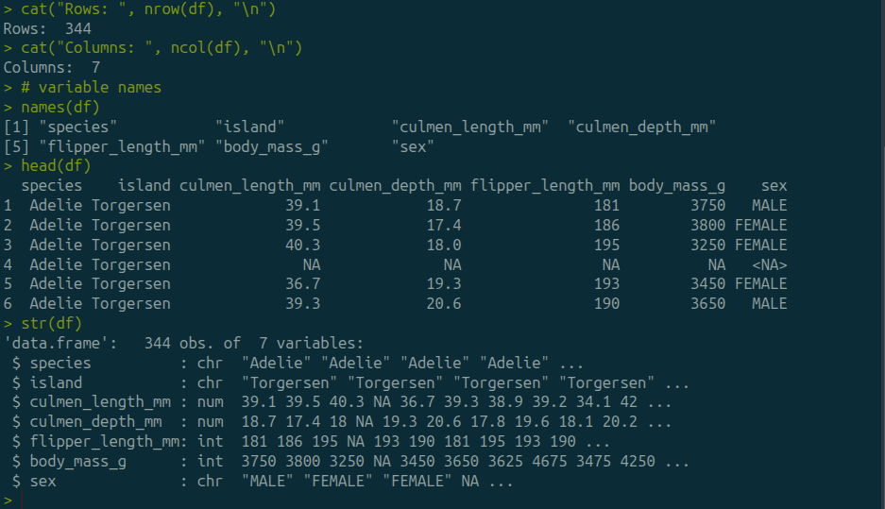

3.1 Reflection on missing values
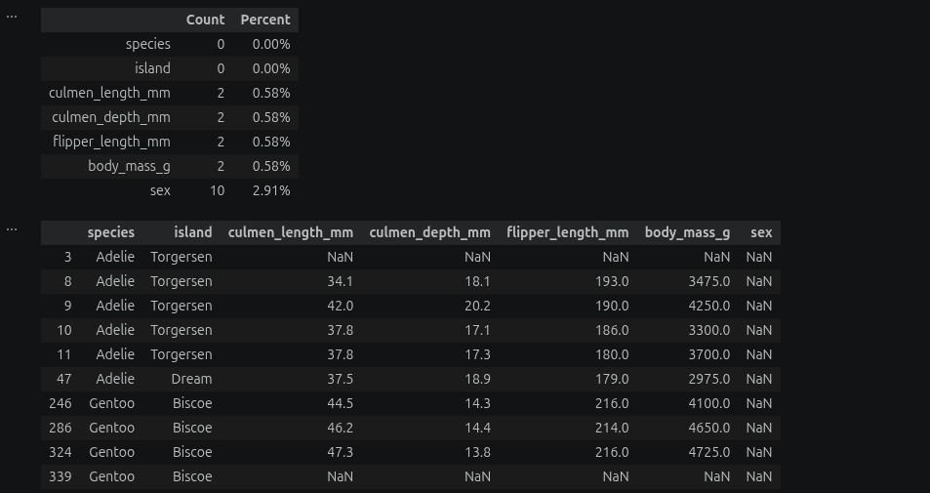
The dataset contains 2 missing observations for each of the four numerical variables and 10 missing observations for the sex variable.
The descriptive statistics calculations below removed the rows with missing values. Pandas statistical functions exclude missing values when calculating statistics, so the numerical summaries are based on 342 out of 344 observations for each numerical variable.
The missing observations for the variable with biggest number of missing values represent 10/344 = 2.9% of the total observations which is relatively small.
They still could affect the subgroup comparisons if the missing observations are not randomly distributed.

3.2 Reflection anomalies/outliers
There are 2 types of outlier analysis:
Overall dataset: in the analysis above, there seems no potential outliers in the dataset overall, since all the values of the numerical variables fall in between their calculated upper and lower bounds.
Within Species: introduced later in this document at the boxplot in section 5.2, potential outliers in the body mass variable appeared within the Chinstrap species with values (4800, 2700) highlighted on the boxplot out of the upper and lower bounds for that species.
other species do not seem to have outliers in the body mass variable within them.

Reflection

Descriptive Statistics
Descriptive statistics were calculated for the four numerical variables. These included the mean, median, variance, standard deviation, minimum, and maximum.

4.1 Overall descriptive statistics
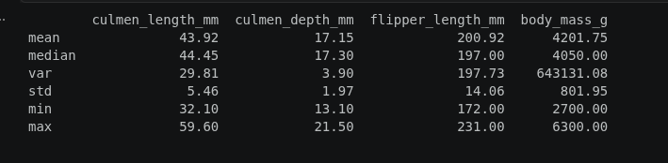
overall mean body-mass is 4201.75 grams, and the median is 4050 grams, i.e mean > median, which is consistent with some higher body-mass observations pulling the mean upward. The histogram also appears to have a somewhat longer upper tail.
The average culmen length was approximately 43.92 mm, while the average culmen depth was 17.15 mm. The average flipper length was approximately 200.92 mm.
The body-mass measurements ranged from 2700 grams to 6300 grams, showing substantial variation in the size of the penguins represented in the dataset.

4.2 Descriptive statistics by category (species was chosen)
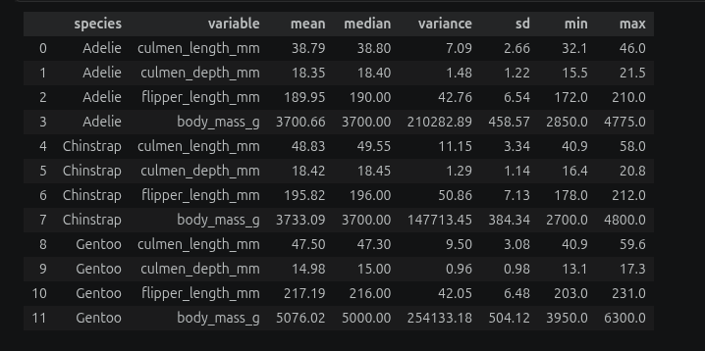
The Adelie species have an average body-mass of 3700 grams which is pretty close to that of the Chinstrap's mean body-mass of 3733 grams, while the Gentoo has a higher mean body-mass at 5076 grams.
The flipper length looks proportional with the body-mass, with the Adelie having a mean flipper length of approximately 190 mm, while it is around 196 mm for the Chinstrap, and the longest for the Gentoo at 217 mm.
The species also differ in culmen measurements. Chinstrap penguins have the highest mean culmen length at approximately 48.83 mm, followed by Gentoo at 47.50 mm and Adelie at 38.79 mm. In contrast, Gentoo penguins have a substantially lower average culmen depth, approximately 14.98 mm, compared with 18.35 mm for Adelie and 18.42 mm for Chinstrap.

5. Visualizations

5.1 Histogram of Body Mass
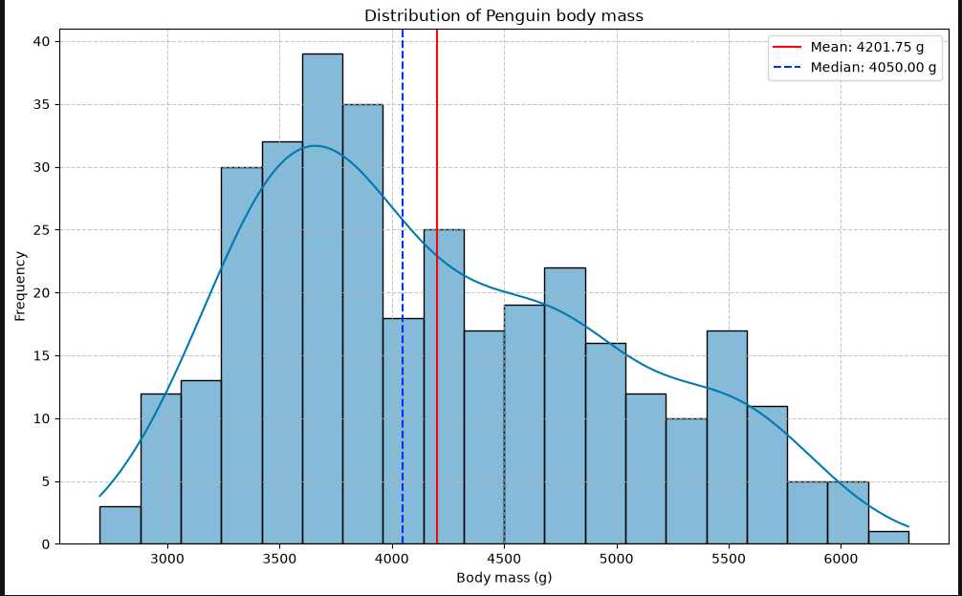
The body mass distribution has considerable variation of values with most of values ranging between "approximately" 3250 and 4250 grams, in the lower to middle portion of the overall range.
The values are spread in between 2700 and 6300 grams.
the graph looks to have longer upper tail with some higher values of body mass pulling the mean value to the right of the median, with the mean at 4201.75 and the median is at 4050 grams.

5.2 Boxplot by species
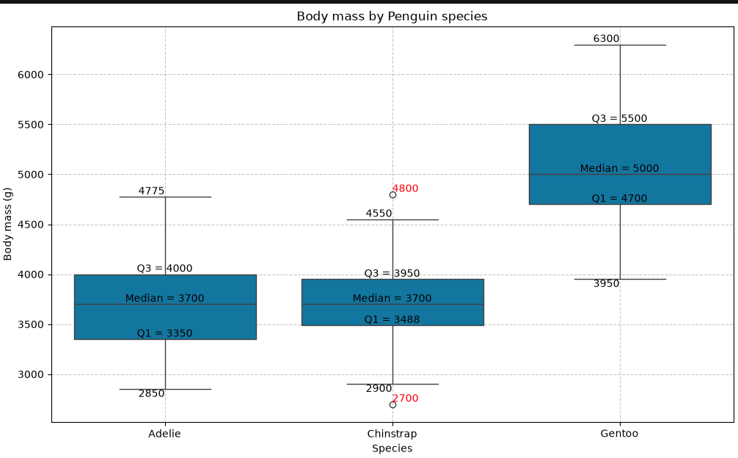
The body-mass differs across the 3 different species:
- Adelie have body mass values ranging from 2850 to 4775 grams.
- Chinstrap have values ranging from 2700 to 4800 grams (although 2700 and 4800 are identified as potential outliers using the 1.5 × IQR rule).
- Gentoo with values between 3950, and 6300 grams.
The Boxplot also suggests that the Chinstrap may have potential outliers at the values highlighted, 2700, and 4800 grams falling out of the calculated upper and lower bounds ranging 1.5 IQR from both Q1 and Q3.
while there were no potential outliers in the overall analysis of the dataset.

5.3 Scatterplot of Flipper Length and Body Mass
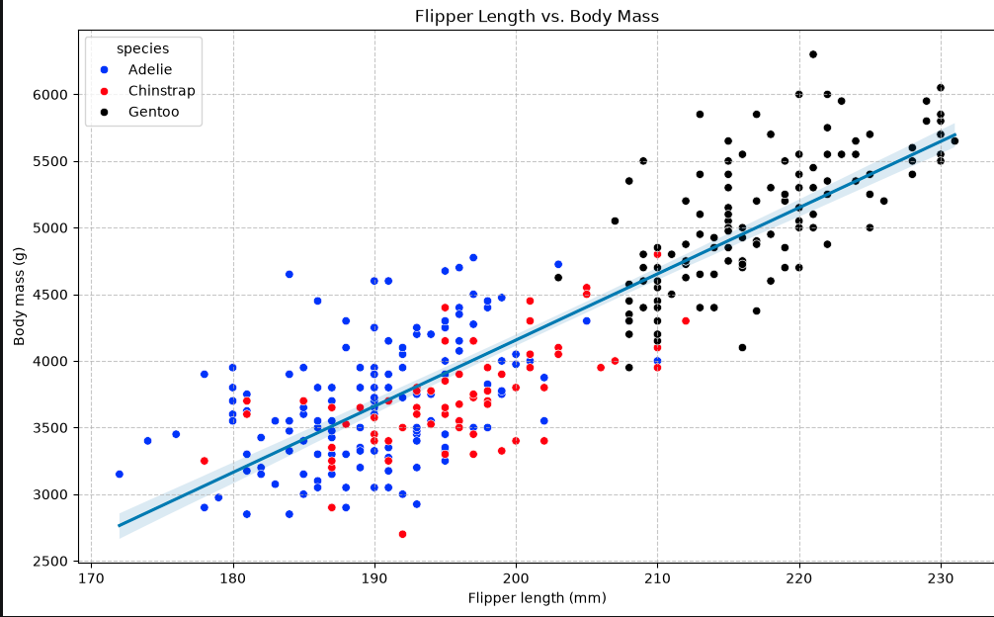
The scatterplot compares flipper length with body mass. The plot shows a positive association between the two variables: penguins with longer flippers generally tend to have greater body mass.
The observations are also separated by species in the visualization. The species occupy somewhat different regions of the plot, with Gentoo penguins generally appearing toward the higher end of both flipper length and body mass, while Adelie penguins generally appear toward the lower end
The regression line provides a visual summary of the overall positive relationship between the two numerical variables. However, this relationship represents an association and does not establish that longer flippers cause greater body mass.

