Week 3 Reflection

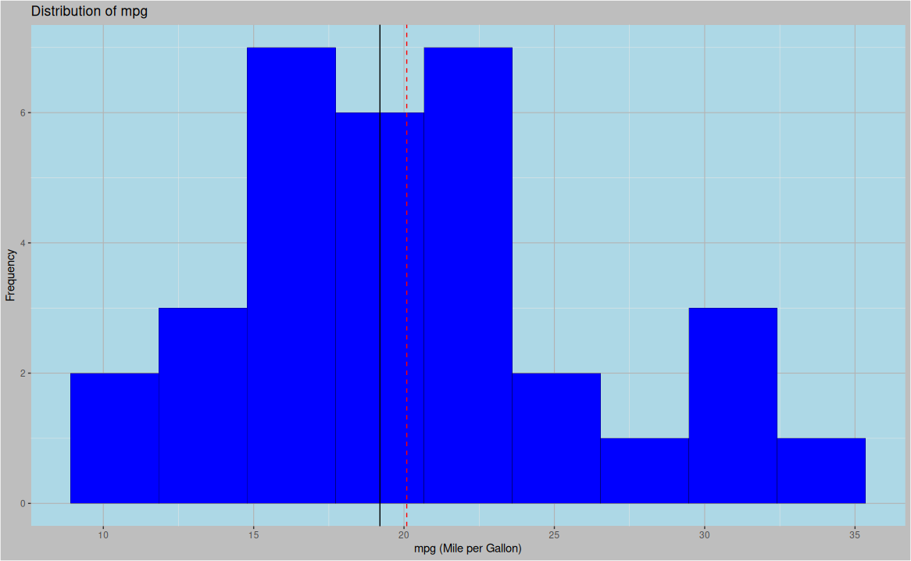

1. What does the histogram reveal about the distribution of mpg?
The distribution of mpg is approximately uni-modal, with most vehicles having mpg values between 15 and 23, regarding spread, values range from 9 to 35 mpg, it also looks slightly right-skewed with some values relatively far from the median to the right pulling the mean value (red dashed line) to the right of the median (solid black line)

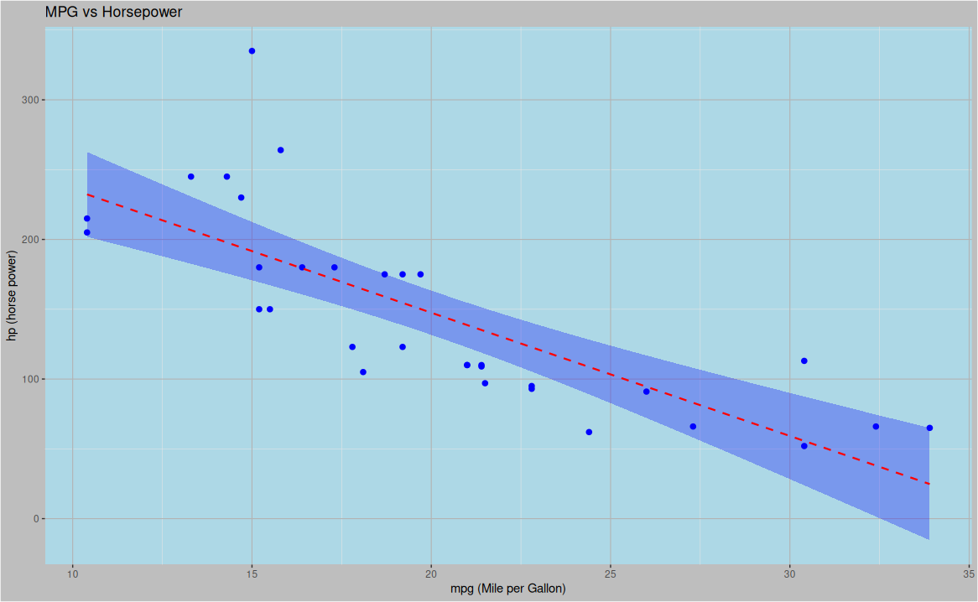
2. What trends do you notice in the scatterplot of hp vs mpg?
There appears to be a negative correlation between the mpg, and the horsepower, this suggests the cars with more powerful engines (higher horse power) tend to have lower fuel efficiency.
There is also some variations around the general trend, suggesting there could be other factors that explain the differences in mpg and not only the horsepower

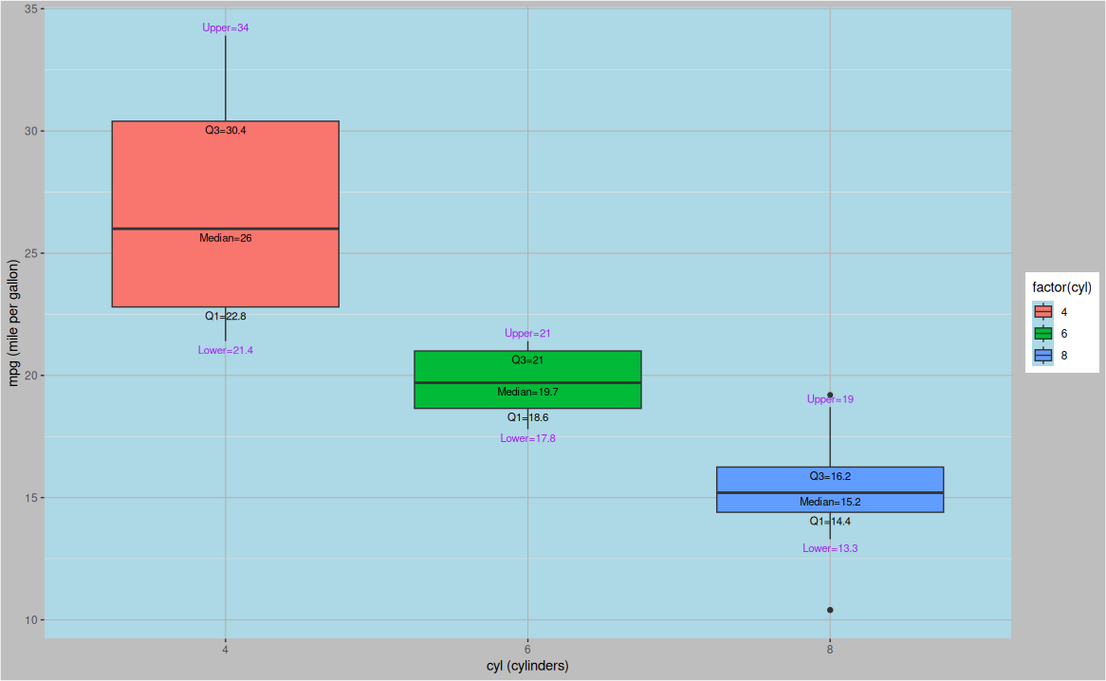
How does mpg differ across cylinder groups in the boxplot?
There appears to be a negative relationship between the number of cylinders and the fuel efficiency. Cars with fewer cylinders tend to have higher mpg.
This is evident from the mpg ranges:
4-cyl cars having their mpg ranging from 21.4 to 34 mpg
6-cyl cars with mpg values falling between 17.8 and 21 mpg
8-cyl cars have the lowest values ranging from 13.3 to 19 mpg

we can also compare the medians
4-cyl cars have a median mpg of 26
6-cyl cars have a median of 19.7
8-cyl cars have a median of 15.2

that suggests cars with more cylinders tend to have lower fuel efficiency

