Data Project Part 2: Data Exploration and Visualization

Introduction and part 1 recap
Part 1 explored the Palmer penguin dataset, which contains 344 observations and seven variables describing penguin species, island, sex, and physical measurements. The initial analysis examined missing values, descriptive statistics, and visualizations. Two observations were missing for each numerical measurement, while sex had 10 missing observations.
The descriptive statistics showed differences in body mass and flipper measurements across species. Gentoo penguins had the highest average body mass and longest average flippers, while Chinstrap penguins had the highest average culmen length.
The visualizations also identified potential body-mass outliers among Chinstrap penguins and showed a positive association between flipper length and body mass.

This report extends Part 1's exploration of the Palmer Archipelago penguin dataset through probability and distribution analysis, correlation analysis, and hypothesis testing. Building on the earlier descriptive statistics and visualizations, Part 2 examines whether the measured variables follow theoretical distributions, quantifies relationships between physical measurements, and tests differences in mean measurements between selected groups. These analyses provide a deeper understanding of patterns in penguin body size and morphology.

Dataset and Preparation
Part 2 includes
- Probability and Distribution Analysis
  - Body Mass
  - Flipper Length
- Correlation Analysis
  - Flipper Length ↔ Body Mass
  - Culmen Length ↔ Body Mass
- Hypothesis Testing
  - Male vs. Female Body Mass
  - Adelie vs. Gentoo Flipper Length

2. Probability and Distribution Analysis

2.1 Body Mass

Statistic | Usable observations | Mean | Standard deviation | Median | 25th percentile | 75th percentile | Minimum–maximum | Missing observations
Body mass | 342 | 4,201.75 | 801.95 | 4,050 | 3,550 | 4,750 | 2,700–6,300 | 2

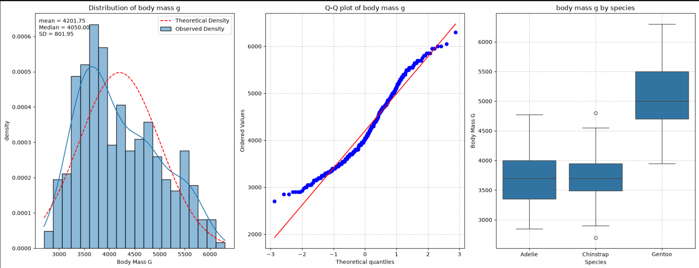

The mean body mass (4,201.75 g) exceeds the median (4,050 g), consistent with the slightly right-skewed distribution. The histogram and density comparison do not closely follow a theoretical normal curve, and the Q–Q plot shows departures from the normal reference line, especially in the tails. The boxplot grouped by species shows substantial differences: Gentoo penguins tend to have higher body mass than Adelie and Chinstrap penguins. The mixture of species with different body sizes likely contributes to the shape of the overall distribution.

2.2 Flipper Length
Statistic | Usable observations | Mean | Standard deviation | Median | 25th percentile | 75th percentile | Minimum–maximum | Missing observations
Flipper length (mm) | 342 | 200.92 | 14.06 | 197 | 190 | 213 | 172–231 | 2

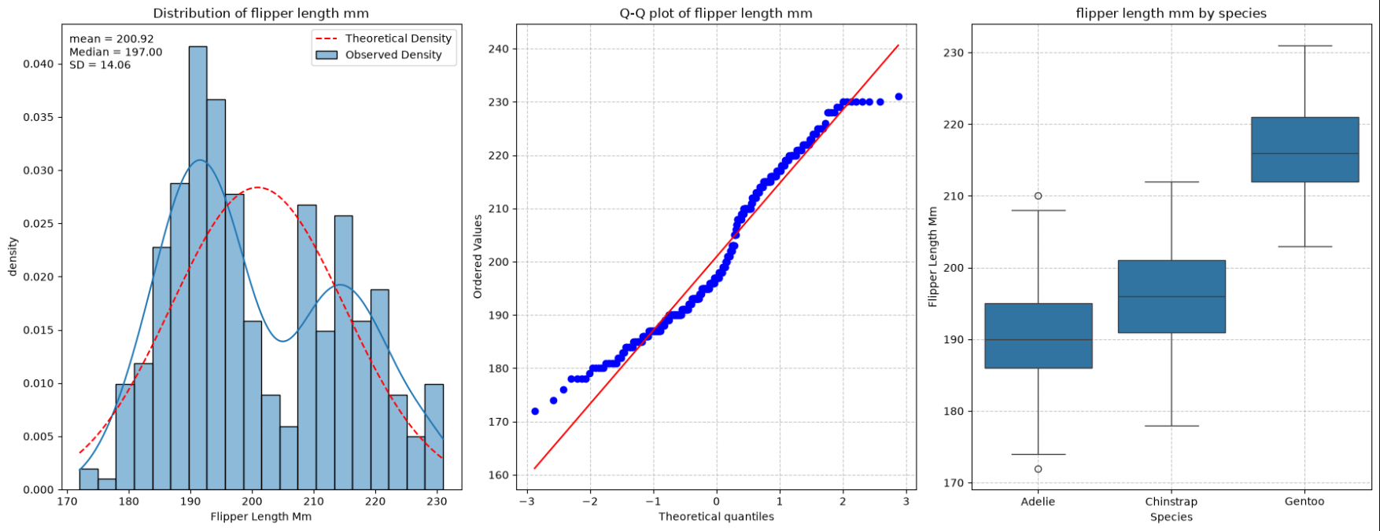
The observed flipper-length distribution also differs from a theoretical normal distribution. The histogram appears bimodal, and the Q–Q plot shows deviations from the normal reference line. The median is 197 mm and the mean is about 200.92 mm. The species-level boxplot shows that Gentoo penguins generally have longer flippers than Adelie and Chinstrap penguins. Combining species with distinct flipper-length profiles helps explain the two-peaked shape of the overall distribution(values of the peaks match the median of the Adelie and the Gentoo since the observations are as follows Adelie 152, Gentoo 124, Chinstrap 68). Consequently, a normal model for all penguins combined may not fully describe the data.

3. Correlation Analysis

3.1 Flipper Length and Body Mass
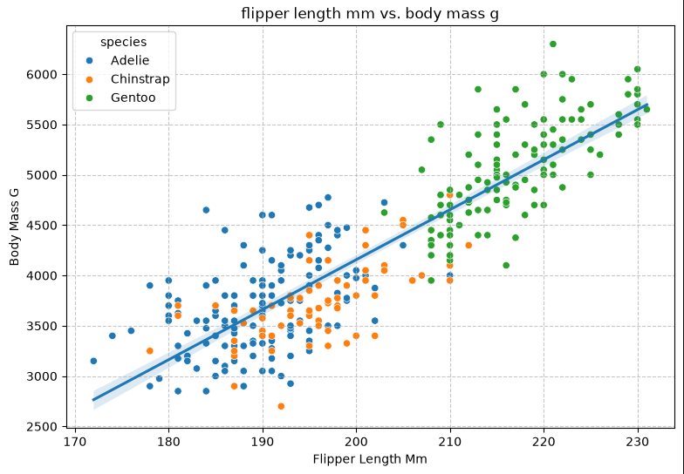
Statistic | Pearson's r | Spearman's ρ | p-value | R² | Statistically significant
Value | 0.871 | 0.840 | < 0.05 | 0.7590 | true

The scatterplot shows a strong positive relationship between flipper length and body mass: penguins with longer flippers generally have greater body mass. Pearson’s correlation was r = 0.871, indicating a strong linear association. Spearman’s rank correlation was ρ = 0.840, indicating a strong monotonic association. Both correlation tests were statistically significant at α = 0.05 (p < 0.05), providing evidence against the null hypothesis of zero population correlation.
The Pearson coefficient of determination is R² = 0.7590. In a simple linear description, approximately 75.9% of the sample variation in body mass is associated with its linear relationship with flipper length. This value describes the strength of the linear fit and does not mean that flipper length causes the same percentage of body mass. The similarity of Pearson and Spearman coefficients supports the conclusion that the relationship is both strongly linear and monotonic, although the scatterplot also shows that species groups differ.

3.2 Culmen Length and Body Mass

Statistic | Pearson's r | Spearman's ρ | p-value | R² | Statistically significant
Value | 0.595 | 0.584 | < 0.05 | 0.3542 | true

Culmen length and body mass also have a positive association, but it is more moderate than the flipper-length relationship. Pearson’s correlation was r = 0.595 and Spearman’s correlation was ρ = 0.584. Both tests were statistically significant at α = 0.05 (p < 0.05), providing evidence of a non-zero population association. The Pearson coefficient of determination was R² = 0.3542, meaning approximately 35.42% of the sample variation in body mass is associated with its linear relationship with culmen length.

The close Pearson and Spearman values suggest that the association is reasonably consistent in direction and form. However, the relationship is not as strong as the relationship between flipper length and body mass. The scatterplot indicates that species differences may contribute to the overall pattern. Neither correlation alone demonstrates a causal relationship.
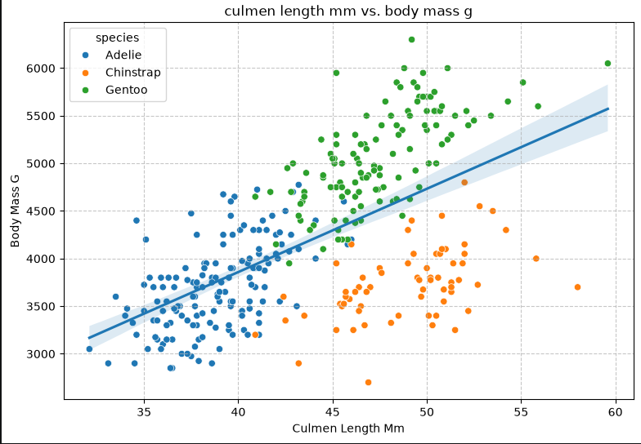

4. Hypothesis Testing

4.1 Male and Female Body Mass
Male sample size | Female sample size | Male mean body mass | Female mean body mass | Difference (male − female) | Welch t-statistic | Two-sided p-value | Decision at α = 0.05
168 | 165 | 4,545.68 g | 3,862.27 g | 683.41 g | t = 8.555 | 4.79 × 10⁻¹⁶ | Reject H₀

The first two-sided Welch independent-samples t-test compared mean body mass between male and female penguins at α = 0.05. The null hypothesis stated that the population means were equal; the alternative stated that they differed.
The p-value is far below 0.05, so the null hypothesis is rejected. The sample provides strong evidence of a difference in population mean body mass between male and female penguins. Males in the usable sample had a higher mean body mass by approximately 683.41 g. This result is consistent with the visible group difference in the boxplot. The test establishes a statistically significant group difference, not a causal explanation for that difference.
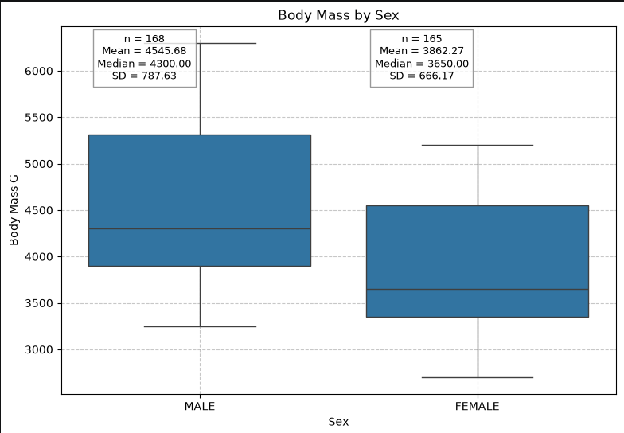

4.2 Adelie and Gentoo Flipper Length
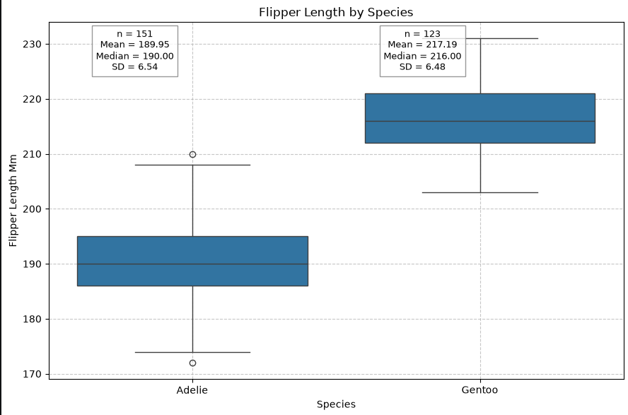

Adelie sample size | Gentoo sample size | Adelie mean flipper length | Gentoo mean flipper length | Difference (Adelie − Gentoo) | Welch t-statistic | Two-sided p-value | Decision at α = 0.05
151 | 123 | 189.95 mm | 217.19 mm | −27.23 mm | t = −34.445 | 3.19 × 10⁻⁹⁹ | Reject H₀

The second two-sided Welch independent-samples t-test compared mean flipper length for Adelie and Gentoo penguins. The null hypothesis stated that the population means were equal; the alternative stated that they differed. The analysis included 151 Adelie and 123 Gentoo penguins with observed flipper length.

The p-value is far below 0.05, so the null hypothesis is rejected. The results provide strong evidence that mean flipper length differs between Adelie and Gentoo penguins in the population represented by the sample. Gentoo penguins had the higher sample mean, by approximately 27.23 mm. The difference is also apparent in the species boxplot. This finding describes a difference between species and should not be interpreted as evidence that species membership alone causes the observed measurement.

Implications and Real-World Applications
These findings demonstrate how statistical analysis can help researchers understand variation in animal measurements. The strong positive relationship between flipper length and body mass may be useful when studying penguin morphology, while differences between species and sexes highlight the importance of considering group characteristics when analyzing biological data. Distribution plots can also reveal patterns that may be hidden when all observations are combined. In ecological research, these methods can support comparisons across groups and help identify patterns for further investigation.

Summary
This project analyzed the Palmer Penguins dataset using descriptive statistics, probability distributions, correlation analysis, and hypothesis testing. The distribution analyses showed that body mass and flipper length do not closely follow a single normal distribution when all species are combined. Correlation analysis identified a strong positive relationship between flipper length and body mass (Pearson $r=0.871$) and a moderate positive relationship between culmen length and body mass (Pearson $r=0.595$). Both relationships were statistically significant. Welch’s independent-samples t-tests also found significant differences in mean body mass between male and female penguins ($p<0.001$) and mean flipper length between Adelie and Gentoo penguins ($p<0.001$). Overall, the findings demonstrate meaningful relationships and group differences in penguin measurements. However, these results indicate associations rather than causation and should be interpreted in light of missing observations and differences among species.

