Active Bots

1. DCA
2. …

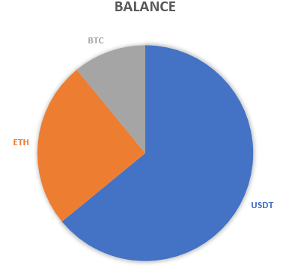

Active Bots

1. DCA
2. …

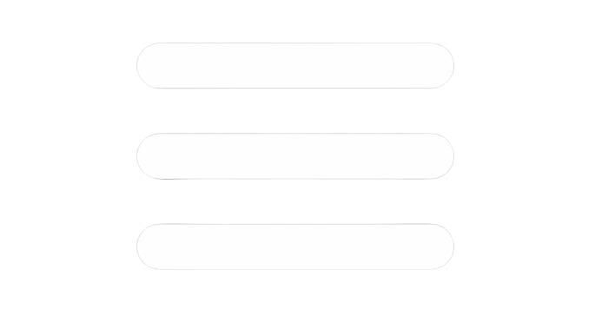

**Connected Exchanges**



**Active Bots**

**Last Orders**

|  |  |  |  |  |  |
| --- | --- | --- | --- | --- | --- |
| Symbol | Exchange | Type | Price | Time | status |
| ETHUSDT | Kucoin | Buy | 3100.32 | 2020/02/15 11:08 PM | FILLED |
| BTCUSDT | …. |  |  |  |  |
|  |  |  |  |  |  |
|  |  |  |  |  |  |

|  |  |  |
| --- | --- | --- |
| Name | Activation Time | ON/OFF |
| DCA |  |  |



**Add new exchange**

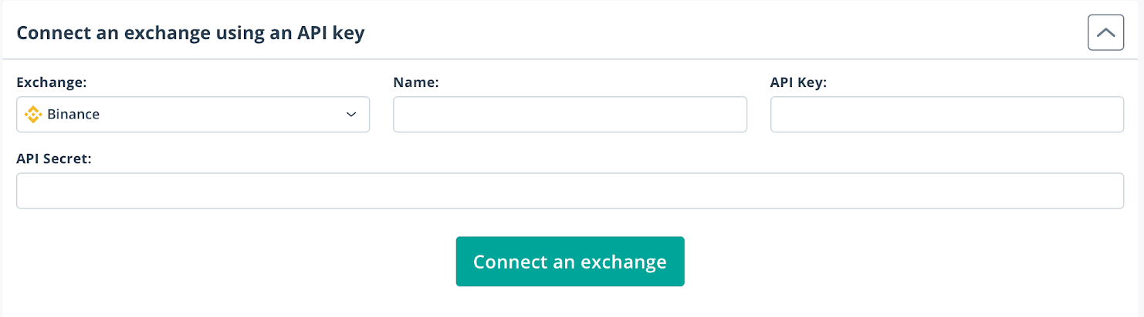

**Order size(USDT)**

**Symbols**

**Bot**

**Tp(%)**

**Maximum (USDT)**

**Add new bot**

