TRACKSAFAR
SYSTEM DIAGRAMS & PROJECT PLAN
Data Flow Diagrams • Activity Diagrams • Entity Relationship Diagram • Gantt Chart
Prepared strictly from the supplied Software Requirements Specification (SRS)
Version 1.0 | 13 October 2026

DFD Flows document
The diagrams translate the supplied TrackSafar SRS into clear system-analysis artefacts. Each diagram is placed on its own page to preserve legibility and prevent text or connectors from overlapping.

DFD Level 0 — Context
Shows the three external actors and the main information exchanged with the TrackSafar system.

DFD Level 1 — Processes and stores
Breaks the backend into major processes and identifies the logical data stores. It is a high-level view, not a physical database schema.

Activity diagrams
Show the principal passenger, driver and administrator flows, including key validation decisions and failure states.

ERD — Proposed logical model
Shows core entities and selected relationships inferred from SRS requirements. Attributes and retention rules must be confirmed during detailed design.

Gantt chart — Planning baseline
Shows a relative 13-week sequence for planning only. The SRS specifies no calendar deadline or approved staffing allocation, so dates are intentionally not invented.
Important modelling constraints: ETA is conditional on sufficient and fresh inputs; driver GPS is accepted only for an authorized active trip; role and resource-ownership checks are enforced by the backend; official route/operator feeds are not assumed.

1. Data Flow Diagram - Level 0
System context and information exchanges between Passenger, Driver, Administrator and TrackSafar.
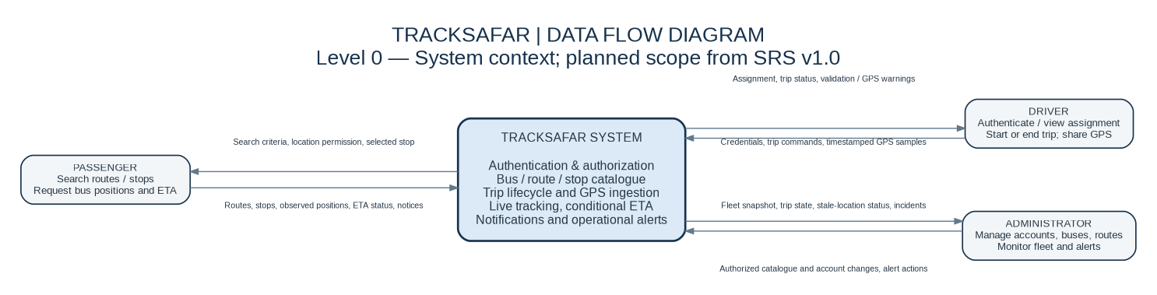

2. Data Flow Diagram - Level 1
Major backend processes and logical data stores. The decomposition is aligned with authentication, catalogue, trip, GPS, tracking, notification and alert requirements.
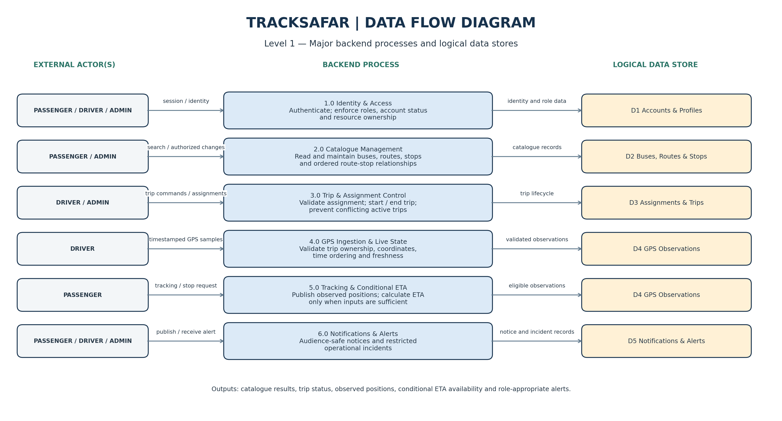

3. Activity Diagram - Passenger
Passenger discovery, route/stop selection and conditional ETA handling, including manual search when GPS permission is denied.
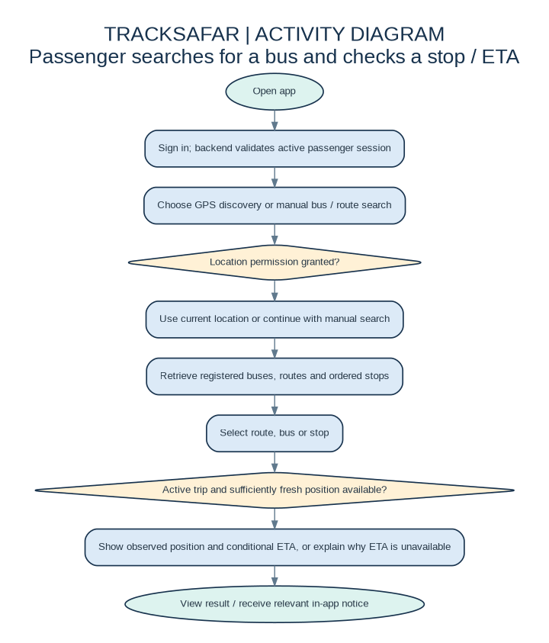

4. Activity Diagram - Driver
Authorized trip start/end, GPS validation, sharing-state feedback and recovery from GPS/network issues.
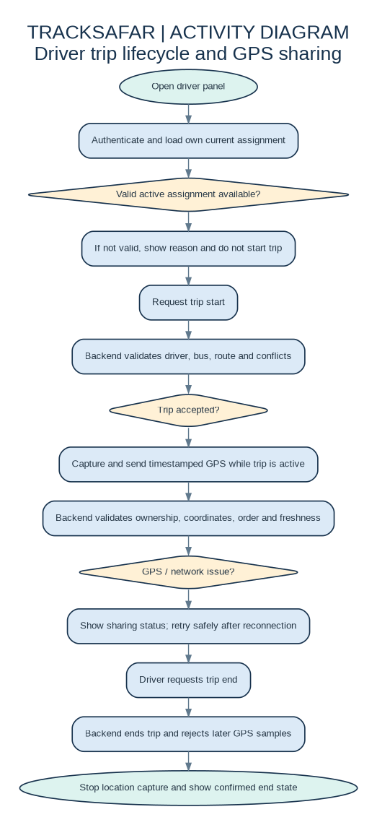

5. Activity Diagram - Administrator
Admin authentication, fleet/network maintenance, validation, audit trail and operational monitoring.
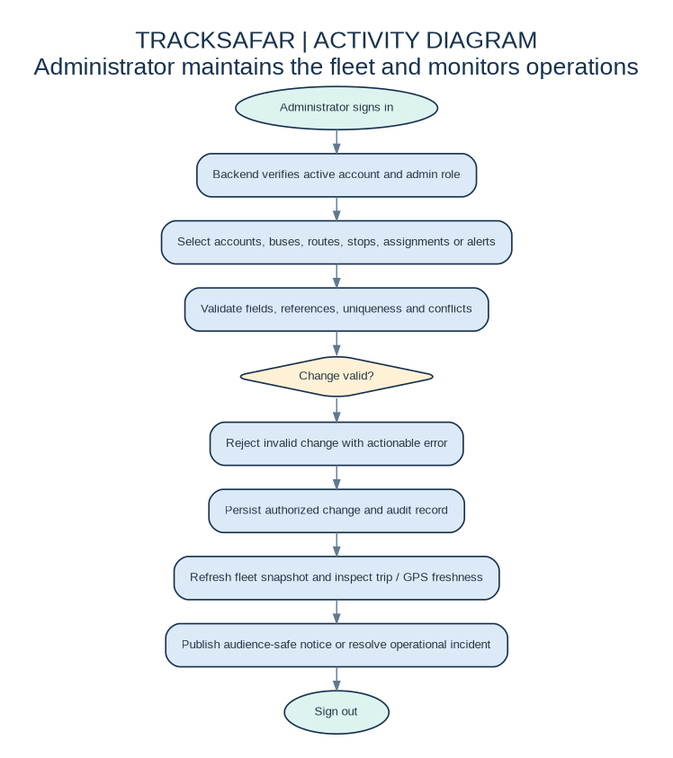

6. Entity Relationship Diagram
Proposed logical data model. It is not a finalized schema; field types, optionality, deletion rules and retention require design review.
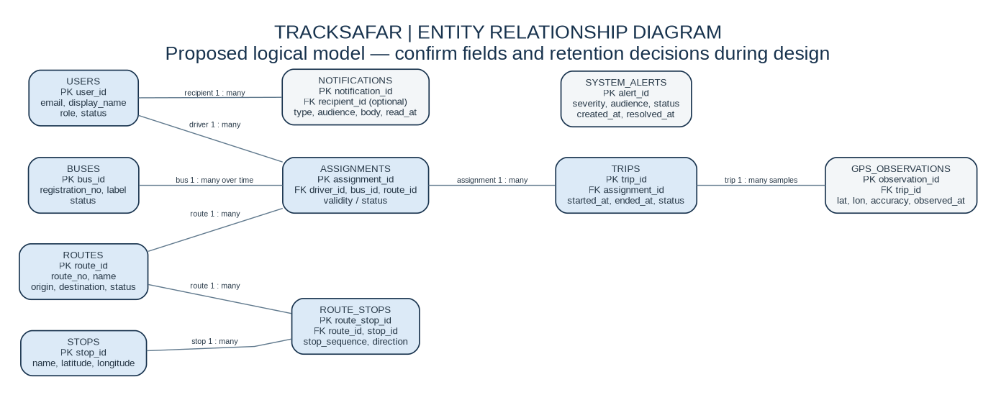
Relationship labels indicate conceptual cardinality. Notifications may target a specific recipient or a broader audience; system alerts are represented separately.

7. Proposed Gantt Chart
Illustrative 13-week plan. Week numbers are relative, not calendar dates; the team should approve durations, dependencies and milestones.
