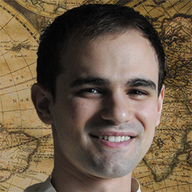

Provided Upon Request

REFERENCES

* National Multiple Sclerosis (MS) Society - Team Booz Allen Hamilton
* Career Mentor - Booz Allen Hamilton
* Volunteer - Friendship Visitor - DuPage Care Center

VOLUTEER EXPERIENCE

* Roepke Research Scholarship Recipient, 2007
* “Mapping the Dynamism of the United States' Geopolitical Code: The Geography of the State of the Union Speeches, 1988–2008”, Taylor & Francis
* “Introduction to Geopolitics”, 3rd Edition, Routledge

ACHIEVEMENTS & CITED PUBLICATIONS

* Geocoded points of interest from global suppliers
* Performed Geospatial analysis of supplier data to determine feasibility
* Conducted content integration assessments of supplier data

Points of Interest Specialist

HERE Maps | 2008 - 2012

* Provided geospatial support and expertise to clients
* Supported client's open data initiatives
* Transformed data sets and web services into usable geo-products

Senior Consultant with 11+ years of total experience, a Bachelor’s degree in Geography, and GIS experience in both digital mapping and government consulting.

* A Proven ability to create global geospatial products using complex source data
* Skilled in terrain modeling, analysis, and data manipulation, and data requirement gathering
* Extensive knowledge of GIS products and methods
* S
* d

CONTACT INFO

Phone

+000 123 456 789

Email

chrisharrison@email.com

Web

www.chrisharrison.com

EDUCATION

University of Wisconsin | Madison

M.S. Geography

2019 - Present

B.A. Geography

University of Illinois | Chapaign

2004 - 2008

EXPERTISES

Office Applications

Virtual Simulations

Web Mapping

Databases

Geospatial Analysis

WORK EXPERENCES

Geospatial Analyst

Booz Allen Hamilton | 2012 - Present

Geospatial Professional

MIKE

ADDUCI