
FreshForks
A Healthy Meal Application

malachi adebayo
DYNAMIC WEB APPLICATIONS
Contents
Outline 2
Architecture 2
Data Model 2
User Functionality 3
Advanced Techniques 5
AI Declaration 8

Outline
FreshForks is a platform where users can discover, share and review healthy meals recipes. The platform encourages nutritious cooking whilst making it easy for users to explore new meal ideas and interact with other people’s meals by rating and commenting. Users can also interact with Maria the meal bot, an AI powered chatbot that suggests meal ideas and recipes, helping users explore food options beyond the existing meal database.

Architecture
The application follows a three tier architecture. The presentation layer uses HTML, CSS and EJS templates rendered in the browser. The application layer is built with Node.js and express, handling the routes, sessions, authentication and the chatbot. The authentication uses bcrypt for hashing. Finally, a mySQL database is used to store users, meals and ratings.
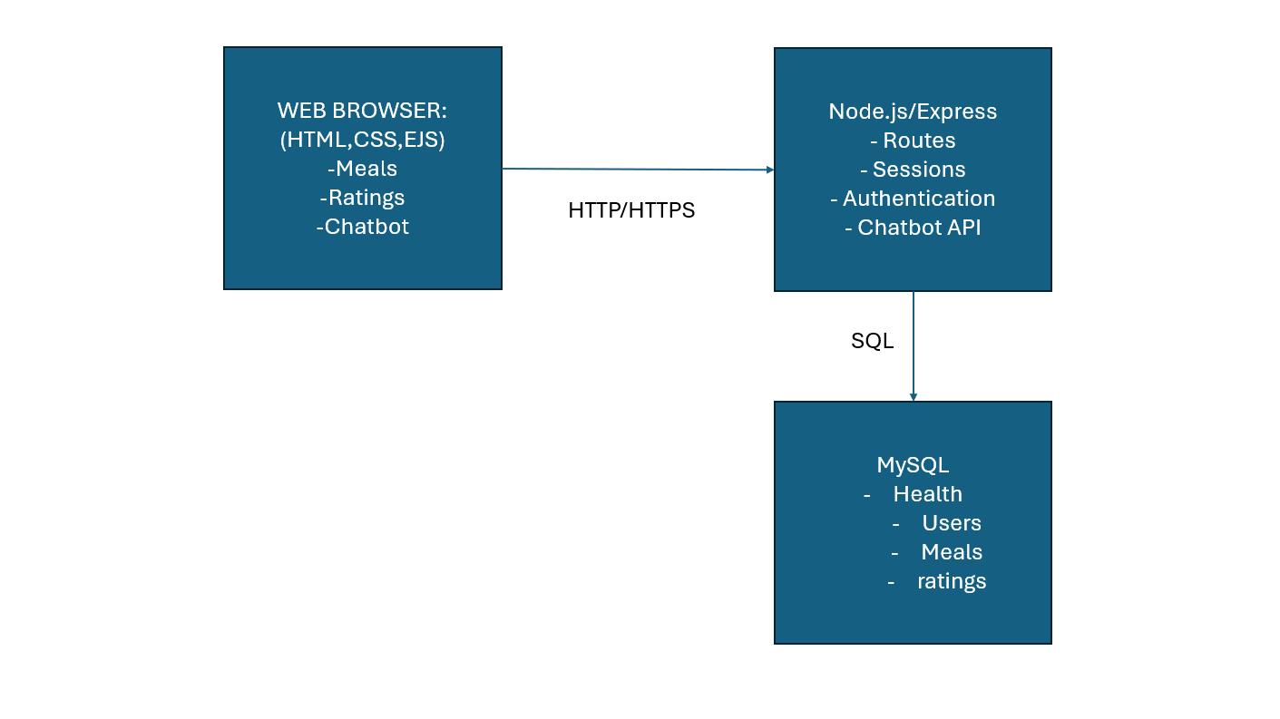

Data Model
The data model consists of three entities, being users, meals and ratings. Users store authentication and profile information. Meals store recipe details including ingredients and the recipe. Ratings act as a linking table between users and meals, allowing each person to rate and comment on each meal. A unique constraint makes sure that a user can only rate once per meal, and any rerate just overwrites the previous one. The foreign key relationships enforce referential integrity and cascading deletes. Finally, the one to many relationships indicate that a single user or meal can be associated with many ratings, however each rating belongs exactly to one meal.
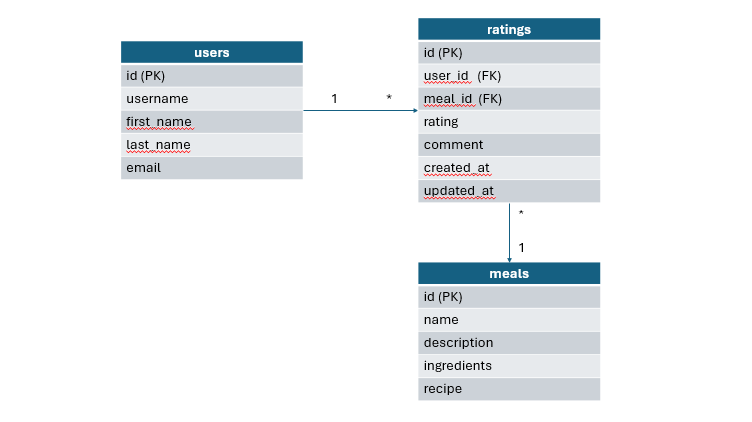

User Functionality
The application is designed to act as a meal sharing and recommendation platform. The system includes browsing meals, viewing ratings and raring themselves, and chatting with an AI for personalised recommendations, creating a full user journey centred around finding the perfect meal.
Users must first create an account, which can be done through the registration page. Registration details are then sent to the database, and now interaction with meals directly tied to their profile. Users provide a username, email and password, which is hashed and stored in the database. After validation, the login page itself intakes username and password, and is simple. Once authenticated, a session is created that keeps users logged in as they navigate the site.
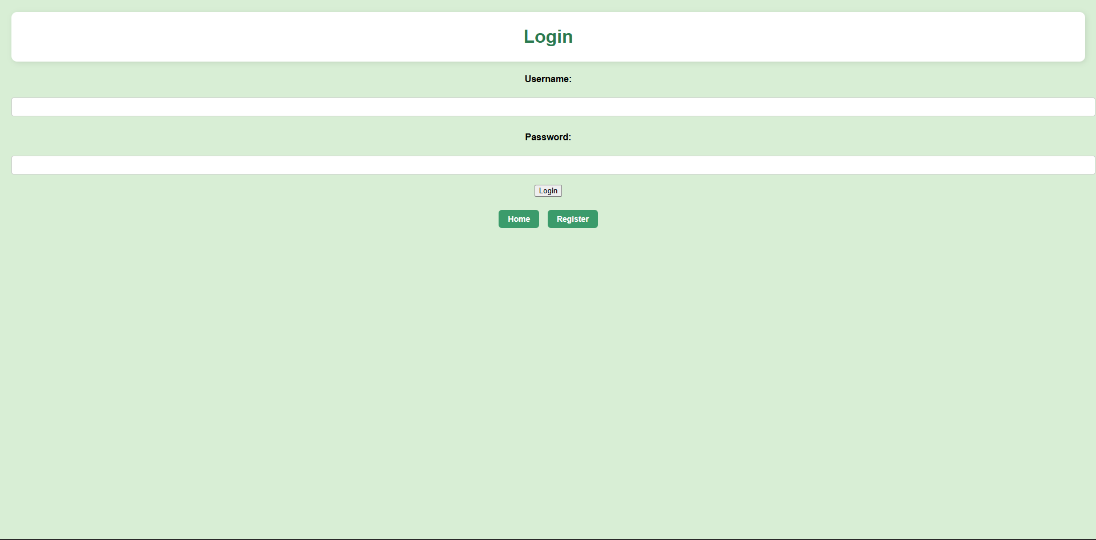
After logging in the users are taken to the homepage. They can navigate their way to the meal list. This page displays all meals stored in the system with a description, the ingredients and the recipe. This will be shown as a card that can be interacted with.
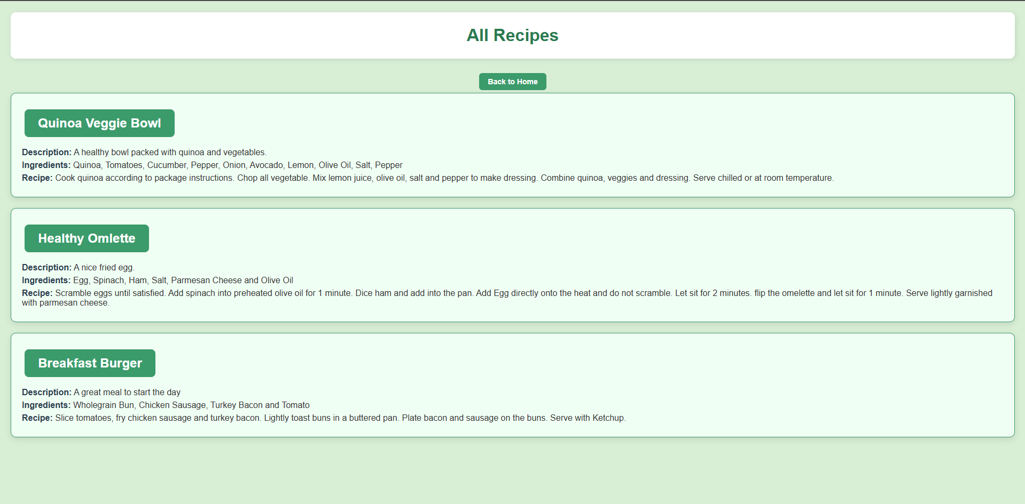
Once pressed, each meal has its own individual detail page, again displaying its description, ingredients and recipe but also average rating, each induvial rating and all comments. Users will also be able to leave their own ratings, which will be displayed under their name.
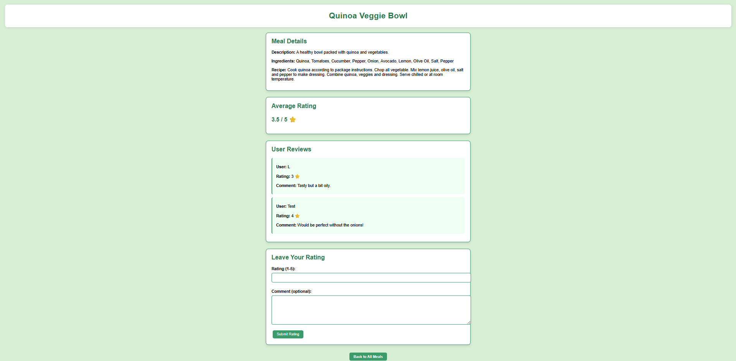

Users can also submit their own meals for people to see and rate, through the form. This all the inputs and feeds it to the meals table, and this is added to the list page. 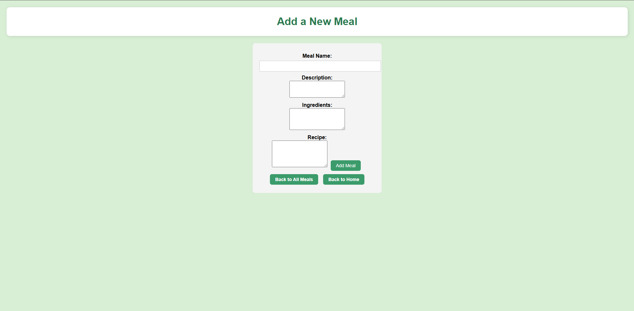

Advanced Techniques
Advanced techniques include the integration of an AI chatbot (Maria the MealBot). The AI chatbot, (learned from an EDX course) intakes user queries about meals, nutrition and food in general. It will feedback meal suggestions based on user input, and anything outside of this prompt, the chatbot will decline to answer. This is found within the chat,js file.
The chat.js defines a GET route to render the chatbot interface, and a POST to process the messages. When a message is submitted, it is sent to OpenAI. The response is returned to the client as JSON and displayed in the chat interface.
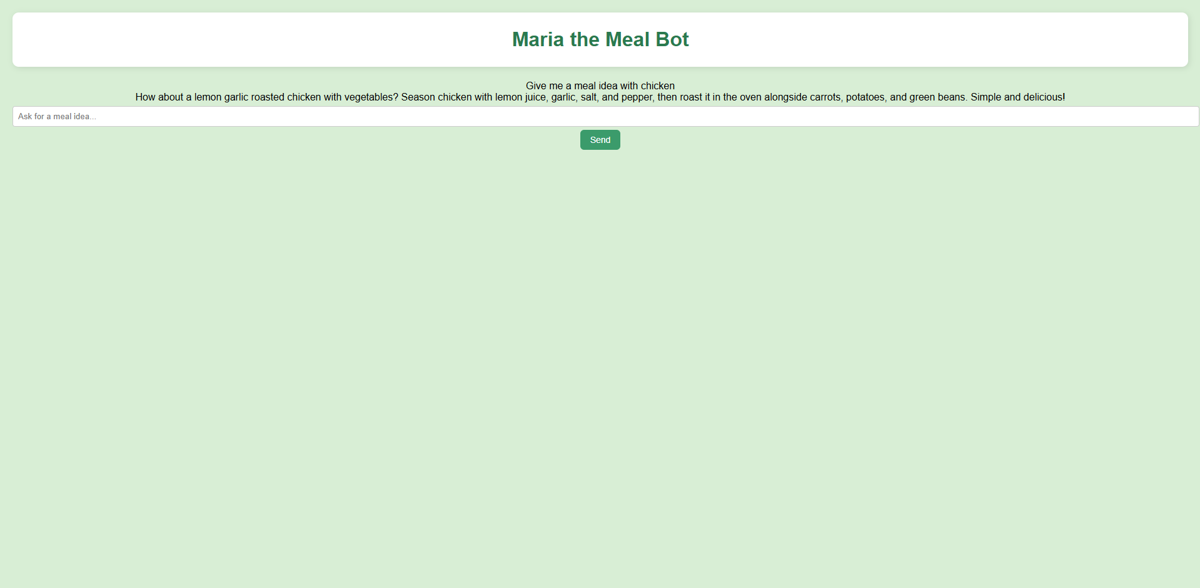
The first line is the user prompt, the second is the reply from the chatbot.
To clarify, I tried to get this to work on the VM, but I couldn’t figure out how to do so.
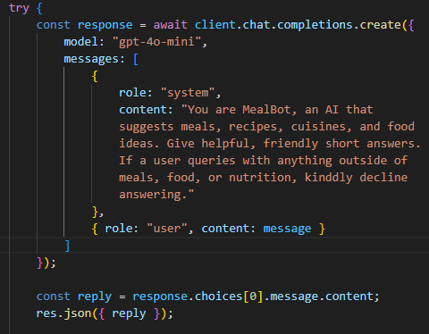
I created this chatbot using the leftover credit on my API key from a previous course I completed. I decided to use gpt 4o mini, as it was the most cost effective for a smaller scale project.
Also, a rating system has been implemented by creating a new table called “ratings”. It has the fields id, user_id, meal_id, rating, comment, created_at and updated_at. User id links with the users table, so the rating displays the username of the user that rated the meal. It also uses the meal_id to ensure that it links with the correct meal.
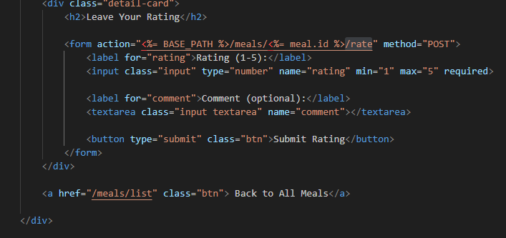
The rating has been given a 1-5 minimum and maximum and is measured in stars.
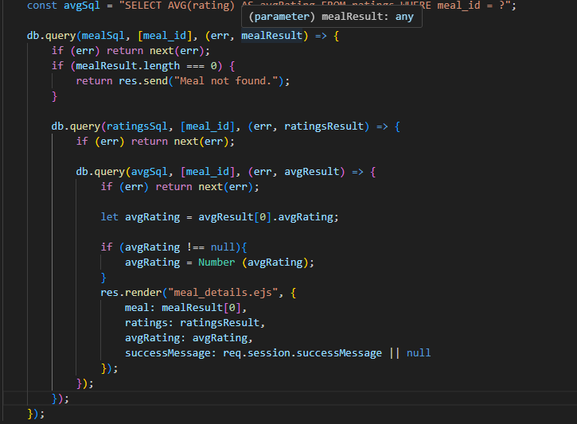
The average rating is calculated and displayed, so a user knows whether a meal is good or not in differing opinions for the person. Everything contributing to ratings is within meals.js, meal_details.ejs, and the CSS.

AI Declaration
AI was partially used during this project. AI was utilised to generate general recipes when testing and inputting into the database. It was also used for a small CSS error I had on the ratings display. I used AI to organise my code at one point and whilst I was doing it, it helped me spot an error, but this was not directly inputted into the work. AI also generated a star emoji for my rating system. I also attempted to use AI at the last minute to fix an issue I was having with the chatbot. The chatbot works locally but does not work on the virtual server. ChatGPT essentially said it is down to the version of Node being used, and the Goldsmiths VM doesn’t use that node, hence why the chatbot functionality doesn’t work on the VM.
Other than that, all work was developed from research, course material or external knowledge.

