**OVERVIEW:**

|  |
| --- |
|  |
| MARKET SEGMENTATION ANALYSIS OF ELECTRIC VEHICLE IN INDIA  MOHAMMAD ADIL |
| |  |  |  | | --- | --- | --- | |  |  |  | |

An Electric Vehicle (EV) is a type of vehicle that uses one or more electric motors for propulsion instead of an Internal Combustion Engine (ICE). EVs produce fewer emissions and are more energy-efficient that can potentially save money on fuel and maintenance costs. While EVs were once seen as niche market, they are becoming increasingly popular as battery technology improves and charging infrastructure becomes more available.

India is massively dependent on oil imports. According to data of Petroleum Planning & Analysis Cell (PPAC), India has spent USD 119.2 billion in FY 2021-22, which is up from USD 62.2 billion spent in the previous fiscal year. India has committed to Net-Zero carbon emission by 2070 and to reduce the total carbon emissions by one billion tones by 2030. So, faster adoption and promotion of EV will not only bring down the import bill but also the pollution arising from the use of ICE vehicles. A total of 18,02,967 Electric Vehicles (EVs) are being used on the roads of India as on 30 November 2022 as per the information received from Ministry of Road Transport and Highways. The details are as under:

Further, the sale of EVs in FY 2021-22 has gone up over three times as compared to sale of EVs in FY 2020-21 from 1,34,460 to 4,28,224 as per the information available on VAHAN-4 centralized database of RC. Although penetration of EVs is increasing, the percentage of EV sales as compared to total auto vehicles sales is still minuscule (2 to 3%).

While it cannot be denied that EVs provide huge benefits over traditional vehicles that use fossil fuels, there are several challenges that have been identified by EV users. The major issues present in the EV space are:

* Charging Infrastructure
* Range Anxiety
* High initial cost
* Scarce battery technology
* Power supply
* Manufacturing capabilities
* Consumer perception
* Consumer protection
* Limited awareness
* Policy support
* Shortage of skilled manpower for servicing and repair of EVs

Government Measures to Promote Adoption of EVs:

* National Electric Mobility Mission Plan (NEMMP) 2020
* Faster Adoption & Manufacturing of (Hybrid &) Electric Vehicles (FAME)
* Advanced Cell Chemistry (ACC) PLI Scheme
* PLI for automobile and auto component Scheme
* Waiving of Road Tax on EV
* Charging Infrastructure Support
* GST Rate Reduction

As an EV startup, we need to analyze the EV market in India using segmentation analysis and come up with a feasible strategy to enter the market, targeting the segments most likely to use the Electric Vehicles.

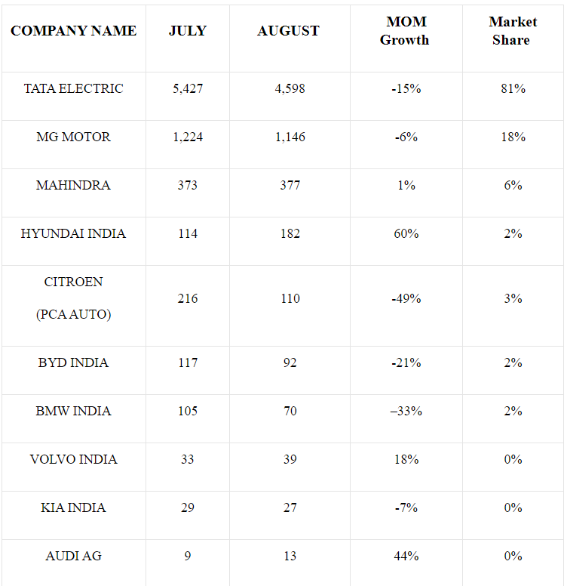

<https://electricvehicles.in/category/electric-vehicles-india/>

<https://www.kaggle.com/datasets/karivedha/indian-consumers-cars-purchasing-behaviour>

<https://www.kaggle.com/datasets/praveenchoudhary1217/electric-vehicle-sales-in-india>

<https://data.gov.in/keywords/Electric>

<https://e-amrit.niti.gov.in/Manufacturers>

<https://vahan.parivahan.gov.in/vahan4dashboard/vahan/view/reportview.xhtml>