University of Central Florida
Department of Computer Science
CDA 5106: Fall 2023
Machine Problem 2: Branch Prediction

by

Aditya Vardhan Mustyala

Honor Pledge: "I have neither given nor received unauthorized aid on this test or assignment."

Student’s electronic signature: Aditya Vardhan Mustyala
(sign by typing your name)

PART 1: SMITH N-BIT COUNTER PREDICTOR

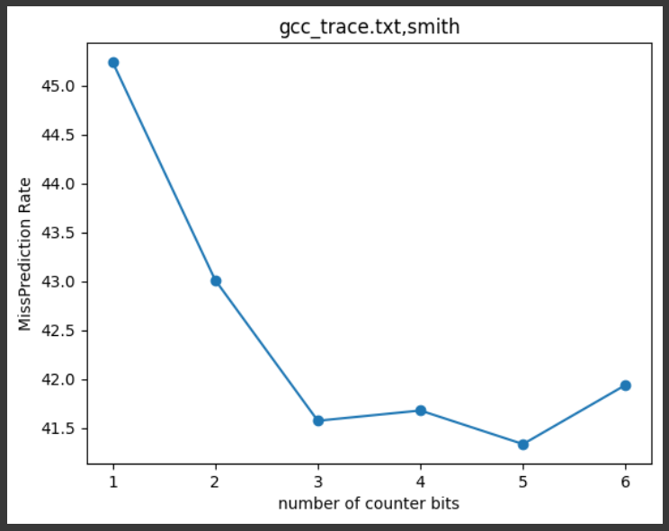
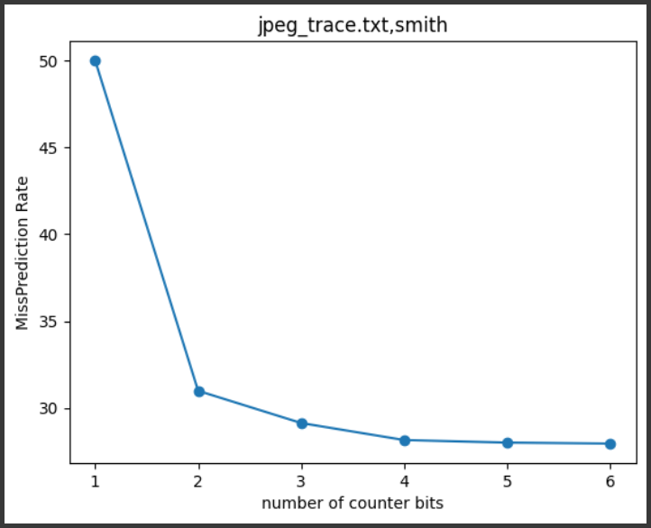
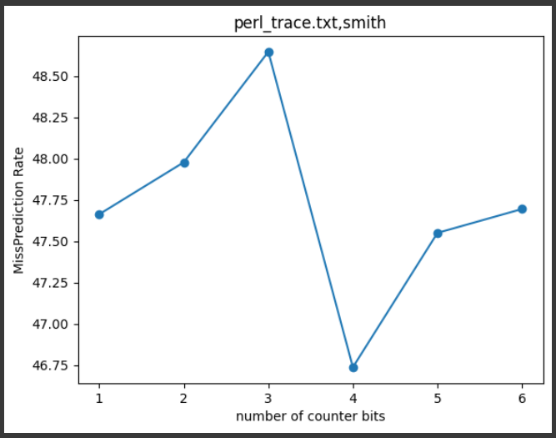

PART 2: BIMODAL PREDICTOR

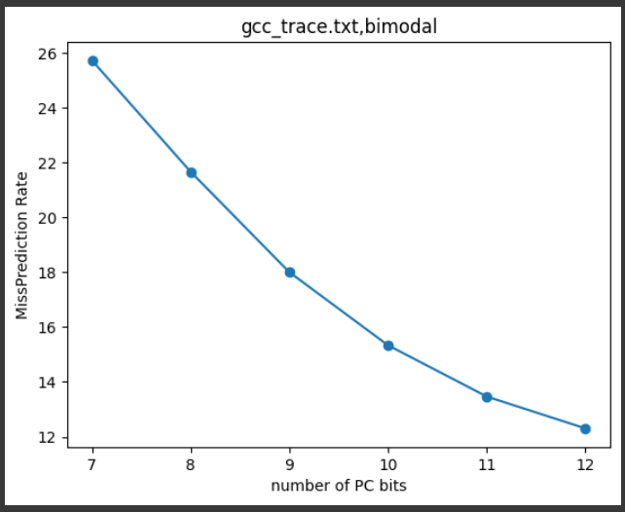
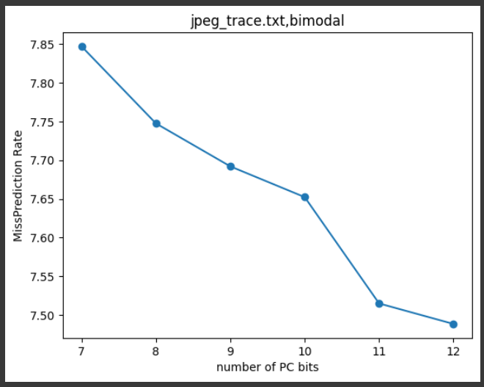
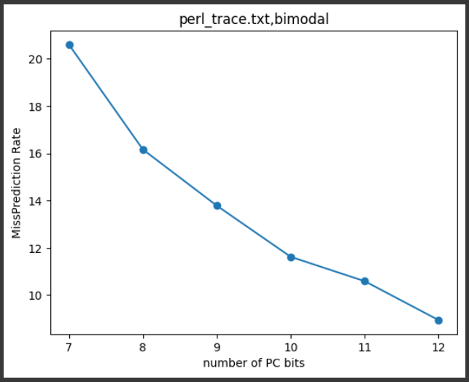

PART 3: GSHARE PREDICTOR
