**University of Central Florida**

**Department of Computer Science**

**CDA 5106: Fall 2023**

**Machine Problem 2: Branch Prediction**

**by**

**Aditya Vardhan Mustyala**

Honor Pledge: "I have neither given nor received unauthorized aid on this test or assignment."

Student’s electronic signature: Aditya Vardhan Mustyala

(sign by typing your name)

**PART 1: SMITH N-BIT COUNTER PREDICTOR**

**­**

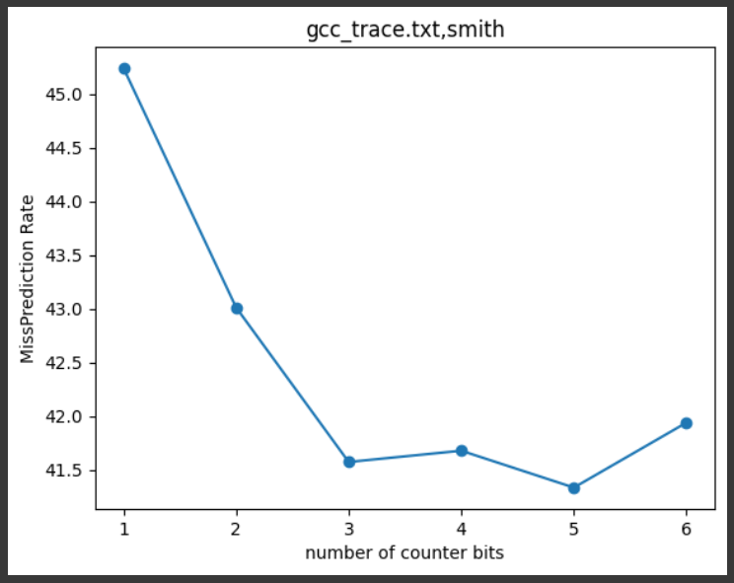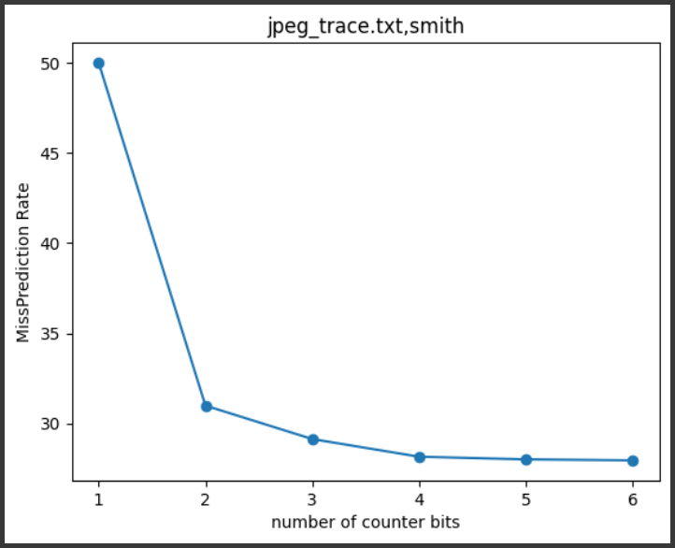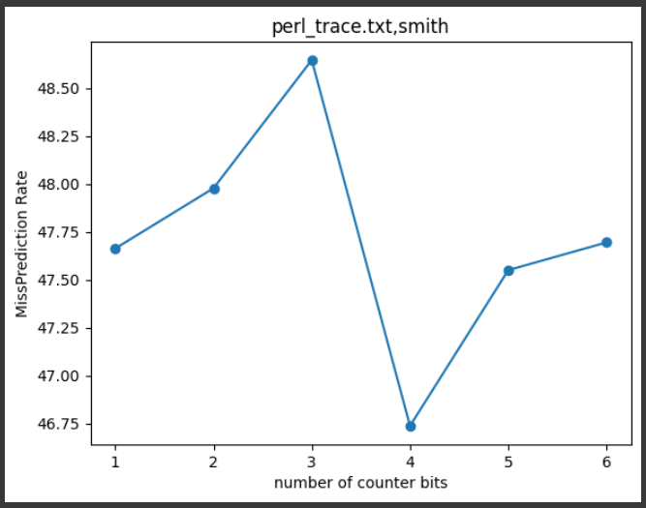

**PART 2: BIMODAL PREDICTOR**

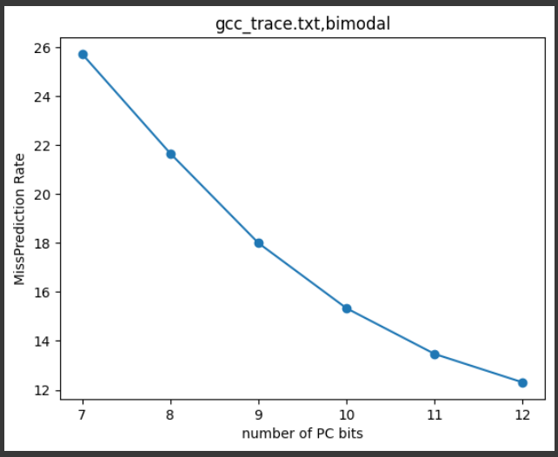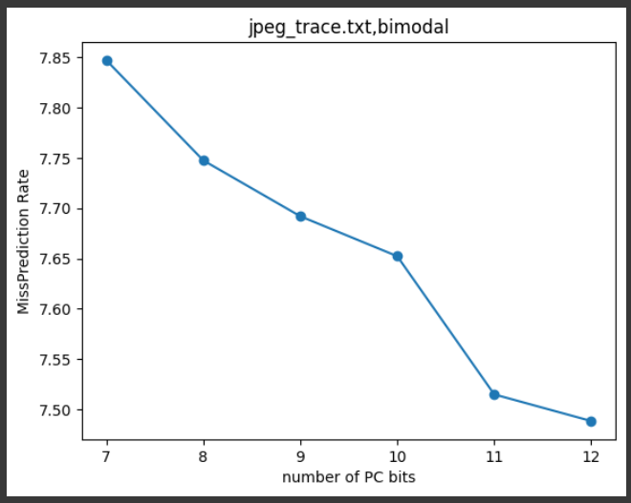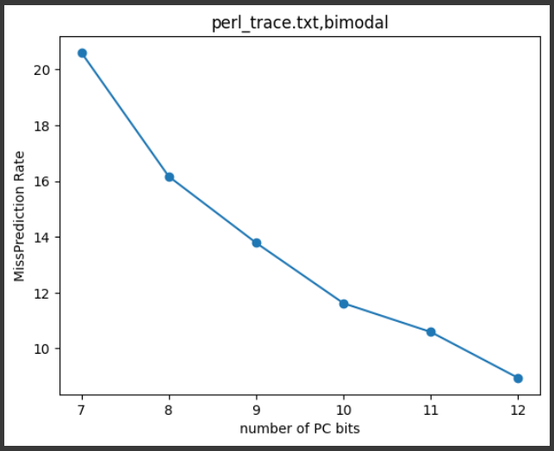

**PART 3: GSHARE PREDICTOR**

