University of Central Florida
Department of Computer Science
CDA 5106: Spring 2020
Machine Problem 1: Cache Design, Memory Hierarchy Design

by

Aditya Vardhan Mustyala

Honor Pledge: "I have neither given nor received unauthorized aid on this test or assignment."

Student’s electronic signature: Aditya Vardhan Mustyala

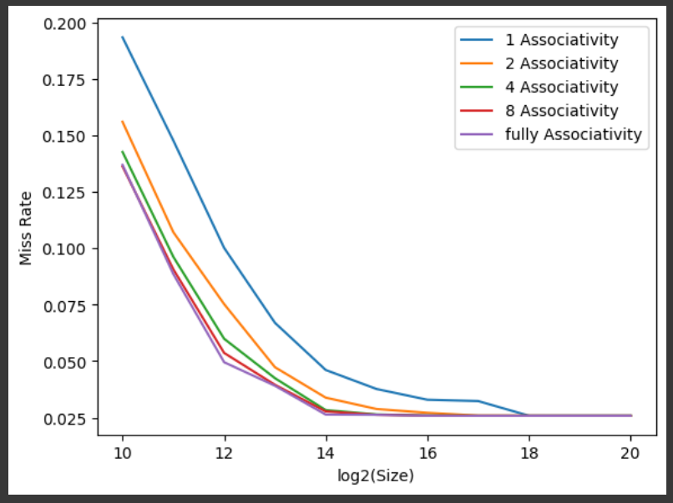

0.02582

