**Dataset: Mental Health in Tech Survey**

**Introduction:**

The dataset under consideration is derived from a 2014 survey focused on assessing attitudes toward mental health and the prevalence of mental health disorders within the technology workplace. Additionally, there is encouragement to extend the analysis to include data from an ongoing 2016 survey. The dataset encompasses diverse demographic and workplace-related variables, offering a comprehensive view of the intersection between mental health and the professional environment.

**Key Dataset Attributes:**

1. **Timestamp:**

Represents the date and time when survey responses were recorded.

1. **Demographic Information:**

* **Age and Gender:**

Provides insights into the age distribution and gender representation of survey participants.

* **Country and State:**

Specifies the geographic location of participants, enabling regional analysis.

* **Self-Employment:**

Indicates whether respondents are self-employed, a factor that may influence mental health experiences.

1. **Family and Personal History:**

* **Family History of Mental Illness:**

Explores whether individuals have a family history of mental health issues, which can contribute to personal susceptibility.

1. **Workplace Dynamics:**

* **Employment-related Factors:**

Covers aspects such as company size, remote work arrangements, and whether the employer is a tech-oriented organization.

* **Treatment and Work Interference:**

Examines whether individuals have sought treatment for mental health conditions and the perceived interference of these conditions with work.

* **Mental Health Benefits:**

Determines if employers provide mental health benefits, indicating organizational support.

* **Awareness Programs and Resources:**

Explores whether employers discuss mental health in wellness programs and provide resources for seeking help.

* **Anonymity and Consequences:**

Assesses the protection of anonymity and perceived consequences of discussing mental health with employers.

* **Leave Policies:**

Evaluates the ease with which employees can take medical leave for mental health conditions.

1. **Attitudes and Perceptions:**

* **Attitudes Towards Mental Health Discussions:**

Investigates the willingness of employees to discuss mental health issues with coworkers, supervisors, and potential employers.

* **Perceived Importance:**

Explores whether respondents believe their employers treat mental health with the same importance as physical health.

* **Observations of Consequences:**

Examines whether respondents have observed negative consequences for coworkers with mental health conditions in the workplace.

1. **Additional Comments:**

* **Comments:**

Provides an open-ended space for respondents to share additional notes or comments regarding their mental health experiences.

**Objective of Analysis:**

The primary objective is to derive actionable insights from this dataset to inform strategies for promoting mental health and well-being within the tech workplace. By exploring patterns, correlations, and influential factors, we aim to identify key areas for intervention and improvement, ultimately fostering a healthier and more supportive work environment. The dataset analysis will be conducted methodically, addressing specific business problems to yield meaningful and targeted outcomes.

**Data cleaning and wrangling**

In Google Colab, I use Python with libraries such as pandas, NumPy libraries for data manipulation and cleaning. Below are step-by-step instructions:

Step 1: Import Necessary Libraries

Step 2: Load the Dataset

Step 3: Explore the Dataset

Step 4: Handle Missing Values

Step 5: Handle Duplicates

Step 6: Convert Data Types

Step 7: Rename Columns (if necessary)

Step 8: Explore Unique Values

Step 9: Data Transformation (if necessary)

Step 10: Save the Cleaned Dataset

**Geographic Variation in Mental Health**

**Problem Statement:** Explore how the frequency of mental health issues and attitudes toward mental health vary by geographic location.

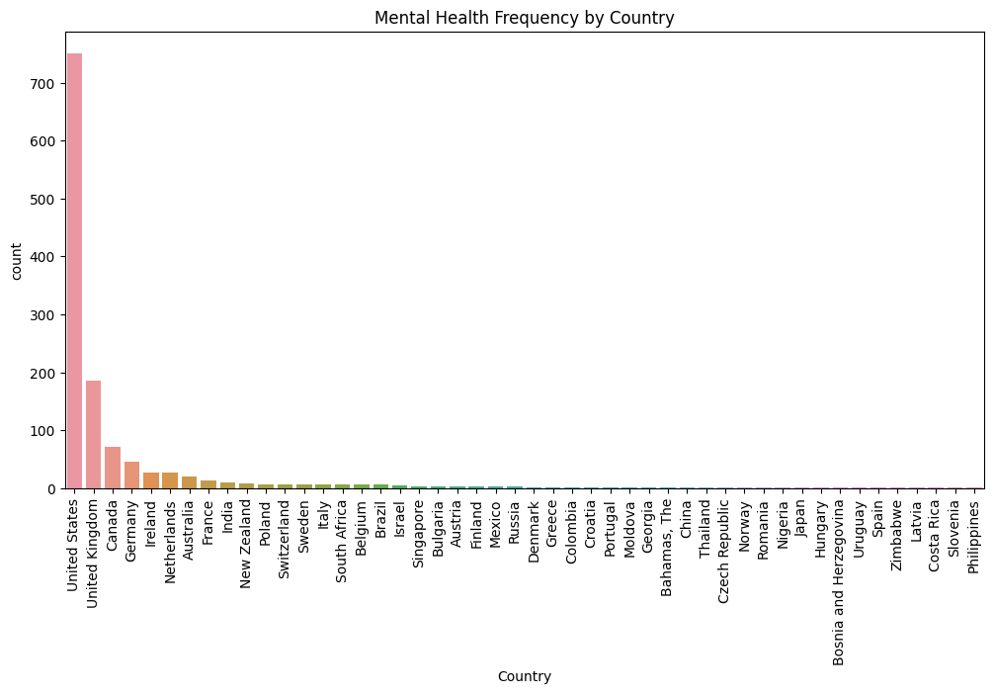**Objective:** Understand the geographic distribution of mental health-related factors in the dataset and identify any patterns or trends based on location.

**Impact of Solving this Problem:** Understanding the geographic variation in mental health can help organizations and policymakers tailor mental health programs and support based on the specific needs of different regions. It may also contribute to reducing stigma and promoting a healthier work environment globally.

**Explore attitudes towards mental health in different countries.**

**Problem Statement**: Conduct a deeper analysis to explore attitudes towards mental health in different countries.

**Objective:** Gain insights into how attitudes towards mental health vary across different countries, examining factors such as willingness to discuss mental health, perceptions of employer support, and overall mental health awareness.

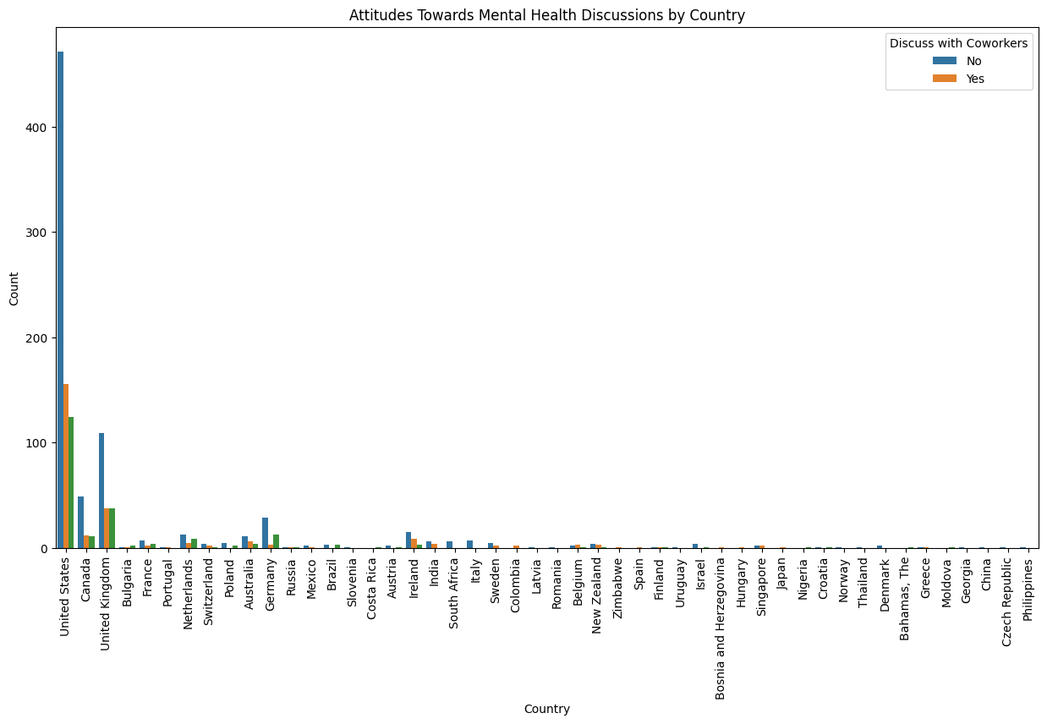

**Impact of Solving this Problem:** Understanding variations in attitudes towards mental health across countries can guide the development of targeted mental health awareness campaigns, training programs, and support systems. It may help organizations create a more inclusive and supportive workplace culture, considering the cultural nuances of different regions. Additionally, identifying areas with more stigma can lead to focused efforts to reduce mental health-related stigma.

**Conduct statistical tests to determine if the variation is significant.**

**Problem Statement:** Conduct statistical tests to determine if the variation in attitudes towards mental health across different countries is significant.

**Objective:** Quantify the significance of variations in attitudes towards mental health by performing statistical tests on relevant variables.

**Table**

|  |  |
| --- | --- |
| Chi-square value | 113.34 |
| P-value | 0.085 |

**Impact of Solving this Problem:** Identifying statistically significant variations in attitudes towards mental health provides a basis for targeted interventions. It helps in understanding whether observed differences are likely due to chance or if they reflect real disparities. This knowledge can guide the development of more effective and tailored strategies to promote mental health awareness and support, both globally and within specific regions.

**Recommendations**

Some recommendations based on the analysis of the mental health survey dataset:

* **Employee Training Programs:** Develop training programs for employees and managers on mental health awareness and support. Increased knowledge can lead to better identification and management of mental health challenges in the workplace.
* **Company Policies:** Review and update company policies to include comprehensive mental health support. Clear policies can create a supportive environment and encourage employees to seek help without fear of negative consequences.
* **Remote Work Policies:** Assess and adapt remote work policies to accommodate mental health needs. Flexible policies can improve work-life balance and reduce stress associated with commuting.
* **Anonymity and Privacy:** Strengthen measures to protect employee anonymity when accessing mental health resources. Increased privacy can boost confidence in seeking help without concerns about confidentiality.
* **Continuous Monitoring:** Implement regular mental health surveys to monitor changes and trends over time. Ongoing monitoring enables proactive measures and ensures the effectiveness of mental health programs.