**Assignment # 3**

**Problem Statement:**

Write a program that hooks 0x65 interrupt to perform the given operations.

|  |  |
| --- | --- |
| Service# | Description |
| 0x1 | Input a 16-bit decimal number from user and store in DX register. |
| 0x2 | Display a 16-bit decimal number stored in DX register on Screen. |

**Code:**  
.MODEL small

.STACK 100h

.DATA

msg1 db 'Enter the Service Number: $'

msg2 db 0Ah, 13, 'Enter a 16-bit Decimal Number: $'

msg3 db 0Ah, 13, 'Decimal Number Stored in DX is: $'

.CODE

mov ax, @data

mov ds,ax

mov ax, 0

mov es, ax

mov dx, offset msg1

mov ah, 0x9

int 21h

mov ah, 0x1

int 21h

mov ah, al

sub ah, 30h

mov dx, 1234h

cmp ah, 1

je service1

cmp ah, 2

je service2

return:

int 0x65

mov ah, 4ch

int 21h

.EXIT

service1:

mov word ptr es:[0x65*4 + 0], isrInput

mov word ptr es:[0x65*4 + 2], cs

jmp return

service2:

mov word ptr es:[0x65*4 + 0], isrOutput

mov word ptr es:[0x65*4 + 2], cs

jmp return

isrInput proc

xor dx, dx

mov dx, offset msg2

mov ah, 9h

int 21h

mov cx, 4

input_loop:

mov ah, 0x1

int 21h

sub al, 0x30

shl dx, 4

or dl, al

loop input_loop

iret

isrInput endp

isrOutput proc

push dx

mov dx, offset msg3

mov ah, 9h

int 21h

pop dx

mov ax, dx

xor dx, dx

mov cx, 1000h

div cx

add ax, 30h

call print

mov cx, 100h

div cx

add ax, 30h

call print

mov cx, 10h

div cx

add ax, 30h

call print

add ax, 30h

call print

iret

isrOutput endp

print proc

push ax

push dx

mov dl,al

mov ah,02h

int 0x21

pop ax

pop dx

xor dx, dx

ret

print endp

**Output:**

1. **Service 1:**

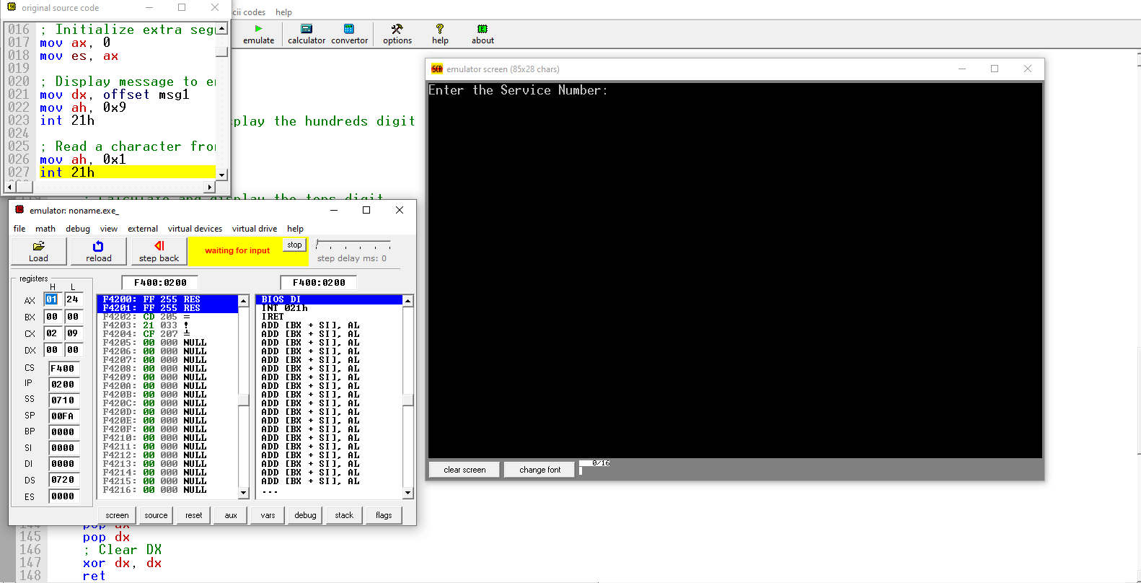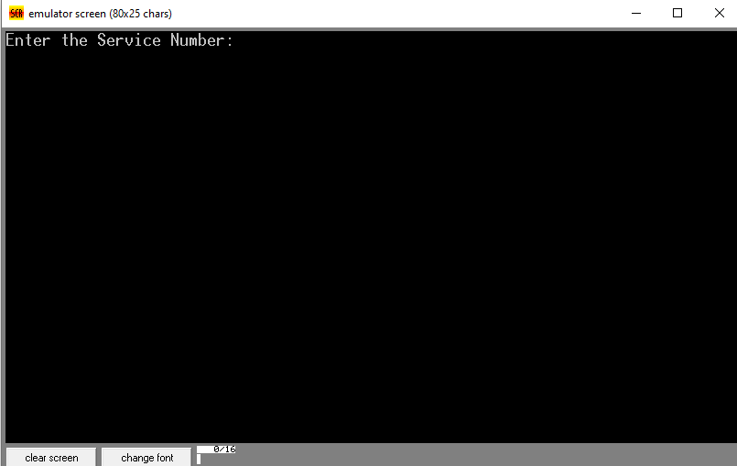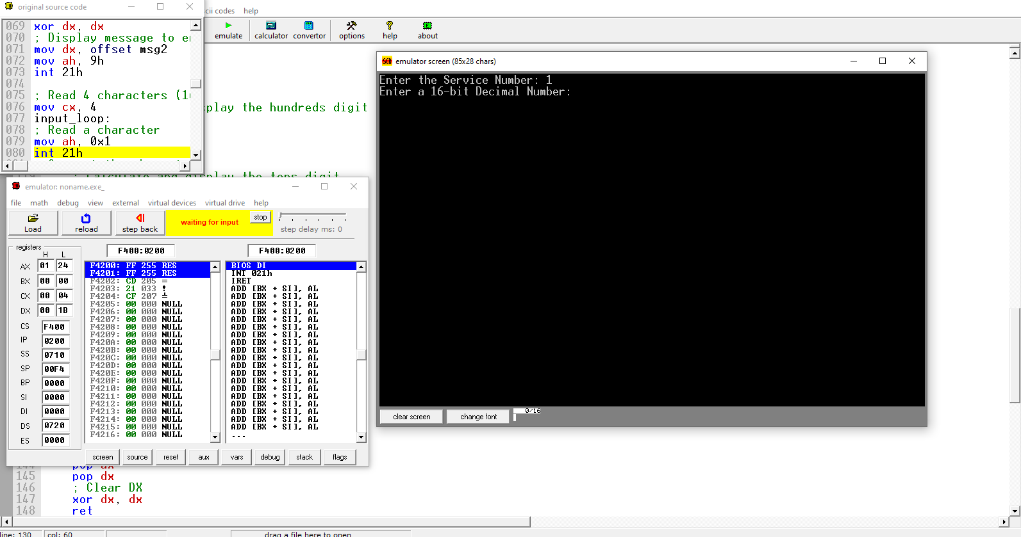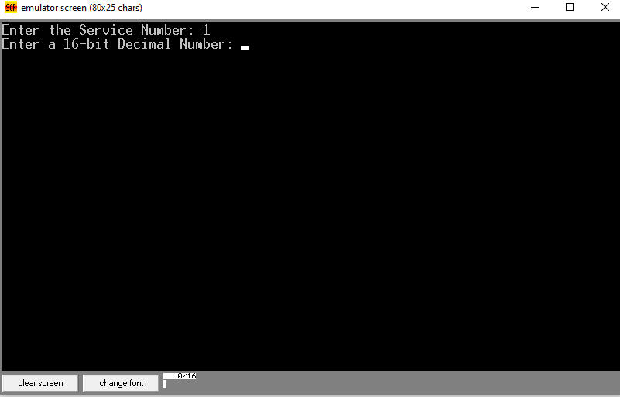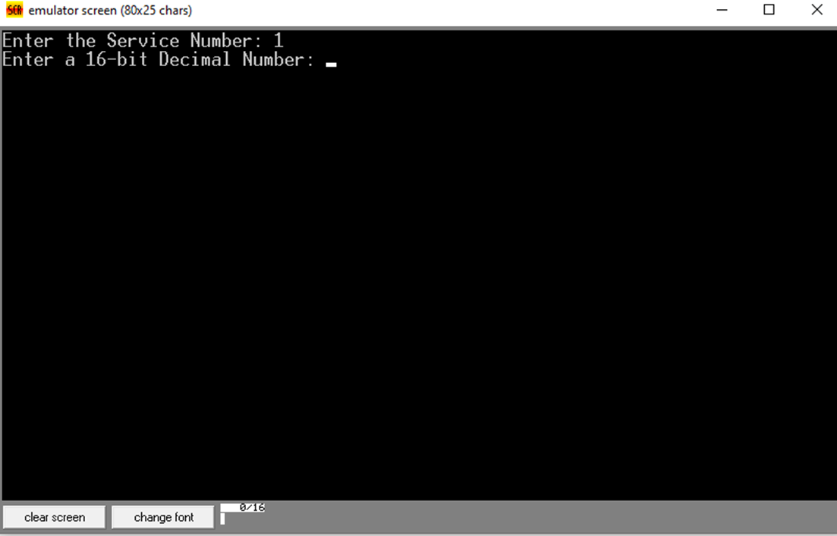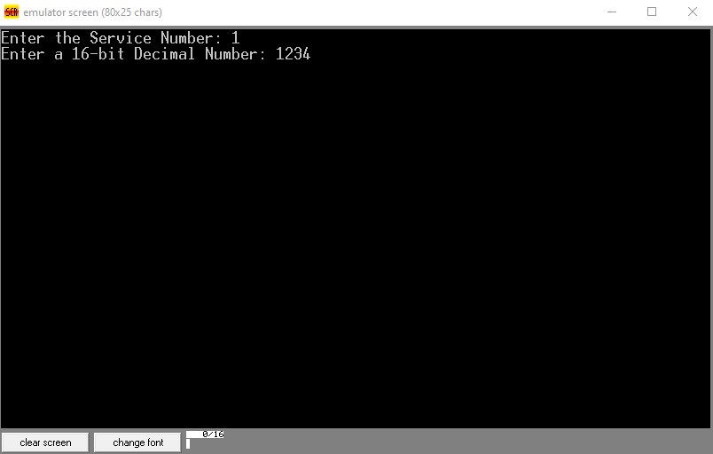

1. **Service 2:**

