**Assignment No. 2**

**University of Central Punjab**

**Faculty of Information Technology**

**Lecturer: Sir. Arshad Sarfraz**

**Multiplication by Shift-and-Add Method**

**Question:**

**Write a program that multiplies two 32-bit numbers using the shift-and-add method given below. The program will store 32-bit multiplicand and multiplier, as well as the 64-bit product in byte arrays.**

**Code:**

.model small

.stack 100h

.data

temp db 4 dup(0) ; Temporary storage for shifting

multiplicand db 0ffh, 0ffh, 0ffh, 0ffh ; Multiplicand (0xFFFFFFFF for testing)

multiplier db 87h, 65h, 43h, 21h ; Multiplier

product db 8 dup(0) ; Product result, initialized to 0

n dw 32 ; Loop counter (32 iterations)

.code

; Initialize data segment

mov ax, @data

mov ds, ax

xor ax, ax

mainloop:

; Check LSB of multiplier and add multiplicand if necessary

mov al, multiplier[3]

shr al, 1

jnc skip_addition

; Add multiplicand to product

clc

mov si, 7

mov cx, 8

addition:

mov al, temp[si]

adc product[si], al

dec si

loop addition

skip_addition:

; Shift multiplicand left

mov si, 7

mov cx, 8

clc

shift_multiplicand:

rcl temp[si], 1

dec si

loop shift_multiplicand

; Shift multiplier right

mov si, 0

mov cx, 4

clc

shift_multiplier:

rcr multiplier[si], 1

inc si

loop shift_multiplier

; Decrement counter and loop if not zero

dec n

cmp n, 0

jnz mainloop

; Terminate program

hlt

.exit

Output:

* Before Running Program:

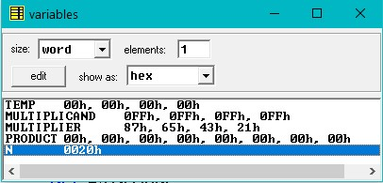

* After Running Program:

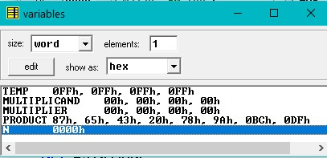

* Calculator Answer: (Product Answer is same)

