# Lab Task 1

Write a program that takes an input **N** from user and computes the Factorial of **N.** For example, if a user enters N=5, the program should display120 as output.

**Code:**

#include<iostream>

using namespace std;

// Task 1

int fact(int n) {

if (n == 0 || n == 1) {

return 1;

}

return n * fact(n - 1);

}

int main() {

int n;

cout << "Enter Number for Factorial: ";

cin >> n;

cout << "Fatcorial of " << n << " is " << fact(n) << endl;

return 0;

}

**Screenshot:**

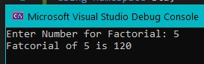

# Lab Task 2

Write a Program that take computes the sum of first **N** natural numbers. For example, if a user enters 5 as input, the program should display 15 as output (since 5+4+3+2+1 = 15).

**Code:**

#include<iostream>

using namespace std;

int naturalSum(int n) {

if (n == 1) {

return n;

}

return n + naturalSum(n - 1);

}

int main() {

int n;

cout << "Enter Number for Sum of Natural Numbers: ";

cin >> n;

cout << "Natural Sum of " << n << " is " << naturalSum(n) << endl;

return 0;

}

**Screenshot:**

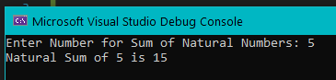

# Lab Task 3

Write a program that takes a string (or char *) as input from user. Write a program to reverse the input string. For example, if a user enters “Pakistan”, your program should display “natsikaP”.

**Code:**

#include <iostream>

using namespace std;

void reverse(char* str, int index)

{

if (str[index] == '\0')

{

return;

}

char temp = str[index];

reverse(str, index + 1);

cout << temp;

}

int main()

{

char a[50];

cout << "Enter the String to Reverse: ";

cin >> a;

cout << "Reversed String is: ";

reverse(a, 0);

return 0;

}

**Screenshot:**

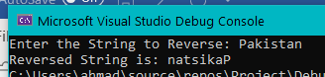

# Lab Task 4

The least common multiple (LCM) of two numbers is the smallest number that is a multiple of both. Write and test a method LCM with the following specification.

PARAMETERS: positive integers j and k

RETURN VALUE: the least common multiple (LCM) of j and k

EXAMPLES: LCM (3, 5) is 15   
 LCM (6, 8) is 24

**Code:**

#include <iostream>

using namespace std;

int hcf(int a, int b)

{

if (b == 0) {

return a;

}

return hcf(b, a % b);

}

int lcm(int a, int b)

{

return (a / hcf(a, b)) * b;

}

int main()

{

int i, j;

cout << "Enter the Value of 'i': ";

cin >> i;

cout << "Enter the Value of 'j': ";

cin >> j;

cout << "LCM of " << i << " and "

<< j << " is " << lcm(i, j);

return 0;

}

**Screenshot:**

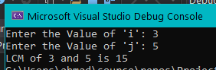

# Lab Task 5

Write a recursive code that returns the sum of digits of an input number N. For example, if the input number is 264, the value returned must be 12 (since 2+6+4 = 12).

**Code:**

#include<iostream>

using namespace std;

int sumofDigits(int n) {

if (n == 0) {

return 0;

}

int temp = n % 10;

return temp + sumofDigits(n / 10);

}

int main()

{

int n;

cout << "Enter a Number to get Sum of Digits: ";

cin >> n;

cout << "Sum of Digits is: " << sumofDigits(n) << endl;

return 0;

}

**Screenshot:**

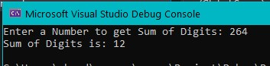

# Lab Task 6

Write a recursive code that gets a filled integer array and size of that array as input to a value returning function and returns the sum of the values stored in it. Understanding this code is a part of the lab task, therefore, no example is being provided. Hint:

Function prototype would be: **int sumElements (int *arr, int N)** where N is size of the array.

**Code:**

#include<iostream>

using namespace std;

int sumElements(int* arr, int N) {

if (N == 0) {

return 0;

}

int temp = arr[N-1];

return temp + sumElements(arr, N-1);

}

int main()

{

int n[5];

cout << "Enter the 5 Elements of Array: ";

for (int a = 0; a < 5; a++) {

cin >> n[a];

}

cout << "Sum of Array Elements is: " << sumElements(n, 5) << endl;

return 0;

}

**Screenshot:**

