**Home Task**

**University of Central Punjab**

**Faculty of Information Technology**

**Spring 2023 – 20/Mar/2023**

**Lecturer: Mam. Hina Tahir**

**Name: Muhammad Ahmad**

**Roll No.: L1F22BSCS0634**

**Section: B12**

**2-D Arrays**

1. **Code to Find Max No. in Each Row of 2-D Array:**

**#include<iostream>**

**using namespace std;**

**int main()**

**{**

**//Decleration and Initialization**

**int array[3][4],rmax;**

**//input of Array from user**

**cout<<"Enter the Values of Array: ";**

**for(int a=0;a<4;a++){**

**for(int b=0;b<4;b++){**

**cin>>array[a][b];**

**}**

**}**

**//Loops to find and print the max No. in each row**

**for(int a=0;a<4;a++){**

**rmax=array[a][0];**

**for(int b=0;b<4;b++){**

**if(array[a][b]>rmax){**

**rmax=array[a][b];**

**}**

**}**

**cout<<"Max Value of Row No. "<<a+1<<" is: "<<rmax<<endl;**

**}**

**return 0;**

**}**

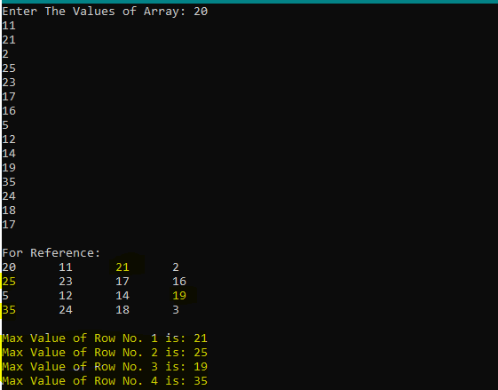**Output:**

1. **Code to Find Max No. in Each Column of 2-D Array:**

**#include<iostream>**

**using namespace std;**

**int main() {**

**//Declaration and Initialization**

**int array[3][4], cmax;**

**//Input of Array from user**

**cout << "Enter The Values of Array: ";**

**for (int a = 0; a < 4; a++) {**

**for (int b = 0; b < 4; b++) {**

**cin >> array[a][b];**

**}**

**}**

**//Loops to find and print the max No. in each column**

**for (int a = 0; a < 4; a++) {**

**cmax = array[0][a];**

**for (int b = 0; b < 4; b++) {**

**if (array[b][a] > cmax) {**

**cmax = array[b][a];**

**}**

**}**

**cout << "Max Value of Column No. " << a + 1 << " is: " << cmax << endl;**

**}**

**return 0;**

**}**

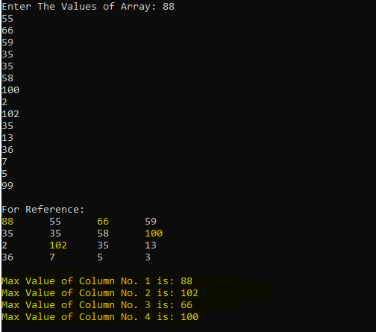**Output:**