**PF Lab no. 2**

**University of Central Punjab**

**Faculty of Information Technology**

**Spring 2023 – 21/Mar/2023**

**Lecturer: Hafiz Bilal Shahid**

**Name: Muhammad Ahmad**

**Roll No.: L1F22BSCS0634**

**Section: B12**

* **Task no. 1: -**

**C++ program to write number 1 to 100 in a data file NOTES.TXT**

**#include<iostream>**

**using namespace std;**

**int main()**

**{**

**// Creating file for storing numbers**

**ofstream file1("NOTES.txt");**

**if(!file1.is_open()){**

**cout<<"File is not created!..... :("<<endl;**

**}**

**else{**

**// Loop to save numbers from 1 to 100**

**for (int a = 1; a <= 100; a++) {**

**file1 << a << endl;**

**cout<<a<<endl;**

**}**

**// Closing the file**

**file1.close();**

**}**

**return 0;**

**}**

**Output:**

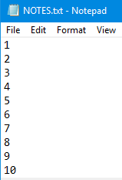

* **Task no. 2: -**

**C++ program that reads and displays the data on console.**

**#include<iostream>**

**using namespace std;**

**int main() {**

**ifstream file("Student.txt");**

**if (!file.is_open()) {**

**cout << "File is not opened!...... :(" << endl;**

**}**

**else {**

**// Declaration and initialization**

**char name[20], email[40], program[30];**

**int roll_no,reg_no;**

**// Loop to read and output the data on console**

**for (int a = 0; a<3;a++) {**

**// Using getline functions**

**file.getline(name,20,' ');**

**file >> roll_no;**

**file.ignore();**

**file.getline(email, 30, ' ');**

**file.getline(program, 30,' ');**

**file>> reg_no;**

**// Output of data on console**

**cout << name << " " << roll_no << " " << email<<" "<<program<<" " <<reg_no<< endl;**

**}**

**return 0;**

**}**

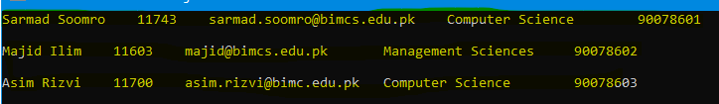**Output:**

* **Task no. 3: -**

**C++ program in which Ask user to enter file name on console and store some character line in new file, and after that, save those details into a file: -**

**#include<iostream>**

**using namespace std;**

**int main() {**

**char file_name[20],line[100],repeat;**

**// Taking input of file name**

**cout << "Enter file Name: ";**

**cin >> file_name;**

**cin.ignore();**

**// Creating File**

**fstream file1(file_name,ios::out);**

**if (!file1.is_open()) {**

**cout << "File is not created!.... :(" << endl;**

**}**

**// Taking input of line to store**

**cout << "Enter a line to store in file: ";**

**cin.getline(line,100);**

**// Printing line on text file**

**file1 << line;**

**cout << "\n\nThe information you entered was successfully saved!... :)" << endl;**

**file1.close();**

**// Asking user to read the file or not**

**cout <<endl<< "Do you want to read the file\"" << file_name << "\"? (y/n): ";**

**cin >> repeat;**

**// Condition for reading the line**

**if (repeat == 'y' || repeat == 'Y') {**

**file1.open(file_name, ios::in);**

**if (!file1.is_open()) {**

**cout << "File is not found!..... :(" << endl;**

**}**

**else {**

**file1.getline(line, 100);**

**cout << line << endl;**

**file1.close();**

**}**

**}**

**return 0;**

**}**

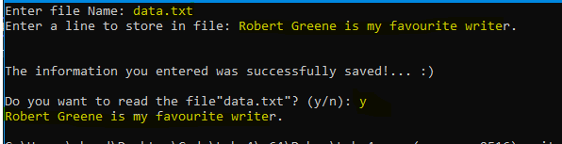**Output: -**

* **Task no. 4: -**

**C++ code in which update your text data in file.**

**#include<iostream>**

**using namespace std;**

**int main() {**

**// Declaration**

**char name[50], program[20], id1[10];**

**//Part 1**

**fstream file1("Data.txt", ios::out|ios::trunc);**

**// Taking input of data of students**

**cout << "Enter Name: ";**

**cin.getline(name, 50);**

**cout << "Enter ID: ";**

**cin.getline(id1, 10);**

**cout << "Enter Program: ";**

**cin >> program;**

**file1 << "Name1: " << name << endl;**

**file1 << "ID: " << id1 << endl;**

**file1 << "Program: " << program << endl;**

**file1.close();**

**cout << endl;**

**cin.ignore();**

**//Part 2**

**fstream file2("Data.txt", ios::out | ios::app);**

**// Again same method is used**

**if(file2.is_open()){**

**cout << "Enter Name 2: ";**

**cin.getline(name, 50);**

**cout << "Enter ID: ";**

**cin.getline(id1, 10);**

**cout << "Enter Program: ";**

**cin >> program;**

**file2 << "\nName2: " << name << endl;**

**file2 << "ID: " << id1 << endl;**

**file2 << "Program: " << program << endl;**

**file2.close();**

**}**

**else{**

**cout<<"File is not founded!...."<<endl;**

**}**

**return 0;**

**}**

**Output: -**

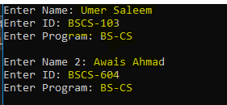

* **Task no. 5: -**
* **Write only those integers to the “sample.txt” file which are greater than 12 using file handling.**

**#include<iostream>**

**using namespace std;**

**int main() {**

**// Declaring Array to take input from user**

**int arr[6];**

**// Making file to store results**

**ofstream file("sample.txt");**

**cout << "Please Enter the '6' integers: ";**

**// Loop to takin input and check the condition at same time**

**for (int a = 0; a < 6; a++) {**

**cin >> arr[a];**

**// Printing on file if condition is true**

**if (arr[a] > 12) {**

**file << arr[a] << " ";**

**}**

**}**

**//Closing file**

**file.close();**

**return 0;**

**}**

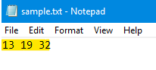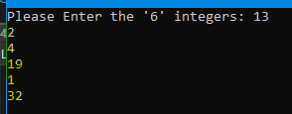**Output: -**