**PF Lab no. 1**

**University of Central Punjab**

**Faculty of Information Technology**

**Spring 2023 – 14/Mar/2023**

**Lecturer: Hafiz Bilal Shahid**

**Name: Muhammad Ahmad**

**Roll No.: L1F22BSCS0634**

**Section: B12**

* **Task no. 1: -**

**Union of Sets or Two Arrays:**

**#include<iostream>**

**using namespace std;**

**int main()**

**{**

**cout<<"\t\tUnion of Two Arrays"<<endl<<endl;**

**//intitialization and declaration**

**int arr1[4], arr2[4],unio[8],b=4;**

**//input of Array 1**

**cout << "Enter the Elements of Array 1 (4): ";**

**for (int a = 0; a < 4; a++){**

**cin >> arr1[a];**

**}**

**//input of Array 2**

**cout << "Enter the Elements of Array 2 (4): ";**

**for (int a = 0; a < 4; a++){**

**cin >> arr2[a];**

**}**

**//loop for union of Array 1 and 2**

**for (int a = 0; a < 4; a++){**

**unio[a] = arr1[a];**

**unio[b] = arr2[a];**

**b++;**

**}**

**//output of union**

**cout << "Union of Array 1 and Array 2 is: ";**

**for (int a = 0; a < 8; a++){**

**cout << unio[a] << " ";**

**}**

**cout << endl;**

**return 0;**

**}**

**Output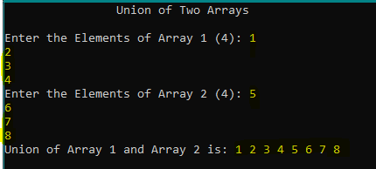:**

* **Task no. 2: -**

**Intersection of Sets or two Arrays:**

**#include<iostream>**

**using namespace std;**

**int main() {**

**cout<<"\t\tIntersection of Two Arrays"<<endl<<endl;**

**//Initialization and declaration**

**int arr1[5], arr2[5],inter[10],count=0;**

**//Input of array 1**

**cout << "Enter the Elements of Array 1 (5): ";**

**for (int a = 0; a < 5; a++){**

**cin >> arr1[a];**

**}**

**//Input of array 2**

**cout << "Enter the Elements of Array 2 (5): ";**

**for (int a = 0; a < 5; a++){**

**cin >> arr2[a];**

**}**

**//Loop to find intersection of two arrays**

**for (int a = 0; a < 5; a++){**

**for (int b = 0; b < 5; b++){**

**if (arr1[a] == arr2[b]){**

**inter[count] = arr1[a];**

**count++;**

**}**

**}**

**}**

**//Output of intersection**

**cout<<"Intersection of Array 1 and 2 is: ";**

**for (int a = 0; a < count; a++){**

**cout << inter[a] << " ";**

**}**

**return 0;**

**}**

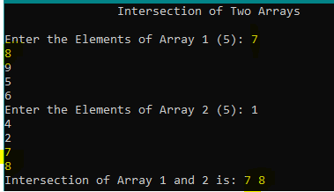**Output:**

* **Task no. 3: -**

**Difference of Sets or two Arrays: -**

**#include<iostream>**

**using namespace std;**

**int main() {**

**cout<<"\t\tDifference of Two Arrays"<<endl<<endl;**

**//initialization and declaration**

**int arr1[5], arr2[5],diff[10],dif=0;**

**//input of array 1**

**cout << "Enter the Elements of Array 1 (5): ";**

**for (int a = 0; a < 5; a++){**

**cin >> arr1[a];**

**}**

**//input of array 2**

**cout << "Enter the Elements of Array 2 (5): ";**

**for (int a = 0; a < 5; a++){**

**cin >> arr2[a];**

**}**

**//Loop 1 to calculate the difference**

**for (int a = 0; a < 5; a++){**

**int check=0;**

**for (int b = 0; b < 5; b++){**

**if (arr1[a] != arr2[b]){**

**check++;**

**}**

**if (check == 5){**

**diff[dif] = arr1[a];**

**dif++;**

**}**

**}**

**}**

**//Loop 2 to calculate the difference**

**for (int a = 0; a < 5; a++){**

**int check = 0;**

**for (int b = 0; b < 5; b++){**

**if (arr2[a] != arr1[b]){**

**check++;**

**}**

**if (check == 5){**

**diff[dif] = arr2[a];**

**dif++;**

**}**

**}**

**}**

**//output the difference**

**cout << "Difference of Both Sets are: ";**

**for (int a = 0; a < dif; a++){**

**cout << diff[a] << " ";**

**}**

**return 0;**

**}**

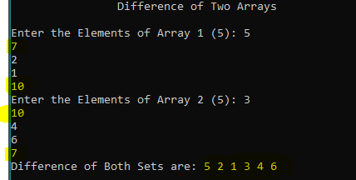**Output: -**

* **Task no. 4: -**

**Compliment of Set: -**

**#include<iostream>**

**using namespace std;**

**int main() {**

**cout<<"\t\tCompliment of Arrays"<<endl<<endl;**

**//Initialization and declaration**

**int arr1[5], uni[10] = {1,2,3,4,5,6,7,8,9,10}, common[5],comp[10],size=0;**

**//Output of universal set for user**

**cout<<"Universal Set: { ";**

**for(int a=0;a<10;a++){**

**cout<<uni[a]<<" ";**

**}**

**cout<<" }"<<endl;**

**//Input of array from user**

**cout << "Enter the Elements of Array 1 (5): ";**

**for (int a = 0; a < 5; a++){**

**cin >> arr1[a];**

**}**

**//Loop to find common b/w array and universal set**

**int place = 0;**

**for (int a = 0; a < 5; a++){**

**for (int b = 0; b < 10; b++){**

**if (arr1[a] == uni[b]){**

**common[place] = arr1[a];**

**place++;**

**}**

**}**

**}**

**//By using the previous common array, finding compliment**

**for (int a = 0; a < 10; a++){**

**int check = 0;**

**for (int b = 0; b <place; b++){**

**if (uni[a] != common[b]){**

**check++;**

**}**

**if (check == place){**

**comp[size] = uni[a];**

**size++;**

**}**

**}**

**}**

**//Output of end result which is compliment of set**

**cout << "Compliment of entered Set is: ";**

**for (int a = 0; a < size; a++){**

**cout << comp[a] << " ";**

**}**

**return 0;**

**}**

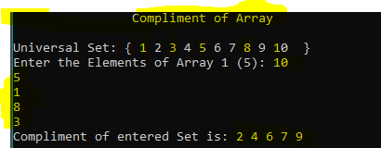**Output: -**