**PF Lab no. 2**

**University of Central Punjab**

**Faculty of Information Technology**

**Spring 2023 – 21/Mar/2023**

**Lecturer: Hafiz Bilal Shahid**

**Name: Muhammad Ahmad**

**Roll No.: L1F22BSCS0634**

**Section: B12**

* **Task no. 1: -**

**Sum of all elements in Array:**

**#include<iostream>**

**using namespace std;**

**int main()**

**{**

**cout<<"\t\t\tSum of Array"<<endl<<endl;**

**//Declaration and Initialization**

**int arr[10],sum=0;**

**cout << "Enter the Values of Array (10): ";**

**for (int a = 0; a < 10; a++) {**

**cin >> arr[a];**

**}**

**//loop for calculating sum**

**for (int a = 0; a < 10; a++){**

**sum =sum+ arr[a];**

**}**

**//Output of sum**

**cout << "The Sum of all elements in Array are: " << sum << endl;**

**return 0;**

**}**

**Output:**

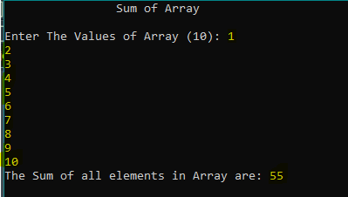

* **Task no. 2: -**

**Word Searching Algorithm:**

**#include<iostream>**

**using namespace std;**

**int main() {**

**cout<<"\t\tWord Searching"<<endl<<endl;**

**//initialization and declaration**

**string input;**

**string arr[10] = {"car","bike","conpiracy","computer","progamming","visual","holistic","bait","robert","computer"};**

**//Input from user to find**

**cout << "Please Enter the word to find: ";**

**cin >> input;**

**//Loop for searching word**

**int count = 0;**

**for (int a = 0; a < 100; a++) {**

**if (input == arr[a]) {**

**count++;**

**}**

**}**

**if (count > 0) {**

**cout << "Word '" << input << "' is present: " << count << " times" << endl;**

**}**

**else**

**{**

**cout << "The word " << input << " is not present" << endl;**

**}**

**return 0;**

**}**

**Output:**

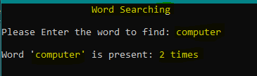

* **Task no. 3: -**

**UBER Stars Problem: -**

**#include<iostream>**

**using namespace std;**

**int main() {**

**cout<<"\t\tUber Rating"<<endl<<endl;**

**//initialization and declaration**

**int rating[10];**

**string names[10]={"Ali","Abdullah","Haris","David","Philips","Ahmad","Azeem","Umair","Muneeb","Zaid",};**

**//input from user of every rider with name**

**for (int a = 0; a < 10; a++) {**

**cout << "Enter Rating of "<<names[a]<<" (1-5): ";**

**cin >> rating[a];**

**if (rating[a] < 1 || rating[a]>5) {**

**cout << "Invalid Value!" << endl;**

**cout << "Please Again Enter Rating of "<<names[a]<<" (1-5): ";**

**cin >> rating[a];**

**}**

**}**

**//output of ratings**

**cout << "Data of Ratings: ";**

**for (int a = 0; a < 10; a++) {**

**cout << rating[a] <<" ";**

**}**

**cout << endl;**

**return 0;**

**}**

**Output: -**

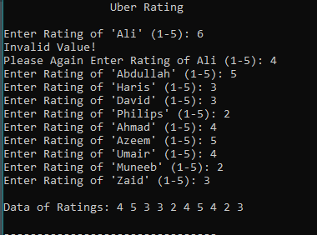

* **Task no. 4: -**

**Grade Analysis Problem: -**

**#include<iostream>**

**using namespace std;**

**int main() {**

**cout << "\t\t\tGrades Analysis of ITC" << endl<<endl;**

**//initialization and declaration**

**char grades[10];**

**int countA = 0, countB = 0, countC = 0, countD = 0, countF = 0;**

**//input from user of grades according to roll no.**

**for (int a = 0; a < 10; a++) {**

**cout << "Enter The Grade of Roll No. " << a + 1 << ": ";**

**cin >> grades[a];**

**if (grades[a] == 'A') {**

**countA++;**

**}**

**else if (grades[a] == 'B') {**

**countB++;**

**}**

**else if (grades[a] == 'C') {**

**countC++;**

**}**

**else if (grades[a] == 'D') {**

**countD++;**

**}**

**else if (grades[a] == 'F') {**

**countF++;**

**}**

**}**

**//output of each grade count**

**cout << "\nCount of Grades are: " << endl;**

**cout<< "A: " << countA << ", B: " << countB << ", C: " << countC << ", D: " << countD << ", F: " << countF << endl;**

**return 0;**

**}**

**Output: -**

