**PF Lab no. 7**

**University of Central Punjab**

**Faculty of Information Technology**

**Spring 2023**

**Lecturer: Hafiz Bilal Shahid**

**Name: Muhammad Ahmad**

**Roll No.: L1F22BSCS0634**

**Section: B12**

* **Task no. 1: -**

**Write C++ code for print given below array with the help of pointer.**

**#include<iostream>**

**using namespace std;**

**// Input Function to take values from user**

**void input(int arr_f[], int size_f) {**

**cout << "Enter the Values: ";**

**for (int a = 0; a < size_f; a++) {**

**cin >> arr_f[a];**

**}**

**}**

**// Print Function to print values of array by pointer array**

**void print(int* arr_ptr,int size_f) {**

**cout << "Array: ";**

**for (int a = 0; a < size_f; a++) {**

**cout << arr_ptr[a]<<" ";**

**}**

**}**

**int main()**

**{**

**// Declaring Array and it's Size**

**const int size = 6;**

**int arr[size];**

**// Calling Function of input and print**

**input(arr,size);**

**print(arr,size);**

**return 0;**

**}**

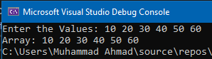**Output:**

* **Task no. 2: -**

**C++ function that only takes pointers to two integer variables as parameters and swaps the contents in those variables using the above pointers and without creating any extra variables or pointers The swapped values are displayed from the main():**

**#include<iostream>**

**using namespace std;**

**// Function to swap values without any new variable**

**void swap_it(int* n1, int* n2) {**

**\*n1 = *n1 + *n2;**

**\*n2 = *n1 - *n2;**

**\*n1 = *n1 - *n2;**

**}**

**int main()**

**{**

**int num1, num2;**

**cout << "Enter 1st Value: ";**

**cin >> num1;**

**cout << "Enter 2nd Value: ";**

**cin >> num2;**

**// Printing Values before swap**

**cout << "Before Swap: \nFirst Value= " << num1 << " Second Value= " << num2 << endl;**

**// Calling the Swap function**

**swap_it(&num1, &num2);**

**// Printing Values after swap**

**cout << "After Swap: \nFirst Value= " << num1 << " Second Value= " << num2 << endl;**

**return 0;**

**}**

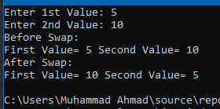**Output:**

* **Task no. 3: -**

**C++ program that only take radius as input and calculate area of circle using pointers and function. The function accept parameter as pointer and calculate the Area and Area should display from the main ():**

**#include<iostream>**

**using namespace std;**

**// Function to calculate the area**

**void calculate_area(float* radius_f,float*area_f) {**

**\*area_f = (*radius_f) * (*radius_f) * 3.14;**

**}**

**int main()**

**{**

**float radius,area;**

**// Taking input of radius from user**

**cout << "Enter Radius of Circle: ";**

**cin >> radius;**

**// Calling function to calculate area**

**calculate_area(&radius,&area);**

**// Printing Area of Circle according to input of user**

**cout << "Area of Circle is: " << area <<" Square Meter"<< endl;**

**return 0;**

**}**

**Output: -**

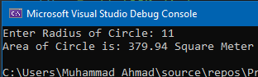

* **Task no. 4: -**

**Function that takes pointers to variables as parameters and calculate the specified operation (+, -, *, /, %). The return type of each function must be void and result should display from the main ():**

**#include<iostream>**

**using namespace std;**

**// All the functions for different arithmetic operations**

**void addition(int n1, int n2, int* ans) {**

**\*ans = n1 + n2;**

**}**

**void difference(int n1, int n2, int* ans) {**

**\*ans = n1 - n2;**

**}**

**void multiply(int n1, int n2, int* ans) {**

**\*ans = n1 * n2;**

**}**

**void divide(int n1, int n2, int* ans) {**

**\*ans = n1 / n2;**

**}**

**void remainder(int n1, int n2, int* ans) {**

**\*ans = n1 % n2;**

**}**

**// Function caller, it will decide which function to call**

**// according to the input**

**void func_caller(char operation_f, int n1, int n2, int* ans) {**

**if (operation_f == '+') {**

**addition(n1, n2, ans);**

**}**

**if (operation_f == '-') {**

**difference(n1, n2, ans);**

**}**

**if (operation_f == '*') {**

**multiply(n1, n2,ans);**

**}**

**if (operation_f == '/') {**

**divide(n1, n2, ans);**

**}**

**if (operation_f == '%') {**

**remainder(n1, n2, ans);**

**}**

**}**

**int main()**

**{**

**int num1, num2,answer;**

**char operation;**

**// Taking input from the user**

**cout << "Enter 1st Number: ";**

**cin >> num1;**

**cout << "Enter 2nd Number: ";**

**cin >> num2;**

**cout << "Enter Operation(+ , - , * , / , % ): ";**

**cin >> operation;**

**// Calling function to do the operaton according to input**

**func_caller(operation, num1, num2, &answer);**

**// Printing the results**

**cout << "Result: " << num1 << " " << operation << " " << num2 << " = " << answer << endl;**

**return 0;**

**}**

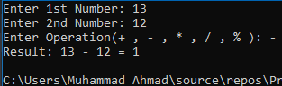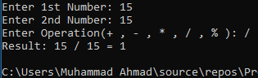**Output: -**

* **Task no. 5: -**

**Program to calculate the Fahrenheit to Celsius using Dynamic Memory: -**

**#include<iostream>**

**using namespace std;**

**// Function to calculate the temperature from 'F' to 'C'**

**int* temp(int* fptr) {**

**\*fptr = ((*fptr - 32) * 5) / 9;**

**return fptr;**

**}**

**int main()**

**{**

**int* temperature = NULL;**

**temperature = new int;**

**// Taking input of temp in Fahrenheit**

**cout << "Enter Temperature in Fahrenheit: ";**

**cin >> *temperature;**

**// Calling pointer returning function**

**temperature = temp(temperature);**

**// Printing temp in Celsius**

**cout << "Temperature in Celsius: " << *temperature << " Celsius" << endl;**

**// Deallocating the temperature pointer memory**

**delete temperature;**

**return 0;**

**}**

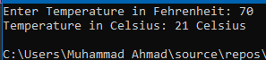**Output: -**

* **Task no. 6: -**

**Program to store GPA of n number of students using memory allocation and display it where n is the number of students entered by the user:**

**#include<iostream>**

**using namespace std;**

**// Funtion to allocate the dynamic memory according to given size**

**float* dynamic_memory(float* arr,int size_f) {**

**arr = new float[size_f];**

**return arr;**

**}**

**// Function to take input of GPA of each student**

**void input(float* arr,int size_f) {**

**cout << "Enter GPA of Students: " << endl;**

**for (int a = 0; a < size_f; a++) {**

**cout << "Student no. " << a + 1<<": ";**

**cin >> arr[a];**

**}**

**}**

**// Function to display the GPA of students**

**void output(float* arr, int size_f) {**

**cout << "\nDisplaying GPA of Students: " << endl;**

**for (int a = 0; a < size_f; a++) {**

**cout << "Student no. " << a + 1 << ": " << arr[a] << endl;**

**}**

**}**

**int main()**

**{**

**float * array = NULL;**

**int size;**

**// Taking size to allocate the dynamic memory**

**cout << "Enter Total Number of Students: ";**

**cin >> size;**

**// Allocating dynamic memory through function**

**array=dynamic_memory(array, size);**

**// Calling input and output function**

**input(array, size);**

**output(array, size);**

**// Deallocating the array pointer memory**

**delete[] array;**

**return 0;**

**}**

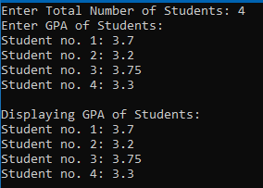**Output: -**

* **Task no. 7: -**

**Program that reads data from user input until -99. Store the data in dynamic array. Then find the second largest number in the array:**

**#include<iostream>**

**using namespace std;**

**// Function to regrow the size of dynamic array**

**int* dynamic_memory(int* oldarray, int size_f) {**

**int* newarray = NULL;**

**newarray = new int[size_f];**

**for (int a = 0; a < size_f; a++) {**

**newarray[a] = oldarray[a];**

**}**

**delete[] oldarray;**

**return newarray;**

**}**

**// Function to find the second largest number in array**

**int second_large(int* array, int size_f) {**

**int max = array[0], sec_max=array[0];**

**for (int a = 0; a < size_f;a++) {**

**if (array[a] > max) {**

**sec_max = max;**

**max = array[a];**

**}**

**}**

**return sec_max;**

**}**

**int main()**

**{**

**int* arr = NULL;**

**int size = 0,num=0,sec_large;**

**arr = new int[size];**

**// Taking input from user until -99**

**cout << "Enter Numbers: ";**

**for (int a = 0; num != -99; a++) {**

**cin >> num;**

**if (num != -99) {**

**size++;**

**// Calling function to regrow the size of dynamic array**

**arr = dynamic_memory(arr, size);**

**arr[a] = num;**

**}**

**}**

**// Calling function to find second largest number**

**sec_large = second_large(arr,size);**

**cout << "Second Largest Number is: " << sec_large << endl;**

**// Deallocating Array memory**

**delete[] arr;**

**return 0;**

**}**

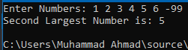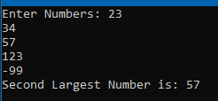**Output: -**

* **Task no. 8: -**

**Program to find the average of students in n number of labs using dynamic memory:**

**#include<iostream>**

**using namespace std;**

**// Function to allocate the dynamic memory according to input**

**int* dynamic_mem(int size_f) {**

**int* array = NULL;**

**array = new int[size_f];**

**return array;**

**}**

**// Function to take input from user**

**void input(int* array, int size_f) {**

**for (int a = 0; a < size_f; a++) {**

**cout << "Enter Total Number of Students in Lab " << a + 1 << ": ";**

**cin >> array[a];**

**}**

**}**

**// To find the average students of all the labs**

**int average_students(int* array, int size_f) {**

**int avg = 0;**

**for (int a = 0; a < size_f; a++) {**

**avg += array[a];**

**}**

**avg /= size_f;**

**return avg;**

**}**

**int main()**

**{**

**int* arr = NULL;**

**int size, average;**

**// Taking size from user**

**cout << "Enter the Number of Labs in University: ";**

**cin >> size;**

**// Allocating memory according to given size by dynamic_mem function**

**arr = dynamic_mem(size);**

**// Taking input from user by calling the input function**

**input(arr, size);**

**// Storing average calculated by average_students function**

**average = average_students(arr, size);**

**// Printing the average on console**

**cout << "Average Number of Students in Lab are: " << average << endl;**

**return 0;**

**}**

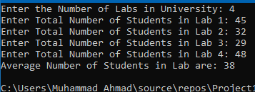**Output: -**