**Graded Lab no. 2**

**University of Central Punjab**

**Faculty of Information Technology**

**Spring 2023 – 02/May/2023**

**Lecturer: Hafiz Bilal Shahid**

**Name: Muhammad Ahmad**

**Roll No.: L1F22BSCS0634**

**Section: B12**

* **Task no. Even: -**

**Search through the array, and count the number of times the item is found:**

**#include<iostream>**

**using namespace std;**

**// Function to find the number in array**

**void search(int arr_f[], int num, int size_f) {**

**int count = 0;**

**for (int a = 0; a < size_f; a++) {**

**if (arr_f[a] == num) {**

**count++;**

**}**

**}**

**// Condition using count to print the result**

**if (count > 0) {**

**cout << "The number " << num << " is present " << count << " times in the array." << endl;**

**}**

**else {**

**cout << "The number " << num << " is not Present in the array." << endl;**

**}**

**}**

**int main()**

**{**

**// Declaring array, input and constant variable for size**

**const int size = 10;**

**int arr[size],input;**

**// Taking input of array numbers from user**

**cout << "Enter The Values of Array: ";**

**for (int a = 0; a < size; a++) {**

**cin >> arr[a];**

**}**

**// Printing the array on console**

**cout << "Input Array: ";**

**for (int a = 0; a < size; a++) {**

**cout << arr[a] << " ";**

**}**

**cout << endl;**

**// Taking input of number from user to search**

**cout << "Enter the No. to Search: ";**

**cin >> input;**

**// Calling function to search the number in array**

**// it will print the respective result**

**search(arr, input, size);**

**return 0;**

**}**

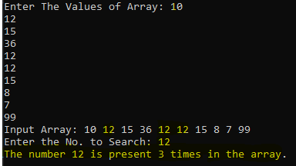**Output:**

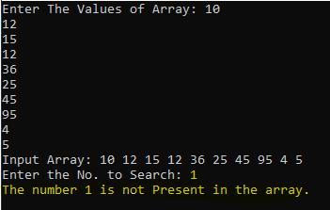**Case 2:**