

**Object Oriented Programming**

**Project Report**

**Project Name: Real Estate Management**

**NAME : Muhammad Ahmed**

**ID: 13460**

**Semester: 3rd**

**Department: Computer Science**

**Instructor: Maam Ghazala Shafi**

**Introduction:**

We have made Real Estate Management system which can be utilize in every agency. This application is used to generate the buy orders and to save the records in databases which can be analyzed by the admin.

**Programming Languages:**

We have used the two programming languages for the development of this application which are:

1)Java

2)Zampp

**Working/usability :**

**i)For Customers:**

1) Firstly, the customers have to register themselves on the application by providing some details like name contact no and email address

2) After completing the registration process now the customer would be eligible to make an online order by filling the buy form

3) For using the application the customer can sign in by just providing the email address and password of his/her account.

4) For orders customer can view the categories of houses by tapping on categories and choose his square yards.

5) After choosing the square yard category customer has to tap on the buy form and after filling the buy form the onwards process will done physically by the admin.

**ii)Admin details:**

1)There is only one admin of this application who can be sign in anytime to see the records of the orders like ongoing orders and pending orders.

2) Admin can see the every single detail of the customer personal details provided at the time of filling the buy form.

3) Admin can see every order placed by the customers.

**Code with screenshots of every window:**

**Login Page:**

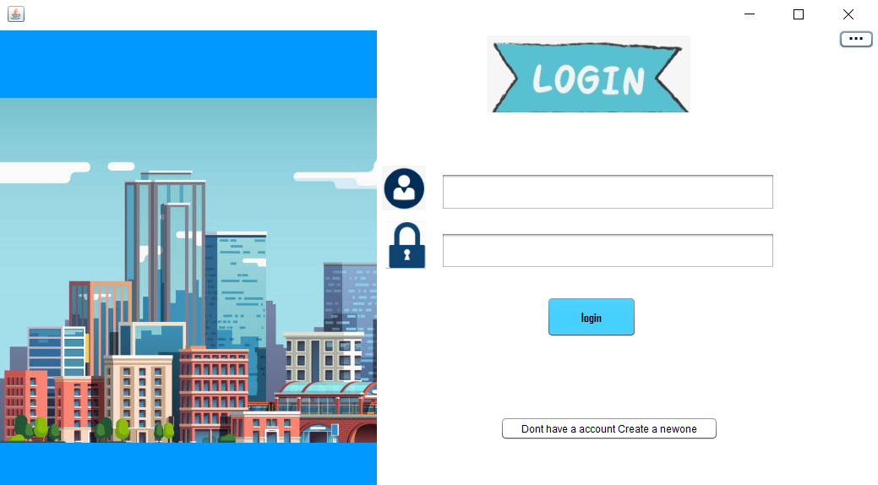

private void btnlActionPerformed(java.awt.event.ActionEvent evt) {

// TODO add your handling code here:

int flag = 1;

try {

// TODO add your handling code here:

Class.forName("com.mysql.jdbc.Driver");

con = DriverManager.getConnection("jdbc:mysql://localhost:3306/java_rst","root","");

Statement st = con.createStatement();

ResultSet rs = st.executeQuery("select * from signup");

while(rs.next()){

if(rs.getString(1).equals(username.getText()) && rs.getString(3).equals(password.getText())){

flag=0;

break;

}

}

dispose();

Interface Interface =new Interface();

Interface.setVisible(true);

}

catch (ClassNotFoundException | SQLException ex) {

Logger.getLogger(Registration.class.getName()).log(Level.SEVERE, null, ex);

}

}

private void passwordActionPerformed(java.awt.event.ActionEvent evt) {

// TODO add your handling code here:

}

private void jButton2ActionPerformed(java.awt.event.ActionEvent evt) {

// TODO add your handling code here:

dispose();

Registration Registration =new Registration();

Registration.setVisible(true);

}

private void jButton1ActionPerformed(java.awt.event.ActionEvent evt) {

// TODO add your handling code here:

dispose();

ADMINLOGIN ADMINLOGIN = new ADMINLOGIN();

ADMINLOGIN.setVisible(true) }

**REGISTRATION FORM:**

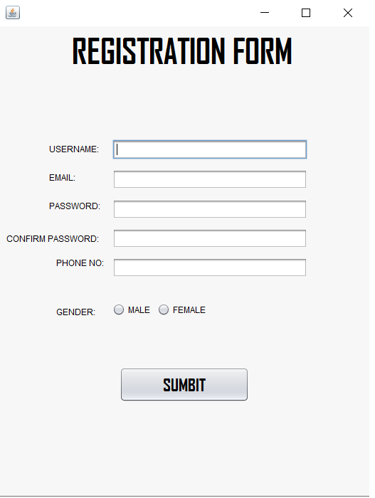

private void signupActionPerformed(java.awt.event.ActionEvent evt) {

// TODO add your handling code here:

try {

Class.forName("com.mysql.jdbc.Driver");

con = DriverManager.getConnection("jdbc:mysql://localhost:3306/java_rst","root","");

String query;

query = "insert into signup(name, emaiil, password, phone) values (?,?,?,?)";

pst = con.prepareStatement(query,Statement.RETURN_GENERATED_KEYS);

pst.setString(1, username.getText());

pst.setString(2, email.getText());

pst.setString(3, cpassword.getText());

pst.setString(4, phone.getText());

pst.executeUpdate();

ResultSet rs = pst.getGeneratedKeys();

JOptionPane.showMessageDialog(null,"Registration Successful..!");

dispose();

new LOGIN_FORM().setVisible(true);

}catch (ClassNotFoundException | SQLException ex) {

Logger.getLogger(Registration.class.getName()).log(Level.SEVERE, null, ex);

}

catch(Exception ex){

JOptionPane.showMessageDialog(null,"Registration Successful..!");

}

dispose();

LOGIN_FORM LOGIN_FORM=new LOGIN_FORM();

LOGIN_FORM.setVisible(true);

}

**DASHBOARD:**



private void HOMEActionPerformed(java.awt.event.ActionEvent evt) {

// TODO add your handling code here:

dispose();

Interface Interface=new Interface();

Interface.setVisible(true);

}

private void ABOUTUSActionPerformed(java.awt.event.ActionEvent evt) {

// TODO add your handling code here:

dispose();

aboutus aboutus=new aboutus();

aboutus.setVisible(true);

}

private void CATEGORIESActionPerformed(java.awt.event.ActionEvent evt) {

// TODO add your handling code here:

dispose();

Categories Categories=new Categories();

Categories.setVisible(true);

}

private void addActionPerformed(java.awt.event.ActionEvent evt) {

// TODO add your handling code here:

dispose();

buyform buyform=new buyform();

buyform.setVisible(true);

}

private void jButton3ActionPerformed(java.awt.event.ActionEvent evt) {

// TODO add your handling code here:

dispose();

LOGIN_FORM LOGIN_FORM=new LOGIN_FORM();

LOGIN_FORM.setVisible(true);

}

/**

* @param args the command line arguments

*/

public static void main(String args[]) {

/* Set the Nimbus look and feel */

//<editor-fold defaultstate="collapsed" desc=" Look and feel setting code (optional) ">

/* If Nimbus (introduced in Java SE 6) is not available, stay with the default look and feel.

* For details see http://download.oracle.com/javase/tutorial/uiswing/lookandfeel/plaf.html

*/

try {

for (javax.swing.UIManager.LookAndFeelInfo info : javax.swing.UIManager.getInstalledLookAndFeels()) {

if ("Nimbus".equals(info.getName())) {

javax.swing.UIManager.setLookAndFeel(info.getClassName());

break;

}

}

} catch (ClassNotFoundException ex) {

java.util.logging.Logger.getLogger(Interface.class.getName()).log(java.util.logging.Level.SEVERE, null, ex);

} catch (InstantiationException ex) {

java.util.logging.Logger.getLogger(Interface.class.getName()).log(java.util.logging.Level.SEVERE, null, ex);

} catch (IllegalAccessException ex) {

java.util.logging.Logger.getLogger(Interface.class.getName()).log(java.util.logging.Level.SEVERE, null, ex);

} catch (javax.swing.UnsupportedLookAndFeelException ex) {

java.util.logging.Logger.getLogger(Interface.class.getName()).log(java.util.logging.Level.SEVERE, null, ex);

}

//</editor-fold>

/* Create and display the form */

java.awt.EventQueue.invokeLater(new Runnable() {

public void run() {

new Interface().setVisible(true);

**CATEGORIES:**

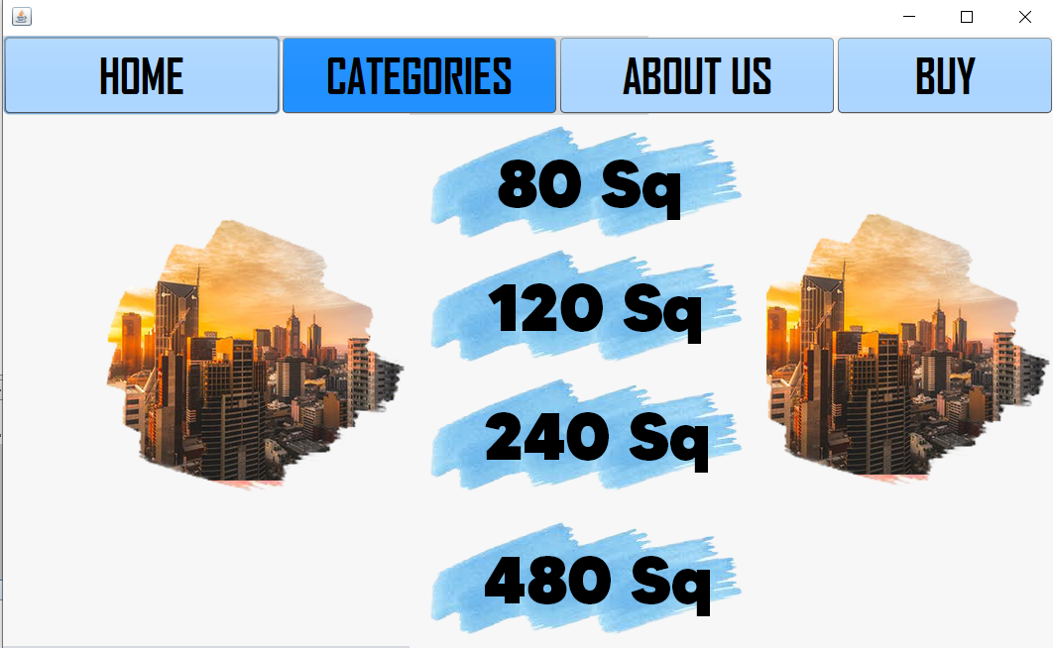

private void HOMEActionPerformed(java.awt.event.ActionEvent evt) {

// TODO add your handling code here:

dispose();

Categories Categories =new Categories();

Categories.setVisible(true);

}

private void HOME1ActionPerformed(java.awt.event.ActionEvent evt) {

// TODO add your handling code here:

dispose();

aboutus aboutus =new aboutus();

aboutus.setVisible(true);

}

private void HOME2ActionPerformed(java.awt.event.ActionEvent evt) {

// TODO add your handling code here:

dispose();

buyform buyform=new buyform();

buyform.setVisible(true);

}

private void HOME3ActionPerformed(java.awt.event.ActionEvent evt) {

// TODO add your handling code here:

dispose();

Interface Interface=new Interface();

Interface.setVisible(true);

}

private void jButton5ActionPerformed(java.awt.event.ActionEvent evt) {

// TODO add your handling code here:

dispose();

sq80 sq80=new sq80();

sq80.setVisible(true);

}

private void jButton6ActionPerformed(java.awt.event.ActionEvent evt) {

// TODO add your handling code here:

dispose();

sq120 sq120=new sq120();

sq120.setVisible(true);

}

private void jButton7ActionPerformed(java.awt.event.ActionEvent evt) {

// TODO add your handling code here:

dispose();

sq240 sq240=new sq240();

sq240.setVisible(true);

}

private void jButton2ActionPerformed(java.awt.event.ActionEvent evt) {

// TODO add your handling code here:

dispose();

sq480 sq480=new sq480();

sq480.setVisible(true);

}

**ABOUT US:**



private void jButton1ActionPerformed(java.awt.event.ActionEvent evt) {

// TODO add your handling code here:

dispose();

Interface Interface=new Interface();

Interface.setVisible(true);

}

**BUY FORM:**

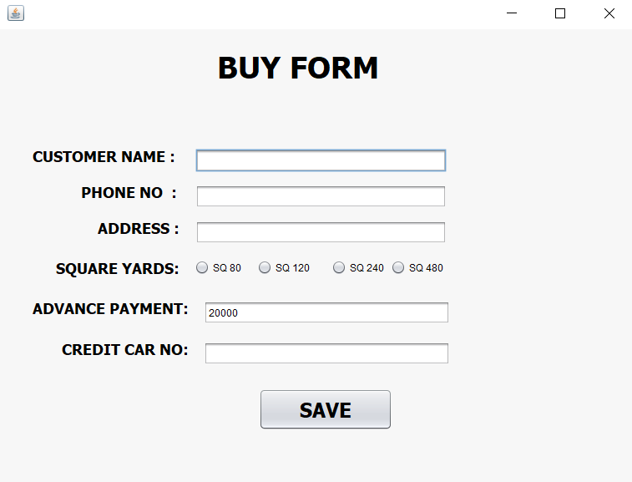

private void jButton1ActionPerformed(java.awt.event.ActionEvent evt) {

// TODO add your handling code here:

String squareyard = "";

if(SQ80.isSelected() == true)

{

squareyard="SQ80";

}

if(SQ120.isSelected() == true)

{

squareyard="SQ120";

}

if(SQ240.isSelected() == true)

{

squareyard="SQ240";

}

if(SQ480.isSelected() == true)

{

squareyard="SQ480";

}

try {

Class.forName("com.mysql.jdbc.Driver");

con = DriverManager.getConnection("jdbc:mysql://localhost:3306/java_rst","root","");

String query;

query = "insert into selling(name, phone, address,squareyards ,price ,creditcard ) values (?,?,?,?,?,?)";

pst = con.prepareStatement(query,Statement.RETURN_GENERATED_KEYS);

pst.setString(1, CSNAME.getText());

pst.setString(2, CSPHONE.getText());

pst.setString(3, CSADDRESS.getText());

pst.setString(4, squareyard);

pst.setString(5, CSPRICE.getText());

pst.setString(6, CSCREDITCARD.getText());

pst.executeUpdate();

ResultSet rs = pst.getGeneratedKeys();

JOptionPane.showMessageDialog(null,"Successful..!A Brooker will assign towards your Door Steps");

dispose();

new Interface().setVisible(true);

}catch (ClassNotFoundException | SQLException ex) {

Logger.getLogger(buyform.class.getName()).log(Level.SEVERE, null, ex);

}

catch(Exception ex){

JOptionPane.showMessageDialog(null,"Registration Successful..!");

}

}

**ADMIN LOGIN:**

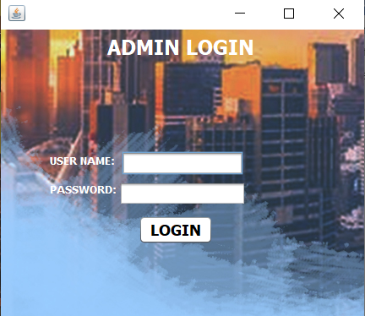

private void jButton1ActionPerformed(java.awt.event.ActionEvent evt) {

// TODO add your handling code here:

int flag = 1;

try {

// TODO add your handling code here:

Class.forName("com.mysql.jdbc.Driver");

con = DriverManager.getConnection("jdbc:mysql://localhost:3306/java_rst","root","");

Statement st = con.createStatement();

ResultSet rs = st.executeQuery("select * from admin");

while(rs.next()){

if(rs.getString(1).equals(username.getText()) && rs.getString(2).equals(password.getText())){

flag=0;

break;

}

}

dispose();

sales sales =new sales();

sales.setVisible(true);

}

catch (ClassNotFoundException | SQLException ex) {

Logger.getLogger(Registration.class.getName()).log(Level.SEVERE, null, ex);

}

}

**RECORD TABLE:**

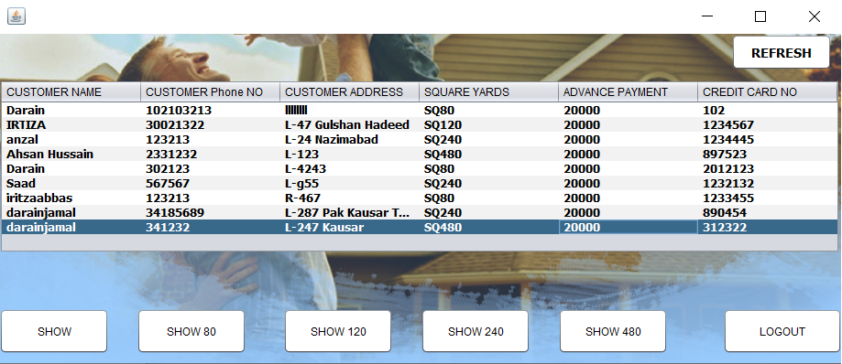

private void jButton1ActionPerformed(java.awt.event.ActionEvent evt) {

// TODO add your handling code here:

try {

// TODO add your handling code here:

Class.forName("com.mysql.jdbc.Driver");

con = DriverManager.getConnection("jdbc:mysql://localhost:3306/java_rst","root","");

Statement st = con.createStatement();

String query = "SELECT * FROM `selling` WHERE squareyards='SQ480'";

ResultSet rs = st.executeQuery(query);

while(rs.next()){

String csname = rs.getString(1);

String csphone = rs.getString(2);

String csaddress = rs.getString(3);

String cssquareyard = rs.getString(4);

String csprice = rs.getString(5);

String cscreditcard = rs.getString(6);

String tbData[] = {csname,csphone,csaddress,cssquareyard,csprice,cscreditcard};

model = (DefaultTableModel)jTable1.getModel();

model.addRow(tbData);

}

con.close();

} catch (ClassNotFoundException ex) {

Logger.getLogger(sales.class.getName()).log(Level.SEVERE, null, ex);

} catch (SQLException ex) {

Logger.getLogger(sales.class.getName()).log(Level.SEVERE, null, ex);

}

}

private void jButton2ActionPerformed(java.awt.event.ActionEvent evt) {

// TODO add your handling code here:

dispose();

LOGIN_FORM LOGIN_FORM=new LOGIN_FORM();

LOGIN_FORM.setVisible(true);

}

private void jButton3ActionPerformed(java.awt.event.ActionEvent evt) {

// TODO add your handling code here:

try {

// TODO add your handling code here:

Class.forName("com.mysql.jdbc.Driver");

con = DriverManager.getConnection("jdbc:mysql://localhost:3306/java_rst","root","");

Statement st = con.createStatement();

String query = "select * from selling";

ResultSet rs = st.executeQuery(query);

while(rs.next()){

String csname = rs.getString(1);

String csphone = rs.getString(2);

String csaddress = rs.getString(3);

String cssquareyard = rs.getString(4);

String csprice = rs.getString(5);

String cscreditcard = rs.getString(6);

String tbData[] = {csname,csphone,csaddress,cssquareyard,csprice,cscreditcard};

model = (DefaultTableModel)jTable1.getModel();

model.addRow(tbData);

}

con.close();

} catch (ClassNotFoundException ex) {

Logger.getLogger(sales.class.getName()).log(Level.SEVERE, null, ex);

} catch (SQLException ex) {

Logger.getLogger(sales.class.getName()).log(Level.SEVERE, null, ex);

}

}

private void jButton4ActionPerformed(java.awt.event.ActionEvent evt) {

// TODO add your handling code here:

try {

// TODO add your handling code here:

Class.forName("com.mysql.jdbc.Driver");

con = DriverManager.getConnection("jdbc:mysql://localhost:3306/java_rst","root","");

Statement st = con.createStatement();

String query = "SELECT * FROM `selling` WHERE squareyards='SQ80'";

ResultSet rs = st.executeQuery(query);

while(rs.next()){

String csname = rs.getString(1);

String csphone = rs.getString(2);

String csaddress = rs.getString(3);

String cssquareyard = rs.getString(4);

String csprice = rs.getString(5);

String cscreditcard = rs.getString(6);

String tbData[] = {csname,csphone,csaddress,cssquareyard,csprice,cscreditcard};

model = (DefaultTableModel)jTable1.getModel();

model.addRow(tbData);

}

con.close();

} catch (ClassNotFoundException ex) {

Logger.getLogger(sales.class.getName()).log(Level.SEVERE, null, ex);

} catch (SQLException ex) {

Logger.getLogger(sales.class.getName()).log(Level.SEVERE, null, ex);

}

}

private void jButton5ActionPerformed(java.awt.event.ActionEvent evt) {

// TODO add your handling code here:

try {

// TODO add your handling code here:

Class.forName("com.mysql.jdbc.Driver");

con = DriverManager.getConnection("jdbc:mysql://localhost:3306/java_rst","root","");

Statement st = con.createStatement();

String query = "SELECT * FROM `selling` WHERE squareyards='SQ120'";

ResultSet rs = st.executeQuery(query);

while(rs.next()){

String csname = rs.getString(1);

String csphone = rs.getString(2);

String csaddress = rs.getString(3);

String cssquareyard = rs.getString(4);

String csprice = rs.getString(5);

String cscreditcard = rs.getString(6);

String tbData[] = {csname,csphone,csaddress,cssquareyard,csprice,cscreditcard};

model = (DefaultTableModel)jTable1.getModel();

model.addRow(tbData);

}

con.close();

} catch (ClassNotFoundException ex) {

Logger.getLogger(sales.class.getName()).log(Level.SEVERE, null, ex);

} catch (SQLException ex) {

Logger.getLogger(sales.class.getName()).log(Level.SEVERE, null, ex);

}

}

private void jButton6ActionPerformed(java.awt.event.ActionEvent evt) {

// TODO add your handling code here:

try {

// TODO add your handling code here:

Class.forName("com.mysql.jdbc.Driver");

con = DriverManager.getConnection("jdbc:mysql://localhost:3306/java_rst","root","");

Statement st = con.createStatement();

String query = "SELECT * FROM `selling` WHERE squareyards='SQ240'";

ResultSet rs = st.executeQuery(query);

while(rs.next()){

String csname = rs.getString(1);

String csphone = rs.getString(2);

String csaddress = rs.getString(3);

String cssquareyard = rs.getString(4);

String csprice = rs.getString(5);

String cscreditcard = rs.getString(6);

String tbData[] = {csname,csphone,csaddress,cssquareyard,csprice,cscreditcard};

model = (DefaultTableModel)jTable1.getModel();

model.addRow(tbData);

}

con.close();

} catch (ClassNotFoundException ex) {

Logger.getLogger(sales.class.getName()).log(Level.SEVERE, null, ex);

} catch (SQLException ex) {

Logger.getLogger(sales.class.getName()).log(Level.SEVERE, null, ex);

}

}

private void jButton7ActionPerformed(java.awt.event.ActionEvent evt) {

// TODO add your handling code here:

dispose();

sales sales =new sales();

sales.setVisible(true);

}

/**

* @param args the command line arguments

*/

public static void main(String args[]) {

/* Set the Nimbus look and feel */

//<editor-fold defaultstate="collapsed" desc=" Look and feel setting code (optional) ">

/* If Nimbus (introduced in Java SE 6) is not available, stay with the default look and feel.

* For details see http://download.oracle.com/javase/tutorial/uiswing/lookandfeel/plaf.html

*/

try {

for (javax.swing.UIManager.LookAndFeelInfo info : javax.swing.UIManager.getInstalledLookAndFeels()) {

if ("Nimbus".equals(info.getName())) {

javax.swing.UIManager.setLookAndFeel(info.getClassName());

break;

}

}

} catch (ClassNotFoundException ex) {

java.util.logging.Logger.getLogger(sales.class.getName()).log(java.util.logging.Level.SEVERE, null, ex);

} catch (InstantiationException ex) {

java.util.logging.Logger.getLogger(sales.class.getName()).log(java.util.logging.Level.SEVERE, null, ex);

} catch (IllegalAccessException ex) {

java.util.logging.Logger.getLogger(sales.class.getName()).log(java.util.logging.Level.SEVERE, null, ex);

} catch (javax.swing.UnsupportedLookAndFeelException ex) {

java.util.logging.Logger.getLogger(sales.class.getName()).log(java.util.logging.Level.SEVERE, null, ex);

}

//</editor-fold>

/* Create and display the form */

java.awt.EventQueue.invokeLater(new Runnable() {

public void run() {

new sales().setVisible(true);

}

});

}

**CONCLUSION:**

By making this application which was fun to make now I am eligible to make more application or something new which can be helpful for other agencies.