SILO Data Report

20 March, 2018

Generated using the R swtools package.

# Station Summary

|  |  |  |  |  |  |  |  |  |
| --- | --- | --- | --- | --- | --- | --- | --- | --- |
|  | Site | Station | StartDate | EndDate | PctMissing | AnnualRainfall | Latitude | Longitude |
| 23718 | GOOLWA | 23718 | 1960-01-01 | 2016-12-21 | 18.65 | 472 | -35.4983 | 138.7646 |
| 24518 | MENINGIE | 24518 | 1960-01-01 | 2016-12-31 | 4.03 | 473 | -35.6902 | 139.3375 |
| 24537 | MENINGIE | 24537 | 1960-01-01 | 2016-11-30 | 13.46 | 461 | -35.6190 | 139.4378 |
| 24539 | NARRUNG | 24539 | 1960-01-01 | 2016-09-30 | 3.98 | 419 | -35.5949 | 139.1296 |
| 24572 | WELLINGTON | 24572 | 1962-01-01 | 2016-12-31 | 1.19 | 370 | -35.2828 | 139.2031 |
| 24576 | MILANG | 24576 | 1963-01-01 | 2016-11-30 | 0.32 | 413 | -35.3480 | 138.9771 |
| 25502 | COOKE | 25502 | 1960-01-01 | 2016-12-31 | 5.89 | 370 | -35.3790 | 139.5617 |

## Data quality codes

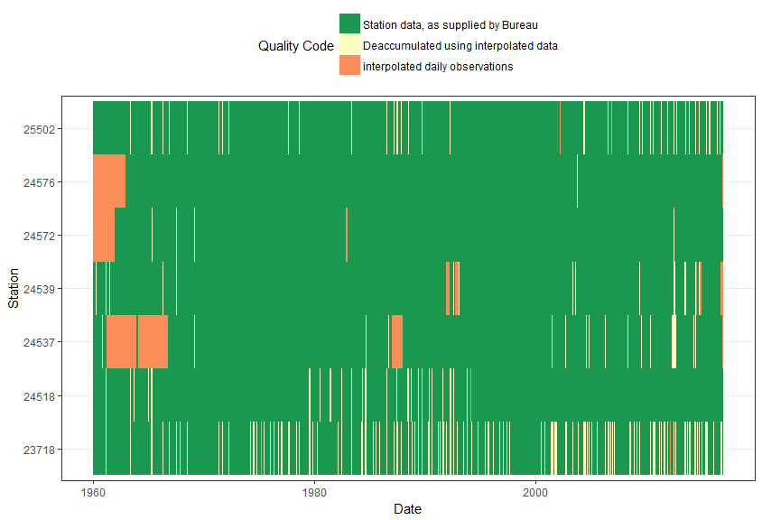

## Map of station locations

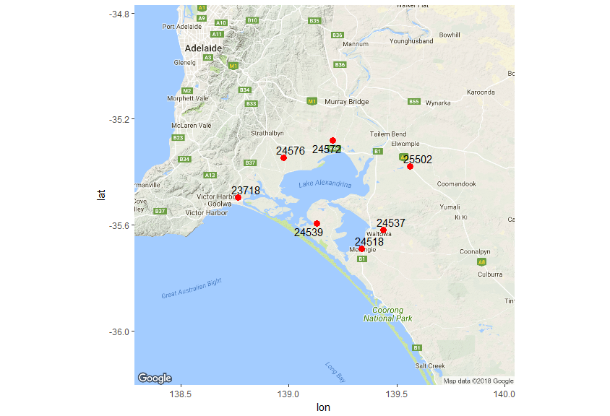

## Cumulative deviation in mean daily rainfall

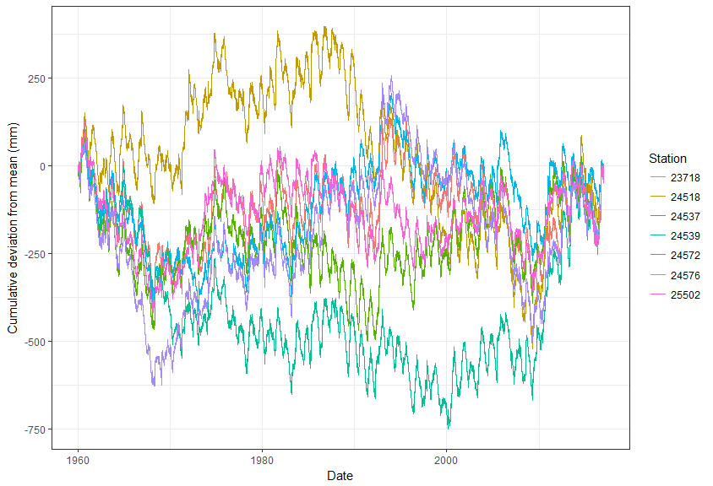

## Double mass plots