gen nevals avg std min max   
0 10 [0.30535051 0.79069768] [0.07176556 0.20930233] [0.20675626 0.1627907 ] [0.48451514 0.86046512]

1 7 [0.2652971 0.86046512] [4.48175786e-02 2.22044605e-16] [0.20675626 0.86046512] [0.3053235 0.86046512]  
2 8 [0.2388138 0.85581396] [0.03297363 0.01395349] [0.20675626 0.8139535 ] [0.29530149 0.86046512]  
3 9 [0.21519783 0.86046512] [1.11255046e-02 2.22044605e-16] [0.20422275 0.86046512] [0.24605266 0.86046512]

4 10 [0.21094086 0.86046512] [3.54919988e-03 2.22044605e-16] [0.20422275 0.86046512] [0.21872199 0.86046512]

5 10 [0.21002844 0.86046512] [2.37578875e-03 2.22044605e-16] [0.20422275 0.86046512] [0.21174153 0.86046512]

Best Performing chromosome :

Epoch 1/20  
 - 4s - loss: 0.4894 - acc: 0.2833 - val_loss: 0.4794 - val_acc: 0.2051  
Epoch 2/20  
 - 0s - loss: 0.4517 - acc: 0.4056 - val_loss: 0.4338 - val_acc: 0.4615  
Epoch 3/20  
 - 0s - loss: 0.4139 - acc: 0.5389 - val_loss: 0.3790 - val_acc: 0.5897  
Epoch 4/20  
 - 0s - loss: 0.3537 - acc: 0.6556 - val_loss: 0.3393 - val_acc: 0.6923  
Epoch 5/20  
 - 0s - loss: 0.3350 - acc: 0.7278 - val_loss: 0.3127 - val_acc: 0.7564  
Epoch 6/20  
 - 0s - loss: 0.3128 - acc: 0.7722 - val_loss: 0.2920 - val_acc: 0.7949  
Epoch 7/20  
 - 0s - loss: 0.3109 - acc: 0.7611 - val_loss: 0.2750 - val_acc: 0.7821  
Epoch 8/20  
 - 0s - loss: 0.2764 - acc: 0.8056 - val_loss: 0.2609 - val_acc: 0.8590  
Epoch 9/20  
 - 0s - loss: 0.2970 - acc: 0.8611 - val_loss: 0.2492 - val_acc: 0.8590  
Epoch 10/20  
 - 0s - loss: 0.2914 - acc: 0.8889 - val_loss: 0.2398 - val_acc: 0.8718  
Epoch 11/20  
 - 0s - loss: 0.2624 - acc: 0.8889 - val_loss: 0.2317 - val_acc: 0.8718  
Epoch 12/20  
 - 0s - loss: 0.2594 - acc: 0.8889 - val_loss: 0.2246 - val_acc: 0.8718  
Epoch 13/20  
 - 0s - loss: 0.2504 - acc: 0.8889 - val_loss: 0.2181 - val_acc: 0.8718  
Epoch 14/20  
 - 0s - loss: 0.2438 - acc: 0.8889 - val_loss: 0.2120 - val_acc: 0.8718  
Epoch 15/20  
 - 0s - loss: 0.2176 - acc: 0.8889 - val_loss: 0.2067 - val_acc: 0.8718  
Epoch 16/20  
 - 0s - loss: 0.2456 - acc: 0.8889 - val_loss: 0.2018 - val_acc: 0.8718  
Epoch 17/20  
 - 0s - loss: 0.2152 - acc: 0.8889 - val_loss: 0.1974 - val_acc: 0.8718  
Epoch 18/20  
 - 0s - loss: 0.2204 - acc: 0.8889 - val_loss: 0.1930 - val_acc: 0.8718  
Epoch 19/20  
 - 0s - loss: 0.2126 - acc: 0.8889 - val_loss: 0.1881 - val_acc: 0.8718  
Epoch 20/20  
 - 0s - loss: 0.2293 - acc: 0.8889 - val_loss: 0.1836 - val_acc: 0.8718  
86/86 [==============================] - 0s 136us/step  
acc: 86.05%

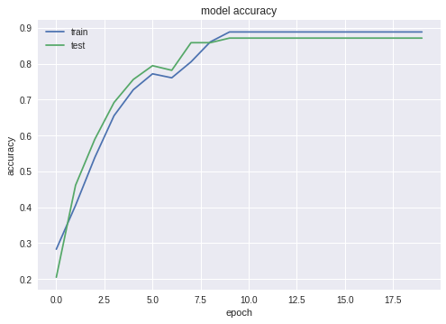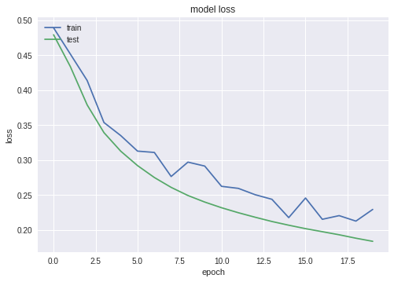

(0.35368909738784615, 0.8604651232098424)