**CS 4403**

**Software Engineering 2**

**Unit 2**

**24 November 2020**

**Part 1: Table of Sequence**

|  |  |  |
| --- | --- | --- |
| **ID** | **Action** | **Dependency** |
| A | Provide SQL compatibility | - |
| B | Provide transaction logging for database integrity | A |
| C | The maintenance of customer history of rentals, rental history for each videotape, creation, and change of rental transaction records | A, B |
| D | The ability to create new customers as part of rental processing | A |
| E | Provide add, change, delete, inquiry functions for the customer, video, and rental information | A, C |
| F | The ability to add new videos to the system as part of rental processing Query of any rental-related information | A |
| G | Computation of late fees owing from prior transactions | A, B, C |
| H | Provide for nine concurrent users | A |
| I | Monitoring of outstanding rentals by customer | A, B, C |
| J | Provide immediate file update | A |
| K | Interactive processing and data display for all outstanding video rentals, including fees owing | A, B, C |
| L | Do a daily backup of all files and application programs | A |
| M | Provide ad hoc reporting capability for all files and legal combinations of files | - |
| N | Provide end-of-day reports | A, B, C |
| O | Minimize data entry in rental processing by using bar codes or similar technology | - |
| P | On-line processing from 8 A.M. to 11 P.M. daily | - |
| Q | Provide for growth of 15 % per year per file | - |

**Part 2: Diagram**

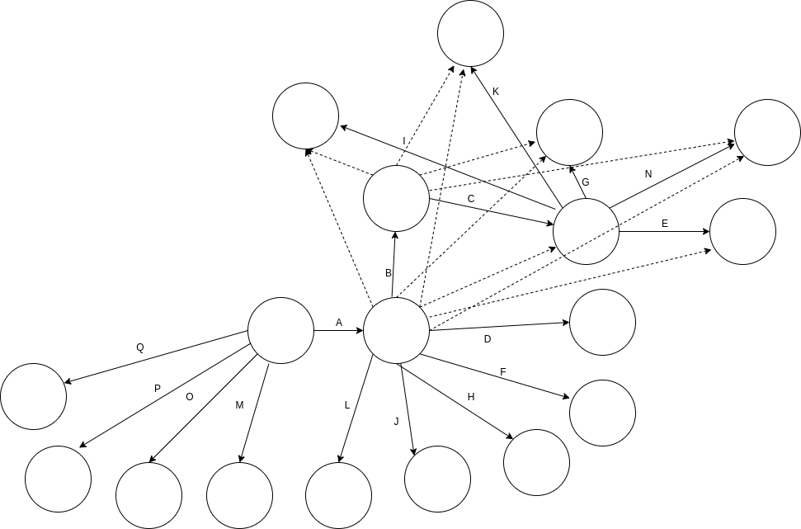

**Part 3: Answer to Question**

***“Assuming Sam and Mary do the project alone, how should the work be allocated among them to (a) allow Mary to do project management tasks, and (b) leverage the work they did during analysis?”***

**Answer:**

|  |  |
| --- | --- |
| **Action** | **Mary & Sam** |
| Provide add, change, delete, inquiry functions for the customer, video, and rental information | **S** |
| Interactive processing and data display for all outstanding video rentals, including fees owing | **M** |
| On-line processing from 8 A.M. to 11 P.M. daily | **S** |
| The maintenance of customer history of rentals, rental history for each videotape, creation, and change of rental transaction records | **M** |
| Monitoring of outstanding rentals by customer | **S** |
| Computation of late fees owing from prior transactions | **M** |
| The ability to create new customers as part of rental processing | **M** |
| The ability to add new videos to the system as part of rental processing Query of any rental-related information | **S** |
| Minimize data entry in rental processing by using bar codes or similar technology | **M** |
| Provide immediate file update | **S** |
| Provide transaction logging for database integrity | **S** |
| Do a daily backup of all files and application programs | **M** |
| Provide ad hoc reporting capability for all files and legal combinations of files | **S** |
| Provide end-of-day reports | **M** |
| Provide for growth of 15 % per year per file | **M** |
| Provide for nine concurrent users | **S** |
| Provide SQL compatibility | **S** |

**Conclusion:**

The Creation of a CPM allows for the streamlining and delegation of the project in manageable modules that the whole project team can understand and manage efficiently.

**Reference:**

Conger, S. (2008). The New Software Engineering

From: [**https://learn.saylor.org/pluginfile.php/235273/mod_resource/content/3/Conger-NewSoftwareEngineering.pdf**](https://learn.saylor.org/pluginfile.php/235273/mod_resource/content/3/Conger-NewSoftwareEngineering.pdf)

P. Bourque and R.E. Fairley, eds., Guide to the Software Engineering Body of Knowledge, Version 3.0, IEEE Computer Society, 2014

From: [**https://my.uopeople.edu/pluginfile.php/1018492/mod_page/content/5/CS4403BourqueFairleyTextbook.pdf**](https://my.uopeople.edu/pluginfile.php/1018492/mod_page/content/5/CS4403BourqueFairleyTextbook.pdf)