Music Recommender algorithm
4AI3 Project Final Report

Michael Altali (400132523)
Bachelor of Technology – Automotive Engineering Tech.
McMaster University
Hamilton, ON Canada
Email: altalim@mcmaster.ca

Abstract
The contents of this report surround an algorithm that can accurately recommend genres of music to a user based on their demographic. The algorithm takes in information the user provides on their: age, gender, and country/region they are in. Based on this information, the algorithm can accurately recommend a style of music they would be interested in. This recommendation comes from real data obtained from various sources on the types of music various age and gender groups listen to in 15 countries across the world. The algorithm is trained on a data set of over 1000 entries of people of all ages and genders across the 15 countries, and operates with an accuracy of larger than 90%, up to 99.9%

Introduction
The music recommender algorithm project has the objective of taking the users demographic information as inputs, and recommended an appropriate genre of music for them (the list of genres it can pick from and recommend is up to 50 genres). The input variables that this algorithm can recommend music based on are 3 variables about the user’s demographic: age, gender, and country/region. The data it has been trained on comes from real data on what particular genres of music that women and men of various age groups listen to around the world. The algorithm works with a data set filled with this information and is a logistic regression decision tree classifier type of algorithm. Picture it as starting at the trunk of a tree, the tree branches all represent various decisions the algorithm makes by comparing the input variable with the threshold of each decision (logistic regression), then making a decision. After many decisions based on user input information, the ‘path’ it takes will lead to the genre of music popular amongst that demographic. It then makes this prediction and displays it for the user. The project was a success, and the algorithm is successfully capable of this.

How the algorithm works

The Data Set
The data set the algorithm is based on began as a simple 20 row prototype set with 2 input variables that represent the user’s age and gender. Their favorite genre is listed in a genre column and covers around 5 genres.

This was very simple test set to see if the algorithm works with the data and can solve the problem (which is music genre recommendation). The age column also only consisted of users aged 20-35. The dataset is pictured below in fig.1
- Table 1: Simple Prototype data set used to test if algoirthm works for the problem of music recommendation

Once the algorithm was found to successfully work for the problem at hand, the data set could be upgraded and massively upscaled to accurately portray real world results. The upgrades to this basic data set began with a much wider range of genres the algorithm can predict from and recommend. An upgrade from 5 genres to around 50 genres of music. The second upgrade was the inclusion of the user’s country as a factor in what genre of music they would likely want to listen to. This is because popular music can vastly differ among regions or countries around the world. The third upgrade is an increase to the range of ages included in the dataset for the algorithm to work with. The upgraded data set now includes all ages, 1-100.
The new upgraded data set I made pulls from many different statistic reports and sources on the internet of popular music genres in different countries, and totals to above 1000 rows of entries that differ on country, age, and gender. The sources used to obtain the realistic data used will be included in this report below. The countries included are:
- The United States
- Canada
- Peru
- China
- South Korea
- South Africa
- Brazil
- Mexico
- India
- Australia
- The United Kingdom
- Germany
- Poland
- Japan
- France

If the user inputs a country not supported by the algorithm, it will simply tell the user that the algorithm does not currently support their country. The countries selected above were chosen based on where the majority of the world resides and the most likely users of music algorithm applications.

The Algorithm

The algorithm, like previously stated, is a decision tree type of algorithm. Each decision it makes is essentially logistic regression. There is a threshold that separates each decision, and the algorithm will take a path of decisions that leads to the genre prediction for that user based on the decisions it made with the user’s information. The decision tree is visualized below, with fig 2 representing the algorithm for the prototype data set, and fig 3 representing what the decision tree looks like for the upgraded data set that involved countries
- The decision tree the algorithm used for the prototype data set before the upgrades

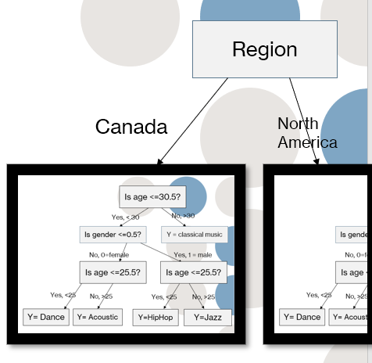

- Recreation of how the decision tree operates with a third input variable like country

Just like in the real world, two people of the same age and gender can have completely different tastes in music, that are largely influenced by the culture around them and the people they grew up with. The algorithm keeps this in mind, and for example can recommend Samba for a 37-year-old male in Brazil, while recommending Rock music for a 37-year-old male in Australia. All of the recommendation of which are based on real data.

Algorithm Creation
The creation of this algorithm is grouped into seven general steps:

Importing the Data set

Cleaning the Data (removing duplicates/null values)

Splitting the data into training/testing sets

Creating the model (selecting the algorithm)

Training the model (feeding it data)

Making predictions

Evaluating and Improving the algorithm (evaluate predictions and improve accuracry)

For the first step, the data set was firstly saved as a csv file. The csv (comma separated values) file was then read with the .read_csv() function from the pandas library. The results were stored in a data frame called musicdata. The data set included both the input and response variables as columns, so the independent variables and dependent variable were separated with the .drop() method. The .drop() method was used to drop the genre column (not from the data set, but in the result of that specific line). The result was then placed in a 2D array called x_data (independent variable). Then the column of genre values was placed in a separate 2D array called y_data. The second major step of the algorithm creation was to clean the data set by removing duplicates and null values. Fortunately, the data set I crafted doesn’t include any null values, there are age duplicates of course, but there is always a difference in one of the input variables.
This is of course because people from different countries could have the same age and gender and still like completely different music. The next major step is to split the data into training and testing sets. This was done with the train_test_split function imported from the sci-kit learn library. The split used was an 80%train/20%test split, which is the generally recommended split for training and testing AI.
The next step is simply to create the model, which was done by importing a DecisionTreeClassifier from sci-kit learn, then creating an instance of it to work with this data set. Step five involves simply feeding the data to this newly created algorithm with the .fit() function. What follows in the next step is to make some predictions with the model, in order to then compare those predictions against test values and determine the accuracy of the model. The .predict() method was used, with the x_test data inputted into it, the result was placed in an array called predictions. To evaluate the accuracy of the model, the .accuracy_score() function was imported from sci-kit learn. Using this function, the y_test values were compared against the predictions array, and the resulting accuracy value placed in a variable I called score. The accuracy could then be printed and displayed.
More code was included after that does not pertain to the algorithm but is for user interaction. When the program is first ran, the code will first print a welcome message and begin asking the user for their information, starting with country. The countries are listed by their representative number, once the user inputs their country, the program will then ask the user for their gender, and then their age. If the user inputs an incorrect value for any of the variables, there are while loops and if-else statements set up to allow them to try again and input a valid value. The program then takes their input and uses the .predict method to recommend a genre of music for them that they would likely enjoy.

Results
The resulting algorithm was a success, capable of predicting music genres that users from various age groups, genders and countries would like to listen, with an above 90% accuracy. From using the .accuracy_score() function to evaluate the model’s accuracy, and rerunning the code several times, the algorithm was found to be able to predict with an accuracy of 90-99.9%. The music genres that people of certain age groups and genders would like across the world are included in the appendix (see appendix A, B and C). For example, running the code and inputting 22 for age, male for gender and country (Canada), the algorithm would recommend the rap music genre (shown in fig. 4), which is based on real statistical reports of what 18–25-year-old males listen to in Canada. The same goes for every other demographic included.
- Display window of user inputted values, and the resulting recommendation done by the algorithm
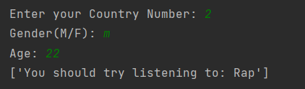

This type of algorithm can have a wide variety of uses in the world, and is one of the most commonly applied algorithms in entertainment based applications. Everything from music streaming services like Spotify and Apple, video streaming services like Youtube, and movie and t.v show streaming services like Netflix and Amazon Prime employ these types of recommendation algorithms. The result is a website that can directly give the user the type of content they would like to see. This type of machine learning application has even found use in social media sites like instagram and twitter, which regularly update and recommend posts and users based on user activity and demographic. The applications for this type of algorithm are huge and continue to improve every day.

Acknowledgment
The writer of this report wishes to acknowledge Dr. Zhen Gao and teaching assistant Hossein Rezaeifar for their guidance and advice on the creation of this algorithm and subsequent report

References
- B. Anderson and D. Coletto, “The music we love,” Abacus Data, 08-Dec-2016. [Online]. Available: https://abacusdata.ca/the-music-we-love/. [Accessed: 10-Dec-2021].
- B. Dupre, “What they're listening to in Peru,” Culture Trip, 09-Aug-2017. [Online]. Available: https://theculturetrip.com/south-america/peru/articles/what-theyre-listening-to-in-peru/. [Accessed: 10-Dec-2021].
- E. Cunningham, “A complete guide to 50 years of music in Japan (1970–2020),” Tokyo Weekender, 26-Dec-2020. [Online]. Available: https://www.tokyoweekender.com/2020/12/a-complete-guide-to-50-years-of-music-in-tokyo-1970-2020/. [Accessed: 10-Dec-2021].
- E. Legrand, Facts and figures about the French music market, 18-Feb-2014. [Online]. Available: http://legrandnetwork.blogspot.com/2014/02/facts-and-figures-about-french-music.html. [Accessed: 10-Dec-2021].
- “Exploring age-specific preferences in listening,” Music Machinery, 13-Feb-2014. [Online]. Available: https://musicmachinery.com/2014/02/13/age-specific-listening/. [Accessed: 10-Dec-2021].
- F. Toscano, “Mexican music genres and the rise of regional Latin Music,” How Music Charts, 14-Jun-2021. [Online]. Available: https://blog.chartmetric.com/regional-latin-music-mexican-music-genres/. [Accessed: 10-Dec-2021].
- “Favorite Music genres among consumers by age group in the U.S. 2018,” Statista, 08-Jan-2021. [Online]. Available: https://www.statista.com/statistics/253915/favorite-music-genres-in-the-us/. [Accessed: 10-Dec-2021].
- “Germany: Most popular music genre 2020,” Most popular music genres in Germany in 2020, 09-Nov-2021. [Online]. Available: https://www.statista.com/statistics/382071/most-popular-music-genres-germany/. [Accessed: 10-Dec-2021].
- instytut badan strukturalnych, J. Sokołowski, W. Hardy, P. Lewandowski, K. Wyrzykowska, K. Messyasz, K. Szczepaniak, and I. Frankiewicz-Olczak, Warsaw: instytut badan strukturalnych, 2019, pp. 1–143.
- J. G. Navarro, “Most Popular Music genres in Brazil 2018,” Statista, 14-Jul-2021. [Online]. Available: https://www.statista.com/statistics/966242/most-popular-music-genres-brazil/. [Accessed: 10-Dec-2021].
- K. Buchholz and F. Richter, “Infographic: Pop, rock or rap? musical tastes around the world,” Pop, Rock or Rap? Musical Tastes Around the World, 06-Aug-2021. [Online]. Available: https://www.statista.com/chart/25488/musical-genre-taste-around-the-world/. [Accessed: 10-Dec-2021].
- L. L. Thomala, “China: Favorite Music genres among digital music listeners 2020,” Statista, 24-Mar-2021. [Online]. Available: https://www.statista.com/statistics/898939/china-favored-music-genres-among-online-music-listeners/. [Accessed: 10-Dec-2021].
- “Most Popular Music genres in Germany 2017,” Most popular music genres in Germany, 2017. [Online]. Available: https://statinvestor.com/data/23866/most-popular-music-genres-germany/. [Accessed: 10-Dec-2021].
- “Most popular music genres in the UK,” pipedown.info, 2020. [Online]. Available: https://pipedown.info/most-popular-music-genres-in-the-uk/. [Accessed: 10-Dec-2021].
- “Music of south africa,” Wikipedia, 25-Nov-2021. [Online]. Available: https://en.wikipedia.org/wiki/Music_of_South_Africa#The_1950s. [Accessed: 10-Dec-2021].
- “Music of the United Kingdom,” Wikipedia, 03-Dec-2021. [Online]. Available: https://en.wikipedia.org/wiki/Music_of_the_United_Kingdom. [Accessed: 10-Dec-2021].
- N. Laishram, “India's most famous music styles,” UrbanPro.com, 17-Apr-2017. [Online]. Available: https://www.urbanpro.com/indian-instrumental-music/indias-famous-music-styles. [Accessed: 10-Dec-2021].
- P. Othen, “The most popular music across the world, country by country,” HuffPost UK, 29-Aug-2018. [Online]. Available: https://www.huffingtonpost.co.uk/entry/the-most-popular-music-across-the-world-country-by-country_uk_5b714b59e4b0bdd0620ab375. [Accessed: 10-Dec-2021].
- R. Pound, “Canadian music ᐈ most popular music in Canada 2021,” Camuz Montreal, 25-Jan-2021. [Online]. Available: https://www.camuz.ca/what-is-the-most-popular-music-in-canada/. [Accessed: 10-Dec-2021].
- Sejong, “What other music genres aside from K-pop is popular in Korea,” Sejong Korean Language School, 28-Dec-2020. [Online]. Available: https://www.sejong.com.sg/what-other-music-genres-aside-from-k-pop-is-popular-in-korea/. [Accessed: 10-Dec-2021].
- “The Top Music from Spotify's first week in India,” Spotify, 06-Mar-2019. [Online]. Available: https://newsroom.spotify.com/2019-03-06/the-top-music-from-spotifys-first-week-in-india/. [Accessed: 10-Dec-2021].
- The Victorian Music Development Office, Southbank, Victoria: Victoria State Government, 2019, pp. 1–20.

Appendix

Appendix A: Collection of Music Genre results for US, Canada, Peru and China
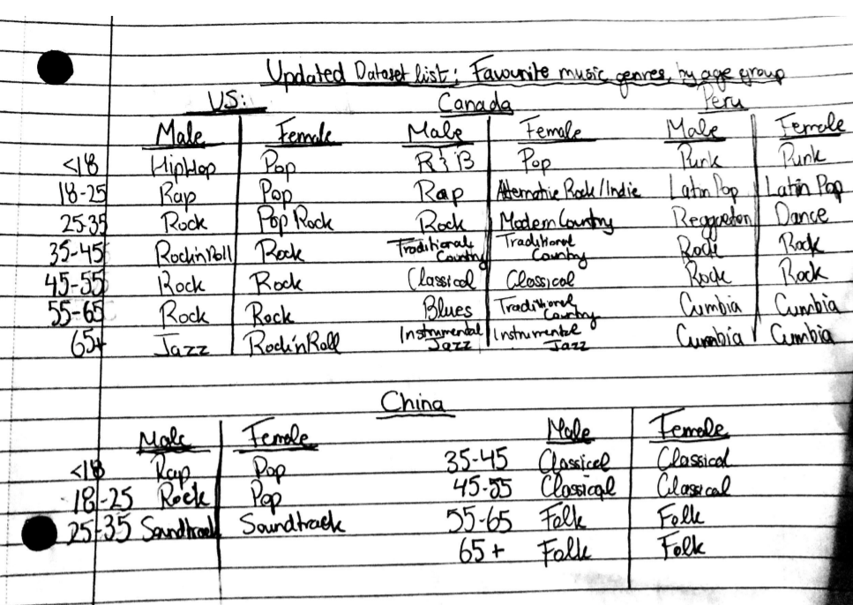

Appendix B: Music Genre results for Demographic for countries, Pg.2
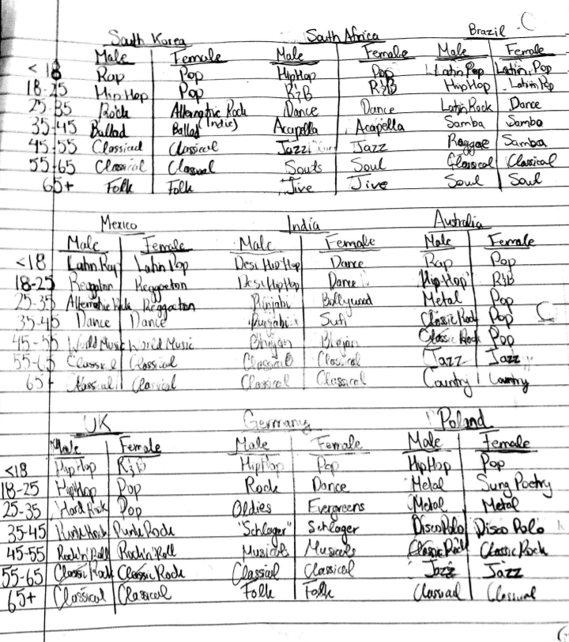

Appendix C: Music Genre results for Demographic for countries, Pg.3

