Semester Project Title: Mess Management System
Student Details
 | Student Name | Student Reg # | Student Degree
Student-1 | Muhammad Ammar | 2025474 | BSAI
Student-2 | Muhammad  Zohran | 2025665 | BSAI
Student-3 | Mustafa  Khan | 2025683 | BSAI
Main Features
1. Registration / Login mechanism of admin/operator
2. Add, view, and search students
3. Mark meal attendance (Breakfast, Lunch + Dinner, Both)
4. Automatic calculation of per-student bill using meal rates
5. Pending dues management with clear-dues and carry-forward
6. Month-end summary (feature-wise totals and per-student bills)
7. File save/load of all records (persistent storage)
Types of Users & Requirements
Operator (Mess Admin)
- Can add new students (with duplicate registration # check).
- Can view all students in aligned tabular format.
- Can mark meal attendance per student.
- Can generate individual bills and a month-end summary.
- Can save and load data from file.
- Can clear dues and reset monthly attendance for paid students.
Student
- Provides registration #, name, hostel, and room details.
- Receives bill details (breakfast, lunch+dinner, dues).
Requirements Breakdown
Requirements of Feature #1: Student Management
1.1 Input student details using getline; ensure clean prompts.
1.2 Prevent duplicates via recursive search before insertion.
1.3 Initialize attendance and dues counters to zero.

Requirements of Feature #2: Meal Attendance

2.1 Provide menu to select Breakfast, Lunch+Dinner, or Both.
2.2 Update counts via pointer-based function.
2.3 Validate student by registration # using recursive search.

Requirements of Feature #3: Billing

3.1 Compute breakfast bill = days × 250; lunch+dinner bill = days × 450.
3.2 Total includes pending dues.
3.3 Print aligned bill details (key-value layout).
Requirements of Feature #4: Month-End Summary
4.1 Show aligned columns for all students.
4.2 Include per-feature counts and computed totals.
Requirements of Feature #5: Persistence
5.1 Save total and all arrays to a text file (space-separated).
5.2 Load file at start and populate arrays, respecting MAX.

Features to Coding Matrix

Sr # | Feature Name | Programming Concept Used | No. of Files Used by File Handling | No. of Arrays Created | No. Pointers / References Used or Created | No. of Variables & Objects Created | Functions Created | Line of Code Written
1 | Login & Register (Operator) | Arrays, functions, recursion, pointers, file I/O | 1 (read & write) | 7 (regNo, name, hostel, room, breakfast, lunchDinner, pendingDues) | 2 (bPtr, lPtr) | Global counters and local variables | addStudent, viewStudents, markAttendance, generateBill, generateMonthSummary, saveToFile, loadFromFile | ≈ 350+
2 | Meal Attendance | Pointers & switch-case | 0 | 2 (breakfast, lunchDinner) | 2 | Local vars for choice | updateAttendance | ≈ 40
3 | Billing | Arithmetic, formatting | 0 | 3 (breakfast, lunchDinner, pendingDues) | 0 | Local totals | generateBill | ≈ 60
Project Screenshots
First interface:
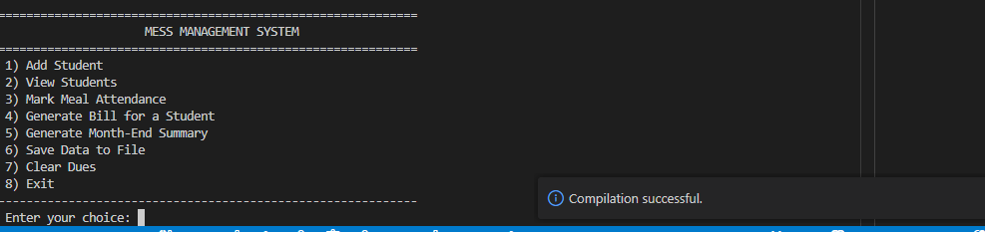

Add student:

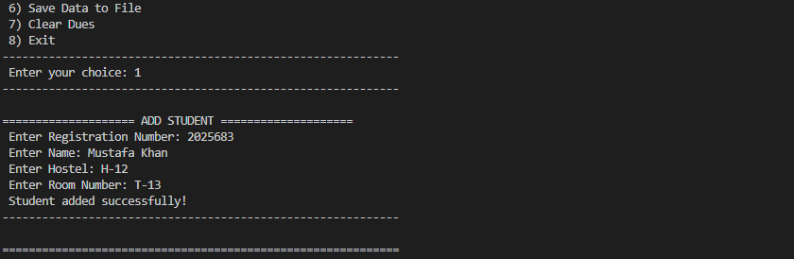
View student:
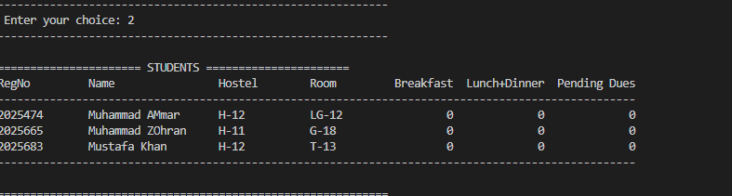
Meal Attendance:
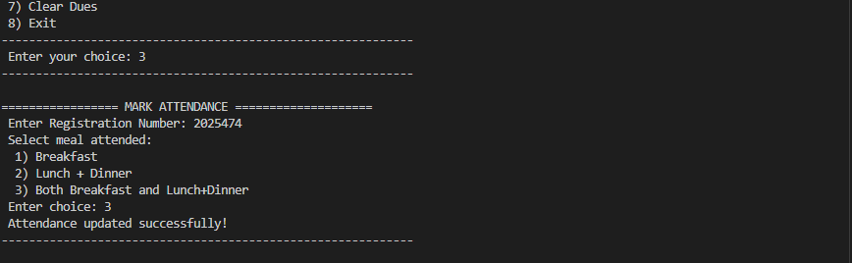

Generate Bill:
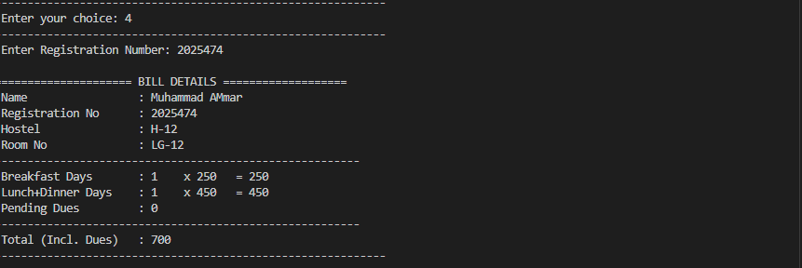
Month End summary:
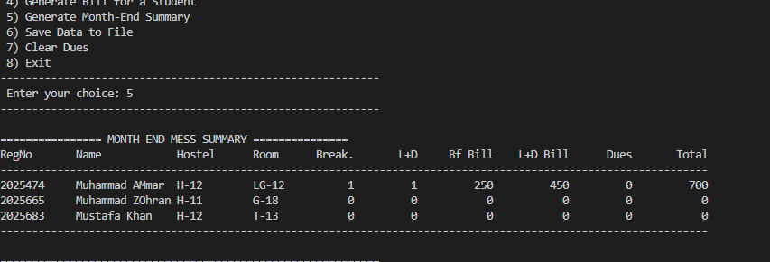
Clear Dues:
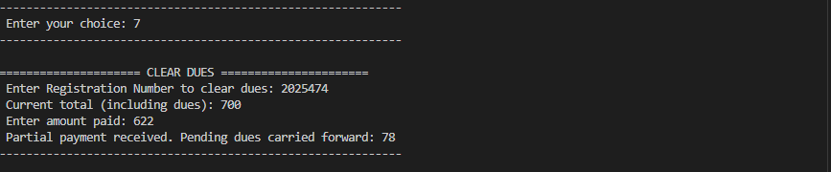

Save data to file: 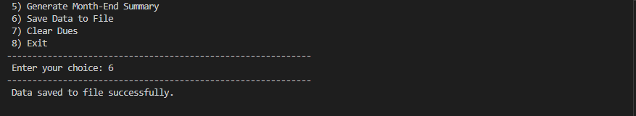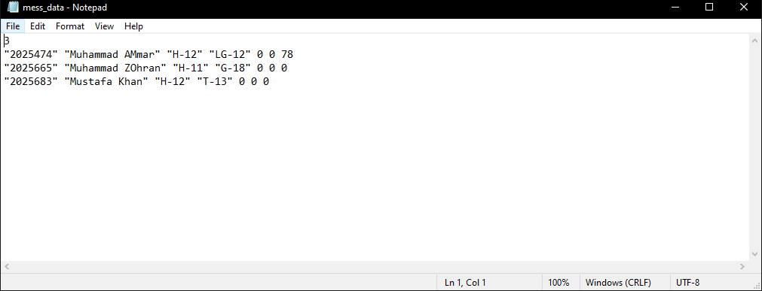
Exit:
