# CSE 4304

# Group C

# 31/01/2017

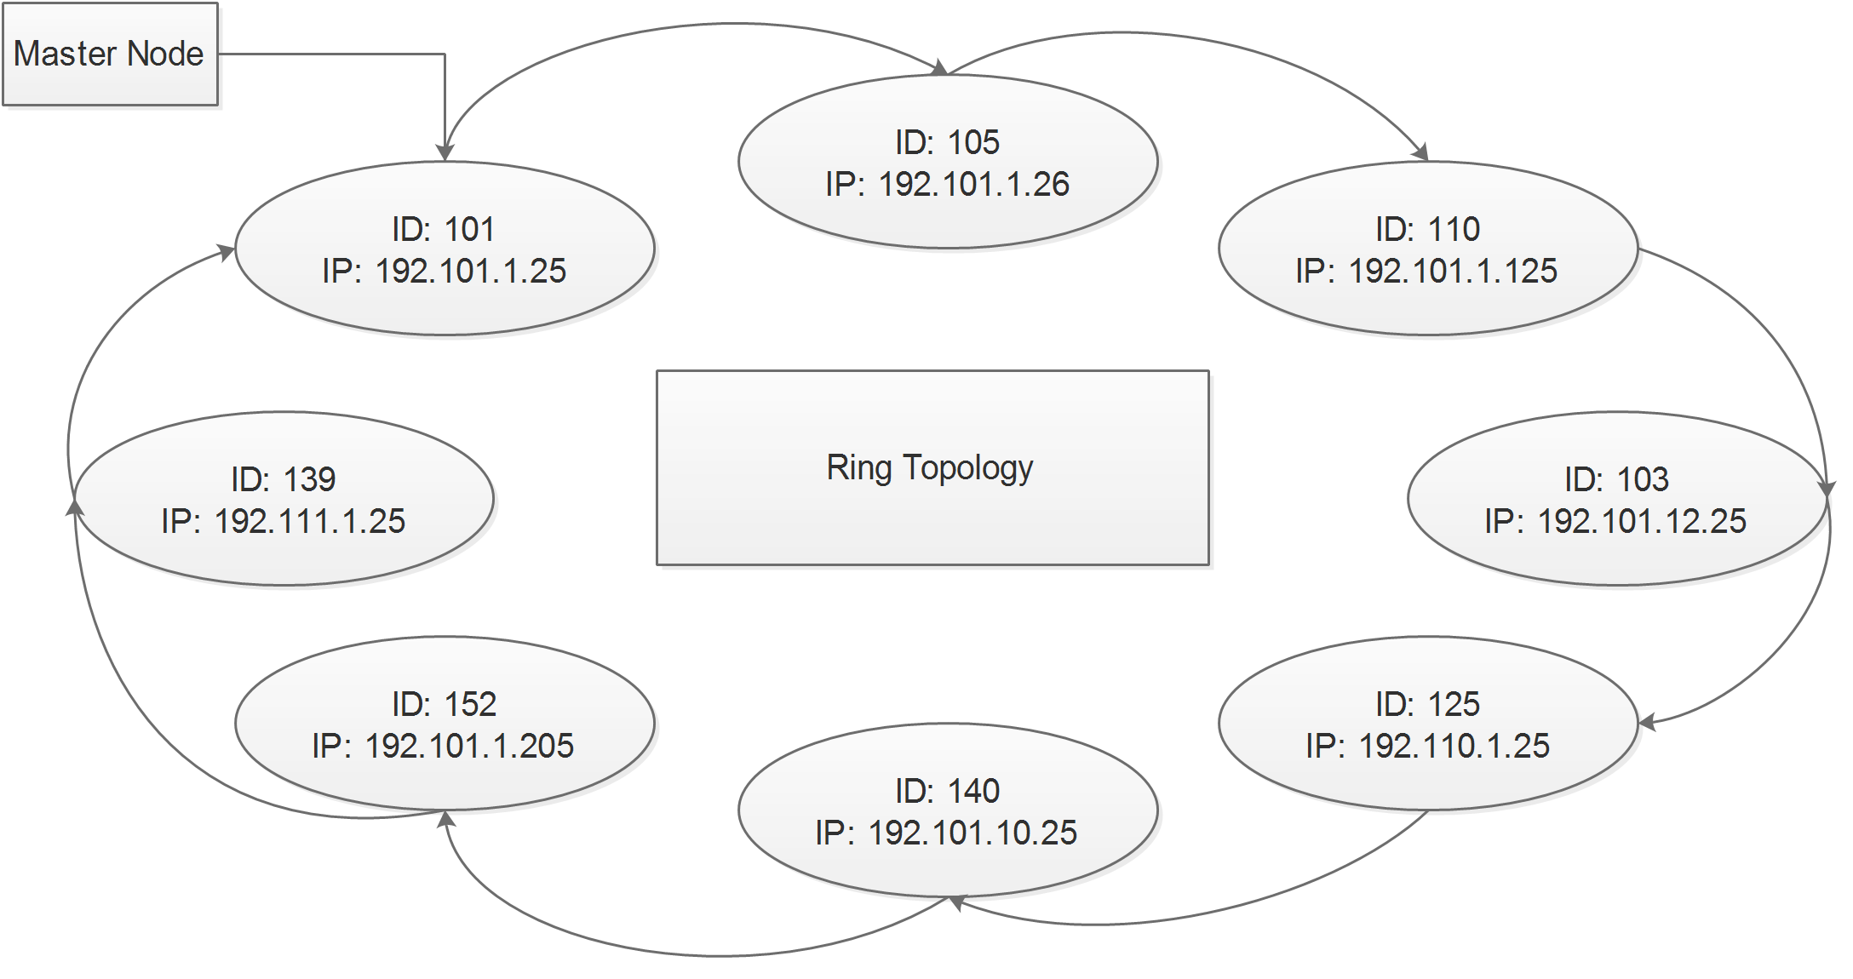

**Problem Definition:**

You need to create a ring topology using a circular linked list. Here each computer is connected to a computer next to it and can only send data to its neighbor computer. You need to keep two information for each computer. First one is an identity (id) which is a number that ranges from 100-999. Identity cannot be a duplicate one. You also need to keep the ip addresses of all the computers. An ip address is 32 bits long. It has 4 parts each 8 bits long and they are separated by a dot (.) symbol. There must be a master node which is the starting point of the ring. Master node can be changed.

**Tasks:**

1. Given the identity of 2 computers print which one is closer to the master node? For example:

Set Master Node: 101

First Node: 105

Second Node: 140

Answer: 105

1. 2 nodes need to be able to transfer data. So given the ids of 2 nodes you need to show all the visiting nodes.

First Node: 105

Second Node: 103

Data Visiting….

Node 1

ID: 110

IP: 192.101.1.125

Node 2

ID: 103

IP: 192.101.12.25

Reached….

1. You need to be able to add a node given proper id and ip address.

Print all nodes after addition.

1. You need to be able to delete a node given an id.

Print all nodes after deletion.