Lightning Protection & Auto-Disconnect
Automatic mains disconnection with remote monitoring via the Internet
Prepared May 2026 | Feasibility & Cost Overview

1. Context
Lightning strikes during the monsoon season are increasingly common across India — the country recorded 2.57 crore strikes in 2024–25, a dramatic rise driven by changing weather patterns. A nearby strike can send a high-voltage surge into a home through the mains supply, destroying electronics, appliances, and wiring in an instant. This system adds an active layer of protection: it detects the approach of a storm and physically disconnects the house from the grid before any surge can enter, then reconnects automatically once the storm has passed.

2. How it works
The system has four connected layers. The diagram below shows how they fit together at a high level.

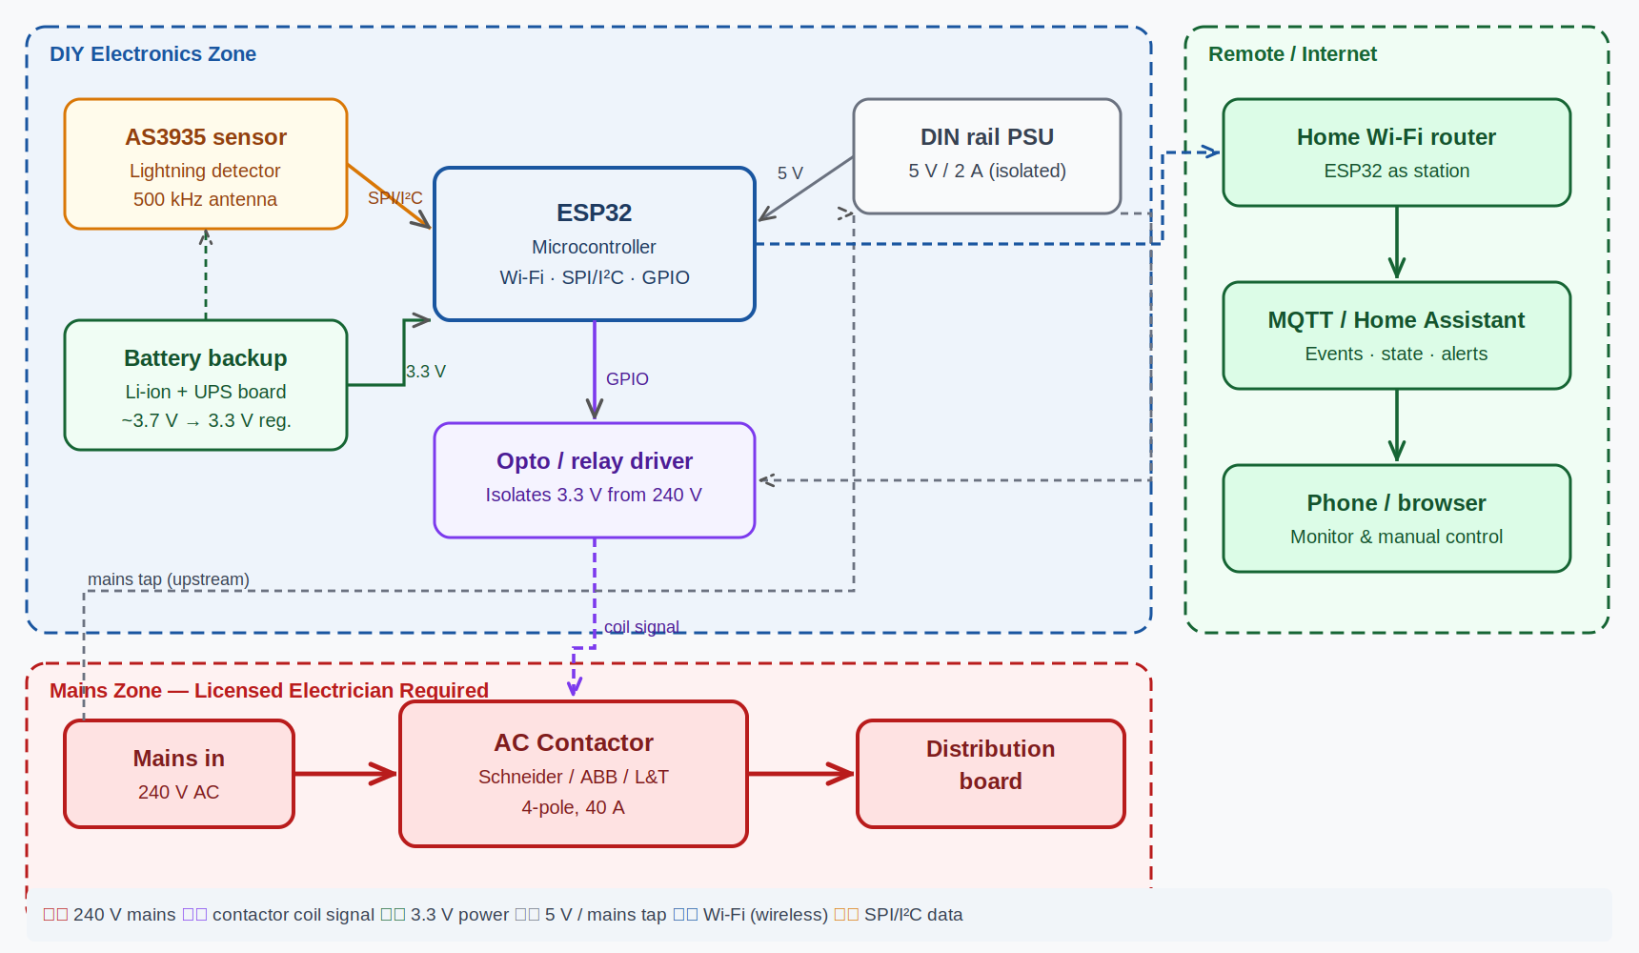
System overview — blue zone is DIY electronics, red zone requires a licensed electrician, green zone is remote monitoring

Lightning sensor (AS3935)
A small chip that listens continuously on the 500 kHz band that lightning radiates on. It detects strikes up to 40 km away, estimates how close the storm front is, and filters out noise from household appliances. It runs on battery so it stays active even if mains power is already cut.

Microcontroller (ESP32)
The brain of the system. It reads sensor data, decides when to trigger the disconnect (configurable distance threshold, e.g. 10 km), manages the auto-reconnect timer once strikes stop, and connects to home Wi-Fi to publish events and accept remote commands.

AC contactor — mains disconnect
An industrial-grade relay rated for 240 V mains, wired in series with the incoming supply before the distribution board. When signalled, it physically opens and isolates the house from the grid. An optocoupler (isolation module) keeps the 3.3 V ESP32 side completely separate from the 240 V contactor coil.

Remote monitoring
All events — strike detections, storm distance, breaker state, battery level — are published to a home automation dashboard (Home Assistant) via MQTT over Wi-Fi. You can monitor in real time and manually open or close the breaker from anywhere on your phone.

3. DIY electronics — wiring detail
The following diagram shows the exact pin-level connections between the AS3935 sensor, ESP32, battery/UPS board, optocoupler, and DIN rail PSU. All of this is low-voltage (3.3 V / 5 V) and can be assembled on a breadboard or custom PCB by anyone comfortable with hobby electronics.

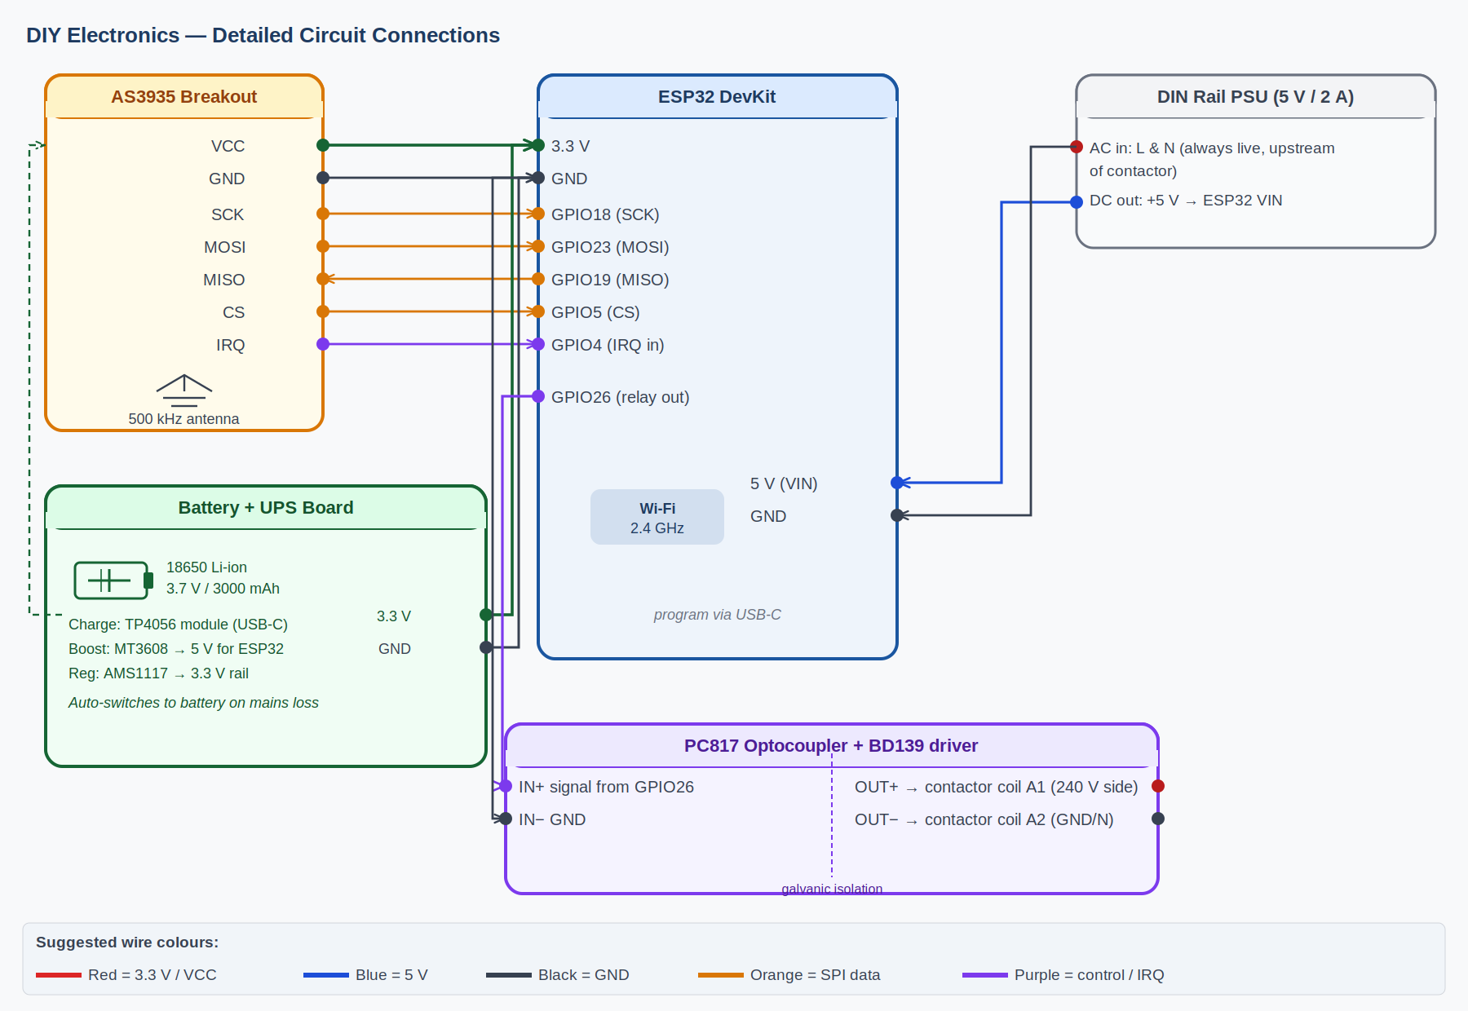
DIY circuit — pin-level connections. Orange = SPI data, purple = control/IRQ, green = 3.3 V, blue = 5 V, black = GND

Key wiring notes
- AS3935 communicates over SPI: connect SCK→GPIO18, MOSI→GPIO23, MISO→GPIO19, CS→GPIO5, IRQ→GPIO4
- The battery UPS board provides 3.3 V to the AS3935 and ESP32. It auto-switches to battery when mains power is cut
- The DIN rail PSU (wired to mains upstream of the contactor, so it is always live) provides 5 V to the ESP32 VIN pin for normal operation
- GPIO26 drives the optocoupler input (IN+). The optocoupler's output side connects to the contactor coil — this is the only wire that crosses from the DIY zone into the mains zone
- Program the ESP32 via USB-C from any laptop — no special equipment needed

4. Mains wiring — contactor terminal detail

⚠ Everything in this section operates at 240 V AC and must be installed by a licensed electrician. The DIY builder's responsibility ends at the two wires coming out of the optocoupler module.

The diagram below shows the contactor's terminal layout and how the mains L, N, and earth wires connect, as well as how the coil control signal arrives from the optocoupler.

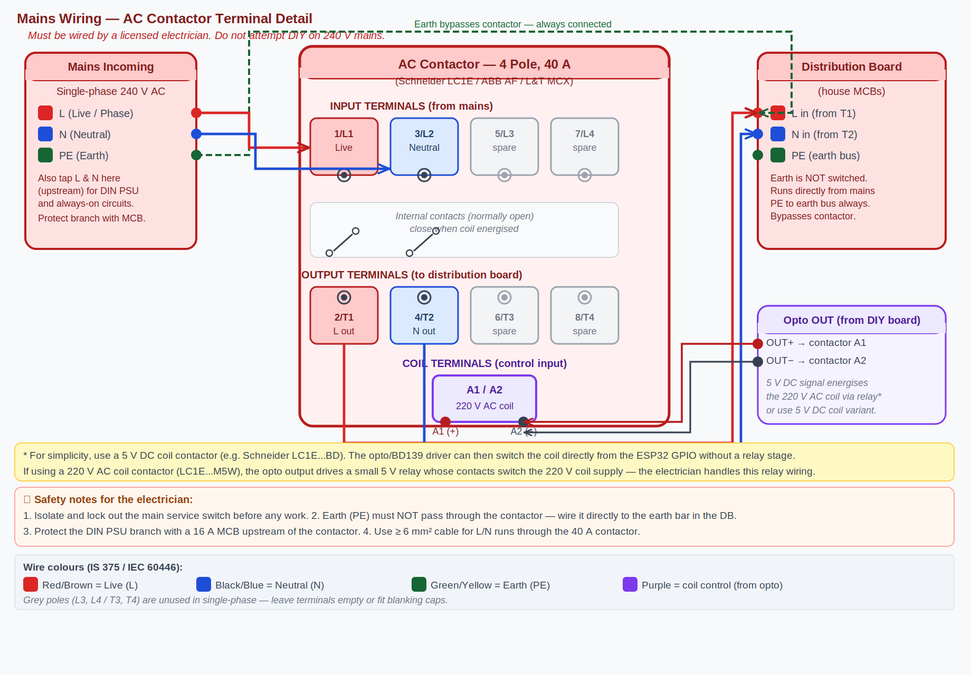
Mains wiring — contactor terminal layout with L/N/PE routes. Grey poles (L3/T3, L4/T4) are unused in single-phase installations.

Key wiring notes for electrician
- Earth (PE) must NOT pass through the contactor — run it directly from mains PE to the distribution board earth bar
- Connect Live (L) → terminal 1/L1 and Neutral (N) → terminal 3/L2. Outputs T1 and T2 go to the distribution board
- Tap L and N upstream of the contactor (at the mains input) for the DIN rail PSU branch; protect this branch with a 16 A MCB
- Coil terminals A1 and A2 receive the control signal from the optocoupler. Use a 5 V DC coil variant (e.g. Schneider LC1E...BD) to drive directly from the ESP32 opto output — this avoids needing a separate relay for the coil
- Use cable rated ≥ 6 mm² for the main L/N runs at 40 A loading
- Mount everything in a DIN-rail enclosure with proper strain relief, labelling, and an IP-rated cover

5. Cost breakdown
Costs are split between hardware you purchase and professional installation work.

Hardware
Hardware component | Where to buy | Approx. cost
AS3935 lightning sensor (breakout board) | Amazon.in | ₹900 – ₹1,800
ESP32 microcontroller devboard | Robu.in / Amazon.in | ₹300 – ₹600
4-pole 40 A AC contactor (Schneider / ABB / L&T) | Moglix / Eleczo / SE eShop | ₹1,500 – ₹3,500
Solid-state relay / optocoupler module (PC817 + BD139) | Robu.in | ₹100 – ₹300
Li-ion battery + UPS charging board | Robu.in / Thingbits | ₹400 – ₹800
5 V DIN-rail power supply | Local electrical supplier | ₹400 – ₹700
DIN-rail enclosure + wiring + cable | Local electrical supplier | ₹500 – ₹1,000
Hardware subtotal | ₹3,700 – ₹8,700

Installation
Installation task | Who does it | Approx. cost
Contactor wiring into mains supply (in DB enclosure) | Licensed electrician | ₹1,000 – ₹2,000
DIN-rail enclosure fitting, cable runs, earthing | Licensed electrician | ₹500 – ₹1,000
Installation subtotal | ₹1,500 – ₹3,000

TOTAL (hardware + installation) | ₹5,200 – ₹11,700

Prices are approximate as of May 2026 and vary by supplier. Verify before purchase.

6. Pros and considerations

Advantages
- Proactive — disconnects before a surge enters, not after damage is done
- Battery-backed — keeps working even if mains power is already lost
- Auto-reconnects — no manual action needed once the storm clears
- Real-time alerts and control from anywhere on your phone
- One-time cost of roughly ₹5,000–12,000 vs. replacing electronics worth ₹50,000+ after a single event

Things to be aware of
- The whole house loses power during a storm — refrigerators and other appliances will cycle off briefly
- Mains wiring must be done by a licensed electrician — non-negotiable
- Occasional false positives possible (industrial interference), though AS3935 has built-in noise rejection
- Requires a working Wi-Fi network for remote monitoring; local auto-disconnect works without internet

7. Where to buy

AC Contactor
- Schneider Electric India eShop (official): eshop.se.com/in — model LC1E18004M5WBIN (220 V coil) or LC1E18004BD (5 V DC coil)
- Moglix: moglix.com — search 'Schneider 4 pole contactor 40A'
- Eleczo: eleczo.com — full EasyPact TVS range
- L&T (Lauritz Knudsen): smartshop.lk-ea.com — MCX series 4-pole
- IndiaMART for local wholesale: indiamart.com — search '4 pole AC contactor 40A'

Electronics
- AS3935 sensor: amazon.in — search 'CJMCU-3935 AS3935' or 'JESSINIE AS3935'
- ESP32 DevKit: robu.in or amazon.in — search 'ESP32-DevKitC'
- UPS board + Li-ion cells: robu.in, thingbits.net
- PC817 optocoupler + BD139: robu.in (sold individually or as module)

8. Summary

Bottom line
For roughly ₹5,000–₹12,000 all-in (parts + electrician), you get a fully automatic system that detects approaching storms, isolates your home from the grid before a surge can reach it, and reconnects automatically once the storm passes — with real-time monitoring on your phone. The electronics are a straightforward DIY build; the mains connection is a short electrician job.

Report prepared May 2026. Prices are approximate and should be verified with suppliers before purchase.

