**Transistor Configuration**We know that transistor has three terminals namely emitter (E), base (B), and collector (C).But to connect a transistor in the circuit, we need four terminals: Two terminals for input and other two terminals for output.But the transistor does not have four terminals, then how do we connect transistor in a circuit. One of the three terminals are used as common to both input and output.When a transistor is to be connected in a circuit, one terminal is used as the input terminal, the other terminal is used as the output terminal and the third terminal is common to the input and output.That means here input is applied between the input terminal and common terminal, and the corresponding output is taken between the output terminal and common terminal.Depending upon the terminal which is used as a common terminal to the input and output terminals, the transistor can be connected in the following three configurations.

They are:**Common collector (CC) configurationCommon base (CB) configurationCommon emitter (CE) configuration**

In every configuration, the base-emitter junction JE is always forward biased and the collector-base junction JC is always reverse biased to operate the transistor as a current amplifier.

**Common base (CB)configuration**

n common base configuration, emitter is the input terminal, collector is the output terminal, and base is the common terminal. The base terminal is grounded in the common base configuration. So the common base configuration is also known as grounded base configuration.The emitter terminal and common base terminal are known as input terminals whereas the collector terminal and common base terminal are known as output terminals.

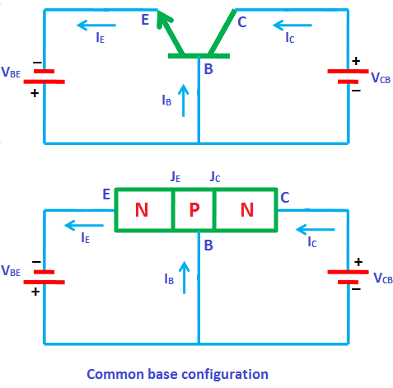

**Common Base NPN and PNP transistor:**

In the Common base circuit for NPN and PNP the input is given between emitter and base terminals and output is taken from collector and base terminals. The input voltage is denoted as VBE and the output voltage is denoted as VCE. In all the configuration the base emitter junction is always forward biased, and the collector base junction is reverse biased.

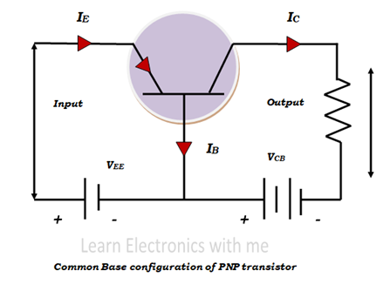

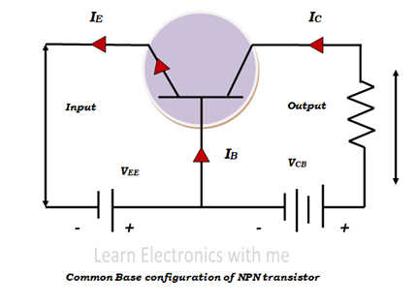

In the common base configuration of NPN circuit emitter is N type base is of P type and collector is of N type. The emitter base terminals are forward biased so the majority charge carriers in the emitter that is the electrons gets repelled by the negative applied voltage and in the same way the majority charge carriers in the base that is the holes gets repelled by the positive applied voltage.

When free electrons from emitter move to the base the free electrons and the free holes combine with each other but since the base is very thin only some free electrons get combined with the holes and most of the electrons are attracted towards the collector because of the positive terminal voltage connected to the collector. Thus, the current flow through the output terminal.

Thus, the emitter current is the sum of the base current and the collector current.

**IE = IB+IC**

**Common Emitter configuration:**

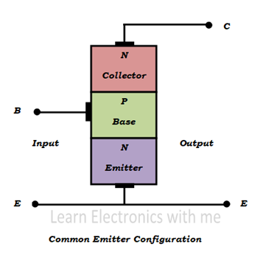

Two terminals are needed for input and two terminals for output. Transistors have three terminals, so one terminal have to be taken as common terminal for both input and output. In Common Emitter configuration, emitter terminal is taken as common for both input and output. So input is given between base and the emitter terminals and output is taken between collector and emitter terminals. This is the most commonly used configuration.

**Common Emitter NPN and PNP Transistor:**

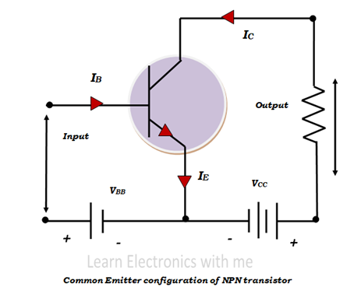

Input voltage VBE is applied between base and emitter terminals and output voltage VCE is applied across emitter and collector. The output current IC is taken across the emitter and collector terminals. The input side is forward biased, and the output side is reverse biased.

Emitter base region acts like forward biased diode and so the depletion region is very small. Emitter collector region acts like reverse biased diode and the depletion region is large. The input current IB is measured in µA because the base region is very lightly doped.

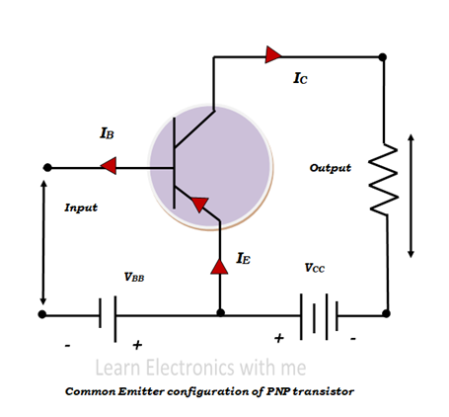

**Common Collector Configuration:**

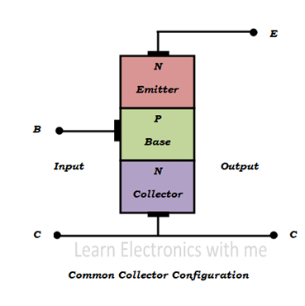

Two terminals are needed for input and two terminals for output. Transistors have three terminals, so one terminal have to be taken as common terminal for both input and output.

In common collector configuration collector terminal is taken as common. So input is applied between base and the collector terminals and output is taken from emitter and collector terminals.

The common collector configuration is also called emitter follower or voltage follower because the output emitter voltage always follows the base input voltage. This configuration is widely used as a buffer and it is also called as voltage buffer.

**NPN and PNP configuration:**

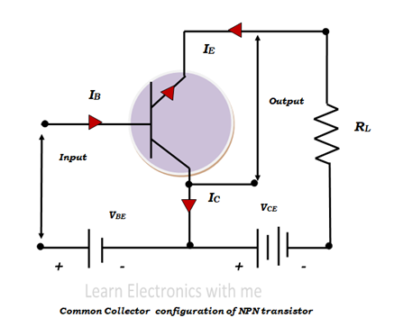

Input is applied between the base and the collector terminals. Input current that is the base current is denoted as IB and the input voltage that is the base emitter voltage is denoted as VBE. Collector terminal which is taken as common is grounded.

The output current is the emitter current, it is denoted as IE and the output voltage is emitter collector voltage and it is denoted as VCE. The output emitter current is the summation of the base and collector current. Emitter junction is forward biased and collector junction is reverse biased.

